|  |  |
| --- | --- |
| Document number 文档编号 | Confidentiality level 密级 |
| Ops-V20180629 | 内部公开 |
| Document version 文档版本 | Total 11 pages 共 11 页 |
| V1.00 |

**监控软件搭建部署方案**

|  |  |  |  |
| --- | --- | --- | --- |
| Prepared by  拟制 | 陳祥敏 | Date  日期 | 2018-06-29 |
| Reviewed by  评审人 | xxx | Date  日期 | 2018-06-29 |
| Approved by  批准 | xxx | Date  日期 | 2018-06-29 |

版权所有 © 广州天鹏计算机科技有限公司 2018。保留一切权利。非经本公司书面许可，任何单位和个人不得擅自摘抄、复制本文档内容的部分或全部，并不得以任何形式传播。

修订记录

| 日期 | 修订版本 | 修改章节 | 修改描述 | 作者 |
| --- | --- | --- | --- | --- |
| 2018/6/29 | V1.0 |  | 拟定初稿 | 陈祥敏 |
|  |  |  |  |  |
|  |  |  |  |  |
|  |  |  |  |  |
|  |  |  |  |  |

目 录

1 引言 6

1.1 目的 6

2 软件环境的准备 7

2.1 配置信息表 7

2.2 服务端基础配置 7

2.3 服务端安装 11

2.4 WEB服务初始化 14

3 Agent安装 21

3.1 windows上安装agent 21

3.2 Linux上安装agent 30

4 安装邮件服务 41

4.1 安装mailx 41

4.2 配置告警媒介类型 42

4.3 动作配置邮件通知用户 45

5 添加windows服务器 48

5.1 添加windows服务器 48

5.2 查看服务器图形数据 50

6 添加linux服务器 51

6.1 添加linux服务器 51

6.2 查看服务器图形数据 52

7 添加web监控 53

7.1 添加web监控 53

7.2 查看web图形数据 56

8 添加应用监控 57

8.1 添加mongodb端口监听监控 57

8.2 模版mongodb监控 59

8.3 添加Redis端口监听监控 61

8.4 模版redis监控 62

8.5 添加tomcat端口监听监控 65

8.6 模版tomcat监控 65

8.7 Fping添加监控 69

8.8 添加memcached端口监听监控 72

8.9 添加oracle端口监听监控 72

8.10 添加oracle端口监听监控 72

8.11 添加elasticcearch端口监听监控 72

9 告警与通知 75

9.1 触发器的设置 75

9.2 告警处置 76

10 全局监控仪表板 77

10.1 仪表板 77

10.2 问题 78

11 图形和数据图 78

11.1 Web监测 78

11.2 图形 79

# 引言

## 目的

# 软件环境的准备

本文档采用在阿里云购买云服务器，建议配置如下。

## 配置信息表

|  |  |  |  |
| --- | --- | --- | --- |
| 名称 | 版本 | 操作系统 | 版本 |
| server端 | 3.4.10 | Linux | Centos 7.4 |
| agent端 | 3.4.10 | linux | Centos 7.4 |
| agent端 | 3.4.10 | windows | windows server 2008 R2 |

## 服务端基础配置

**upgrade**

说明：

yum -y update 升级所有包，改变软件设置和系统设置,系统版本内核都升级

yum -y upgrade 升级所有包，不改变软件设置和系统设置，系统版本升级，内核不改变

# yum -y upgrade

**iptables-services**

# systemctl status firewalld.service

# systemctl stop firewalld.service

# systemctl disable firewalld.service

# yum list |grep iptables-services

# yum install iptables-services.x86_64 或 yum install iptables-services

# vim /etc/sysconfig/iptables

# systemctl restart iptables.service

# systemctl enable iptables.service

**telnet**

# yum list |grep telnet

# yum install telnet.x86_64

# yum install telnet-server.x86_64

# systemctl enable telnet.socket

# systemctl enable xinetd.service

# systemctl start telnet.socket

# systemctl start xinetd

**snmp**

# yum install net-snmp

# systemctl enable snmpd

# systemctl start snmpd

**iftop&nethogs**

# yum install libpcap libpcap-devel ncurses ncurses-devel

# yum install flex byacc

# wget <http://dl.fedoraproject.org/pub/epel/6/i386/epel-release-6-8.noarch.rpm>

# rpm -ivh epel-release-6-8.noarch.rpm

# yum install iftop

# yum install nethogs

**Hostname**

# hostnamectl set-hostname yunzhenyun-zabbix-server

# vi /etc/hosts

# vi /etc/sysconfig/network

**SElinux**

禁用SElinux（一定要关闭，否则有些功能不能正常使用）

查看是否修改

# cat /etc/selinux/config |grep -v ^# |grep -v ^$

SELINUX=disabled

SELINUXTYPE=targeted

修改/etc/selinux/config配置文件

# sed -i "s/SELINUX=enforcing/SELINUX=disabled/g" /etc/selinux/config

查看SELinux状态

# sestatus

SELinux status: disabled

**Ssh**

修改ssh端口为8930

# vim /etc/ssh/sshd_config

# yum -y install policycoreutils-python

# semanage port -l | grep ssh

# semanage port -a -t ssh_port_t -p tcp 8930

# systemctl restart sshd.service

**Group&users**

group：

1）groupadd DevGroup /*开发测试账号组*/

3）groupadd DevOpsAuditGroup /*运维账号组（运维审计、配置等）*/

4）groupadd DevOpsGroup /*运维账号组（管理员）*/

5）groupadd Root /*超级管理组（运维组，已存在）*/

user：

1）useradd devuser /*开发测试用户*/

3）useradd audituser /*运维审计、配置用户*/

4）useradd devopsuser /*运维用户（运维）*/

5）useradd root /*运维用户（运维，已存在）*/

#--------------------------------------

#groupadd DevGroup

#useradd -g DevGroup devuser

#passwd devuser （passwd）

#--------------------------------------

#groupadd DevOpsAuditGroup

#useradd -g DevOpsAuditGroup audituser

#passwd audituser （passwd）

#--------------------------------------

#groupadd DevOpsGroup

#useradd -g DevOpsGroup devopsuser

#passwd devopsuser （passwd）

## 服务端安装

所依赖的安装包

# yum -y install gcc* make php php-gd php-mysql php-bcmath php-mbstring php-xml curl curl-devel net-snmp net-snmp-devel perl-DBI httpd mariadb* mysql-devel libxml2-devel curl-devel unixODBC-devel net-snmp-devel OpenIPMI-devel openldap openldap-devel libevent-devel php-ldap

创建安装目录

# mkdir -pv /app/zabbix

创建zabbix用户和组

# groupadd ZBX_Group

# useradd -g ZBX_Group zabbix

# passwd zabbix（passwd）

解压及安装

# tar -xvf zabbix-3.4.10.tar.gz

# cd zabbix-3.4.10

# ./configure --prefix=/app/zabbix --enable-server --enable-agent --with-mysql --with-net-snmp --with-libcurl --with-libxml2 --with-openipmi --with-unixodbc

# make && make install

# cd /app && chown -R zabbix:ZBX_Group zabbix

启动及配置数据库

# systemctl status mariadb.service

# systemctl start mariadb.service

# mysql (# mysql -uroot -p)

Welcome to the MariaDB monitor. Commands end with ; or \g.

Your MariaDB connection id is 4

Server version: 5.5.56-MariaDB MariaDB Server

Copyright (c) 2000, 2017, Oracle, MariaDB Corporation Ab and others.

Type 'help;' or '\h' for help. Type '\c' to clear the current input statement.

MariaDB [(none)]> **SET PASSWORD FOR 'root'@'localhost' = PASSWORD('passwd');**

Query OK, 0 rows affected (0.00 sec)

MariaDB [(none)]> **FLUSH PRIVILEGES;**

Query OK, 0 rows affected (0.00 sec)

MariaDB [(none)]> **Grant all privileges on *.* to 'root'@'%' identified by 'passwd' with grant option;**

Query OK, 0 rows affected (0.00 sec)

MariaDB [(none)]> create database if not exists zabbix default character set utf8 collate utf8_general_ci;

Query OK, 1 row affected (0.00 sec)

MariaDB [(none)]> **grant all privileges on zabbix.* to zabbix@localhost identified by 'passwd';**

Query OK, 0 rows affected (0.00 sec)

MariaDB [(none)]> **FLUSH PRIVILEGES;**

Query OK, 0 rows affected (0.00 sec)

启动及配置数据库

MariaDB [(none)]> use zabbix;

MariaDB [zabbix]> source /home/software/zabbix-3.4.10/database/mysql/schema.sql;

MariaDB [zabbix]> source /home/software/zabbix-3.4.10/database/mysql/images.sql;

MariaDB [zabbix]> source /home/software/zabbix-3.4.10/database/mysql/data.sql;

创建日志目录-

# cd /app/zabbix

# mkdir /app/zabbix/logs /app/zabbix/alertscripts /app/zabbix/externalscripts

# chown zabbix:ZBX_Group /app/zabbix/logs /app/zabbix/alertscripts /app/zabbix/externalscripts

移动zabbix项目到httpd目录中去

# cp -r /home/software/zabbix-3.4.10/frontends/php/ /var/www/html/zabbix

# ll /var/www/html/

# chown zabbix:ZBX_Group /var/www/html/zabbix/ -R

修改zabbix_server.conf

# vim ./etc/zabbix_server.conf

PidFile=/tmp/zabbix_server.pid

LogFile=/app/zabbix/logs/zabbix_server.log

DBPassword=passwd

Include=/app/zabbix/etc/zabbix_server.conf.d/*.conf

AlertScriptsPath=/app/zabbix/alertscripts

ExternalScripts=/app/zabbix/externalscripts

修改zabbix_agent.conf

# vim ./etc/zabbix_agentd.conf

PidFile=/tmp/zabbix_agentd.pid

LogFile=/app/zabbix/logs/zabbix_agentd.log

Include=/app/zabbix/etc/zabbix_agentd.conf.d/*.conf

修改zabbix服务启动脚本

# cp /home/software/zabbix-3.4.10/misc/init.d/fedora/core/zabbix_server /etc/init.d/

# vim /etc/init.d/zabbix_server

# BASEDIR=/usr/local

BASEDIR=/app/zabbix

修改php.ini

vim /etc/php.ini

date.timezone = Asia/Shanghai #设置时区

max_execution_time = 300 #php脚本最大执行时间

post_max_size = 16M #上传文件大小

mbstring.func_overload = 1

max_input_time = 300 #以秒为单位对通过POST、GET以及PUT方式接收数据时间进行限制

修改httpd.conf

# vi /etc/httpd/conf/httpd.conf

Listen 8989

ServerName 127.0.0.1:8989

DocumentRoot "/var/www/html/zabbix/"

设置开机启动

# chkconfig --add zabbix_server

# chkconfig zabbix_server on

# systemctl enable httpd.service

# systemctl enable mariadb.service

# systemctl start httpd.service

启动zabbix_server和zabiix_agent服务

# /app/zabbix/sbin/zabbix_server

# /etc/init.d/zabbix_server stop

# /app/zabbix/sbin/zabbix_agentd

# systemctl start httpd.service

# vim /usr/lib/systemd/system/zabbix_agentd.service

[Unit]

Description=Zabbix Agent

After=syslog.target

After=network.target

[Service]

Environment="CONFFILE=/app/zabbix/etc/zabbix_agentd.conf"

EnvironmentFile=-/app/zabbix/sbin/zabbix_agentd

Type=forking

Restart=always

PIDFile=/tmp/zabbix_agentd.pid

KillMode=mixed

ExecStart=/app/zabbix/sbin/zabbix_agentd -c $CONFFILE

[Install]

WantedBy=multi-user.target

# systemctl enable zabbix_agentd.service

# systemctl stop zabbix_agentd.service

# systemctl status zabbix_agentd.service

检查服务是否正常

# ps -ef|grep zabbix

# ps -ef|grep httpd

# ps -ef|grep mysql

# systemctl status zabbix_server.service

# systemctl status zabbix_agentd.service

# systemctl status httpd.service

## WEB服务初始化

浏览器访问：<http://IP地址:8989/setup.php>

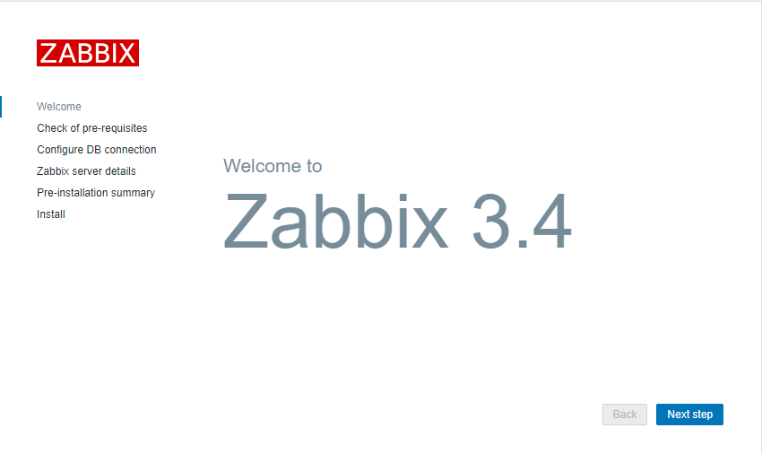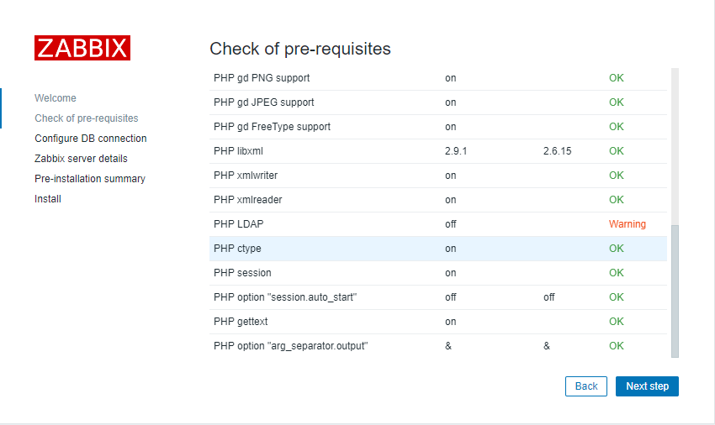需安装此包 php-ldap，重启httpd解决

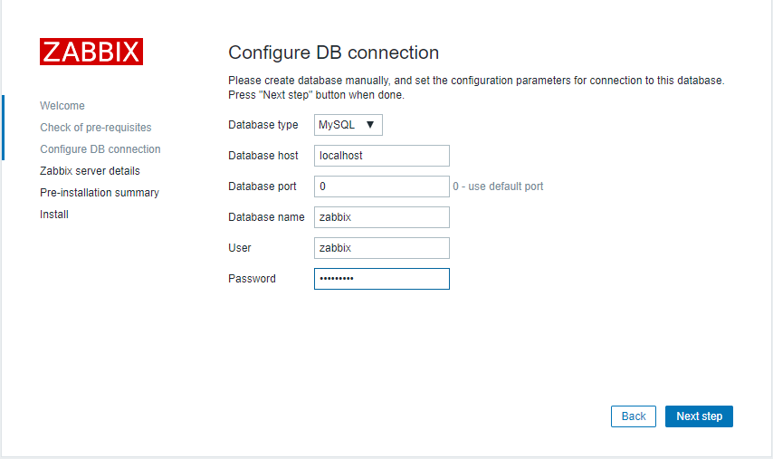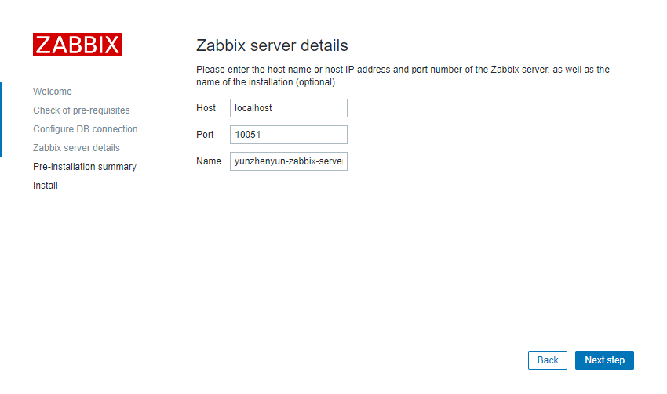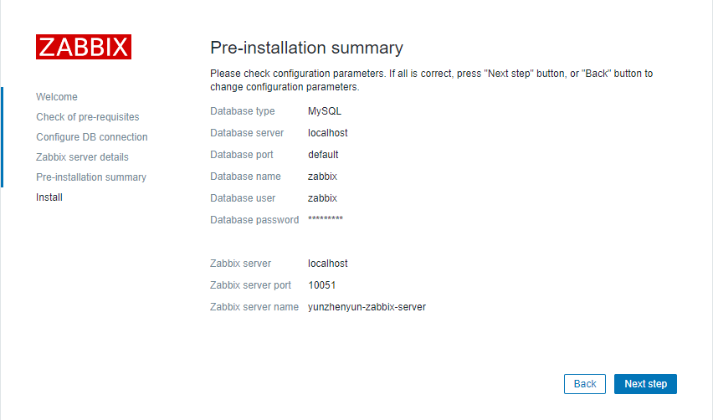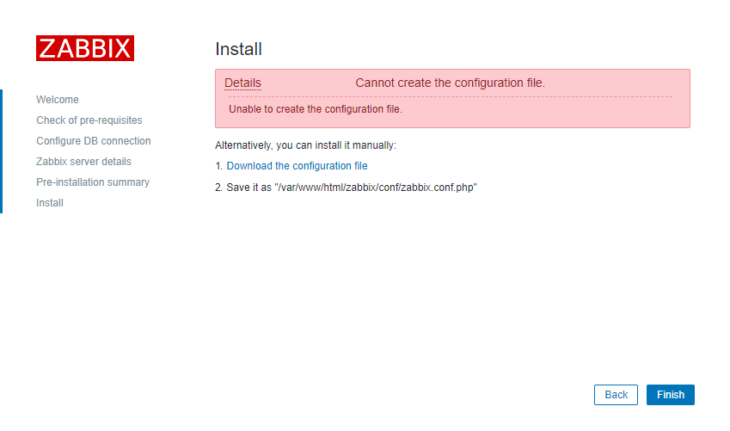

手动另存传到此位置

/var/www/html/zabbix/conf/zabbix.conf.php

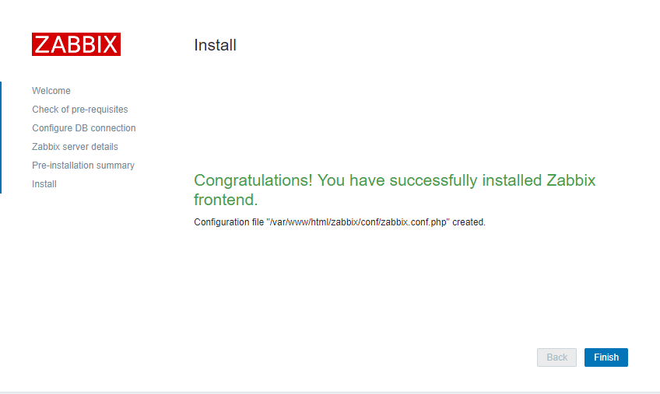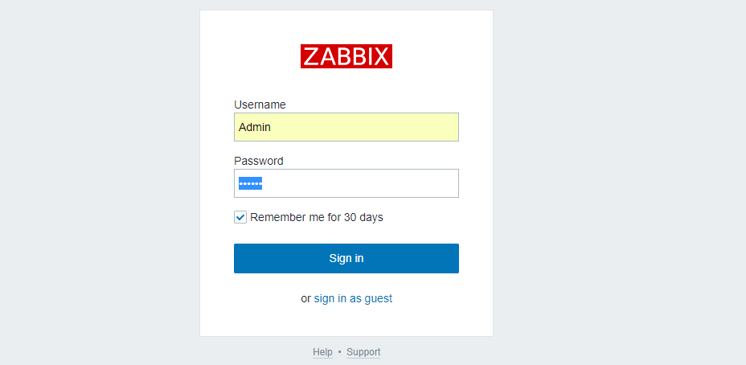

默认密码为Admin/Zabbix

界面中文调整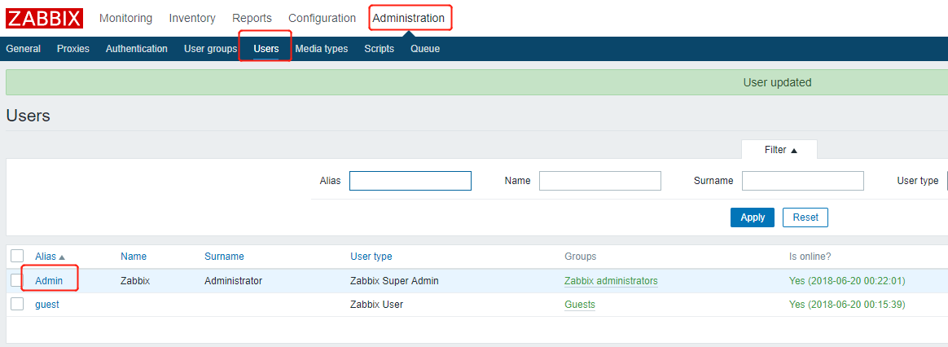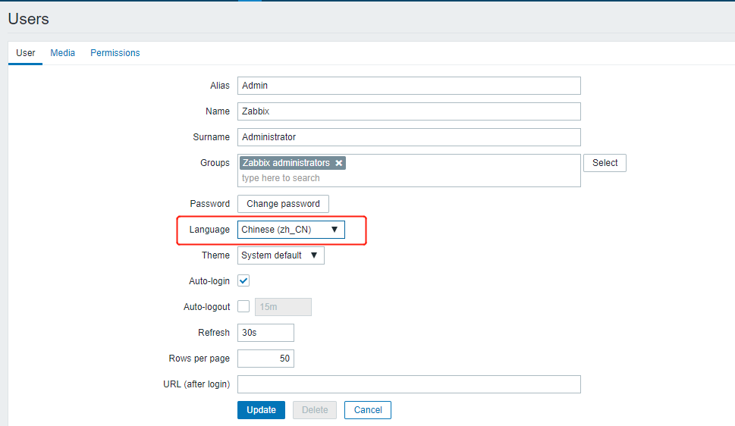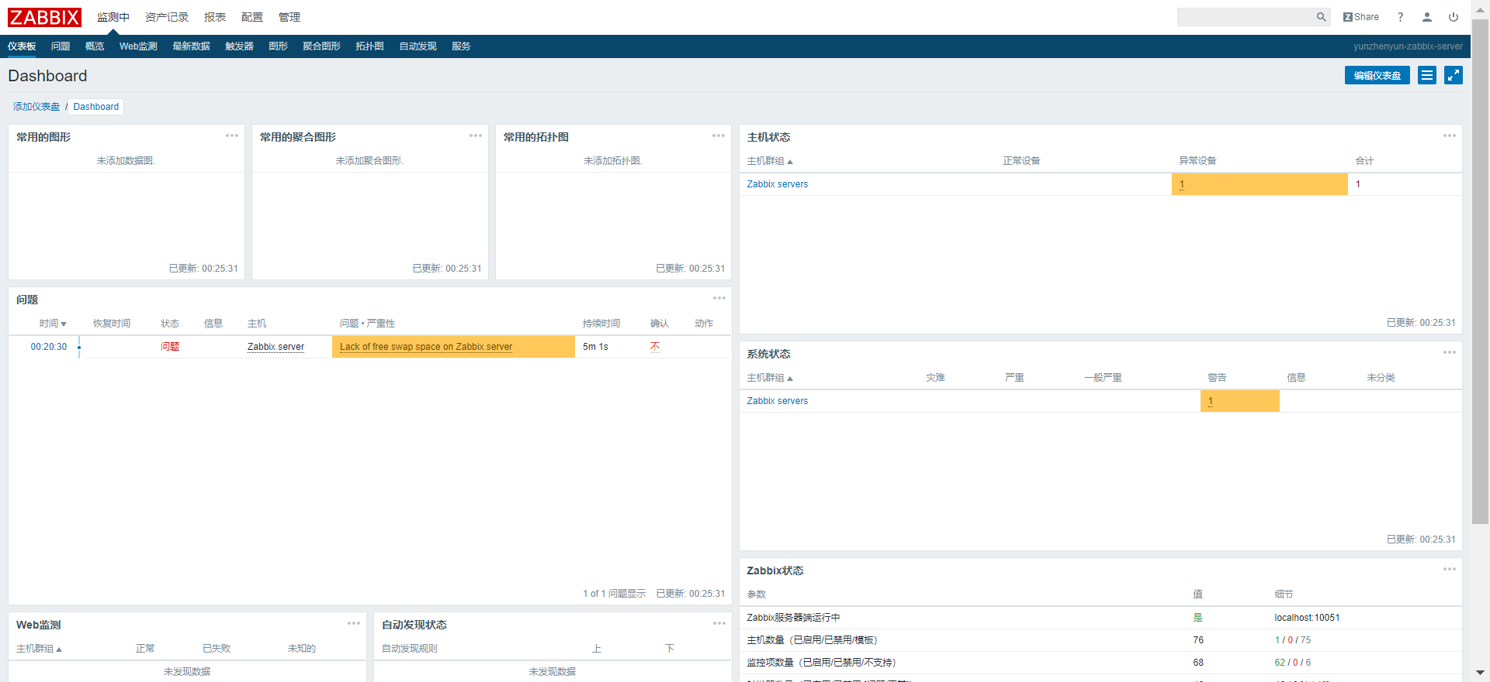

解决乱码2种方案

# yum install google-noto-sans-simplified-chinese-fonts.noarch -y

# mv /var/www/html/zabbix/fonts/DejaVuSans.ttf /var/www/html/zabbix/fonts/DejaVuSans.ttf_bk #源码安装时

# cp /usr/share/fonts/google-noto/NotoSansSC-Regular.otf /var/www/html/zabbix/fonts/DejaVuSans.ttf

# chown zabbix:ZBX_Group /var/www/html/zabbix/fonts/DejaVuSans.ttf

# mv /etc/alternatives/zabbix-web-font /etc/alternatives/zabbix-web-font_bak #yum安装字体

# ln -s /usr/share/fonts/google-noto/NotoSansSC-Regular.otf /etc/alternatives/zabbix-web-font

或者

修正图形乱码字体

设置为中文界面后，zabbix 图形的中文文字会显示小方框,因为没有字体，需要从字体库找到字体传到

/usr/share/zabbix/fonts/中，一般为 windows 中“C:\Windows\Fonts\”，找到‘msyh.ttf’微软雅黑常规字体，传进去修改名称

为 graphfont.ttf 即无乱码

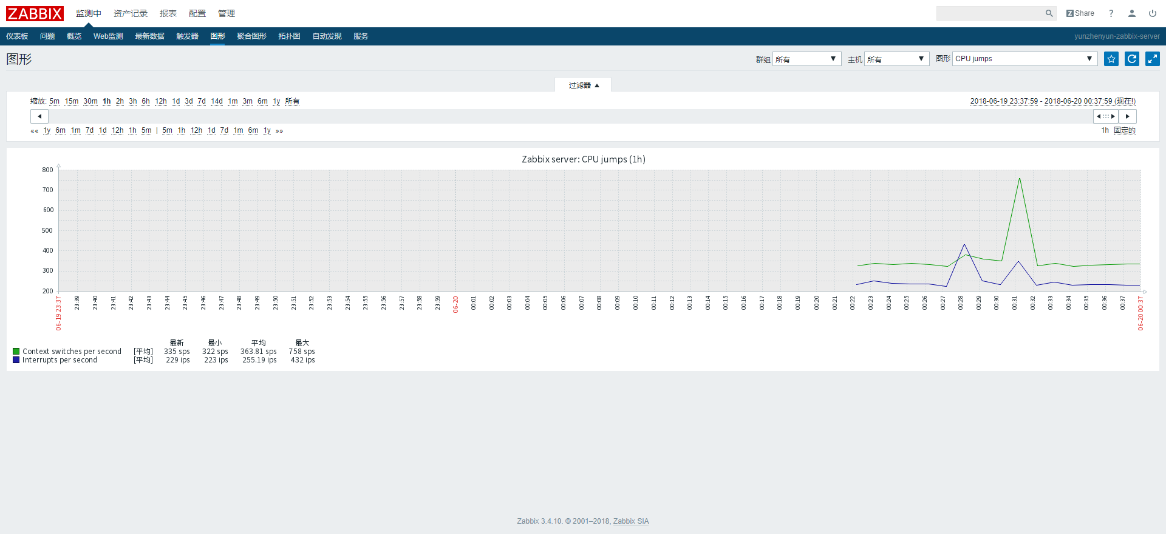

# Agent安装

## windows上安装agent

配置文件

修改zabbix_agentd.win.conf（修改为检测被动模式）

# This is a configuration file for Zabbix agent service (Windows)

# To get more information about Zabbix, visit <http://www.zabbix.com>

############ GENERAL PARAMETERS #################

### Option: LogType

#        Specifies where log messages are written to:

#                system - Windows event log

#                file - file specified with LogFile parameter

#                console - standard output

#

# Mandatory: no

# Default:

# LogType=file

### Option: LogFile

#        Log file name for LogType 'file' parameter.

#

# Mandatory: no

# Default:

# LogFile= #日志输出的路径

LogFile=C:\Program Files\zabbix_agents_3.4.6\logs\zabbix_agentd.log

### Option: LogFileSize

#        Maximum size of log file in MB.

#        0 - disable automatic log rotation.

#

# Mandatory: no

# Range: 0-1024

# Default:

# LogFileSize=1 #当日志文件达到多大时进行轮询操作

### Option: DebugLevel

#        Specifies debug level:

#        0 - basic information about starting and stopping of Zabbix processes

#        1 - critical information

#        2 - error information

#        3 - warnings

#        4 - for debugging (produces lots of information)

#        5 - extended debugging (produces even more information)

#

# Mandatory: no

# Range: 0-5

# Default:

# DebugLevel=3 #日志信息级别

DebugLevel=3

### Option: SourceIP

#        Source IP address for outgoing connections.

#

# Mandatory: no

# Default:

# SourceIP= #连接的源ip地址，默认为空，即可

### Option: EnableRemoteCommands

#        Whether remote commands from Zabbix server are allowed.

#        0 - not allowed

#        1 - allowed

#

# Mandatory: no

# Default:

# EnableRemoteCommands=0 是否允许zabbix server端的远程指令，0表示不允许，1表示允许

### Option: LogRemoteCommands

#        Enable logging of executed shell commands as warnings.

#        0 - disabled

#        1 - enabled

#

# Mandatory: no

# Default:

# LogRemoteCommands=0 #是否开启日志记录shell命令作为警告 0表示不允许，1表示允许

##### Passive checks related #被动检测模式

### Option: Server

#        List of comma delimited IP addresses, optionally in CIDR notation, or hostnames of Zabbix servers.

#        Incoming connections will be accepted only from the hosts listed here.

#        If IPv6 support is enabled then '127.0.0.1', '::127.0.0.1', '::ffff:127.0.0.1' are treated equally and '::/0' will allow any IPv4 or IPv6 address.

#        '0.0.0.0/0' can be used to allow any IPv4 address.

#        Example: Server=127.0.0.1,192.168.1.0/24,::1,2001:db8::/32,zabbix.domain

#

# Mandatory: no

# Default:

# Server= #被动zabbix服务器IP地址或主机名，可同时列出多个，需要用逗号隔开

Server=172.17.70.22

### Option: ListenPort

#        Agent will listen on this port for connections from the server.

#

# Mandatory: no

# Range: 1024-32767

# Default:

# ListenPort=10050 #zabbix agent监听的端口

ListenPort=10050

### Option: ListenIP

# List of comma delimited IP addresses that the agent should listen on.

# First IP address is sent to Zabbix server if connecting to it to retrieve list of active checks.

#

# Mandatory: no

# Default:

# ListenIP=0.0.0.0 #zabbix agent监听的ip地

### Option: StartAgents

#        Number of pre-forked instances of zabbix_agentd that process passive checks.

#        If set to 0, disables passive checks and the agent will not listen on any TCP port.

#

# Mandatory: no

# Range: 0-100

# Default:

# StartAgents=3 #zabbix agent开启进程数

##### Active checks related 主动检测模式

### Option: ServerActive

#        List of comma delimited IP:port (or hostname:port) pairs of Zabbix servers for active checks.

#        If port is not specified, default port is used.

#        IPv6 addresses must be enclosed in square brackets if port for that host is specified.

#        If port is not specified, square brackets for IPv6 addresses are optional.

#        If this parameter is not specified, active checks are disabled.

#        Example: ServerActive=127.0.0.1:20051,zabbix.domain,[::1]:30051,::1,[12fc::1]

#

# Mandatory: no

# Default:

# ServerActive= #主动模式的server IP地址(开启主动检查)

#ServerActive=127.0.0.1

### Option: Hostname

#        Unique, case sensitive hostname.

#        Required for active checks and must match hostname as configured on the server.

#        Value is acquired from HostnameItem if undefined.

#

# Mandatory: no

# Default:

# Hostname= #在zabbix server前端配置时指定的主机名要相同，最重要的配置

#Hostname=Windows host

### Option: HostnameItem

#        Item used for generating Hostname if it is undefined. Ignored if Hostname is defined.

#        Does not support UserParameters or aliases.

#

# Mandatory: no

# Default:

# HostnameItem=system.hostname

### Option: HostMetadata

#        Optional parameter that defines host metadata.

#        Host metadata is used at host auto-registration process.

#        An agent will issue an error and not start if the value is over limit of 255 characters.

#        If not defined, value will be acquired from HostMetadataItem.

#

# Mandatory: no

# Range: 0-255 characters

# Default:

# HostMetadata=

### Option: HostMetadataItem

#        Optional parameter that defines an item used for getting host metadata.

#        Host metadata is used at host auto-registration process.

#        During an auto-registration request an agent will log a warning message if

#        the value returned by specified item is over limit of 255 characters.

#        This option is only used when HostMetadata is not defined.

#

# Mandatory: no

# Default:

# HostMetadataItem=

### Option: RefreshActiveChecks

#        How often list of active checks is refreshed, in seconds.

#

# Mandatory: no

# Range: 60-3600

# Default:

# RefreshActiveChecks=120 #主动检查刷新的时间，单位为秒数

### Option: BufferSend

#        Do not keep data longer than N seconds in buffer.

#

# Mandatory: no

# Range: 1-3600

# Default:

# BufferSend=5 #数据缓冲的时间

### Option: BufferSize

#        Maximum number of values in a memory buffer. The agent will send

#        all collected data to Zabbix server or Proxy if the buffer is full.

#

# Mandatory: no

# Range: 2-65535

# Default:

# BufferSize=100 #zabbix agent数据缓冲区的大小，当达到该值便会发送所有的数据到zabbix server

### Option: MaxLinesPerSecond

#        Maximum number of new lines the agent will send per second to Zabbix Server

#        or Proxy processing 'log', 'logrt' and 'eventlog' active checks.

#        The provided value will be overridden by the parameter 'maxlines',

#        provided in 'log', 'logrt' or 'eventlog' item keys.

#

# Mandatory: no

# Range: 1-1000

# Default:

# MaxLinesPerSecond=20 #zabbix agent发送给zabbix server最大的数据行

############ ADVANCED PARAMETERS #################

### Option: Alias

#        Sets an alias for an item key. It can be used to substitute long and complex item key with a smaller and simpler one.

#        Multiple Alias parameters may be present. Multiple parameters with the same Alias key are not allowed.

#        Different Alias keys may reference the same item key.

#        For example, to retrieve paging file usage in percents from the server:

#        Alias=pg_usage:perf_counter[\Paging File(_Total)\% Usage]

#        Now shorthand key pg_usage may be used to retrieve data.

#        Aliases can be used in HostMetadataItem but not in HostnameItem or PerfCounter parameters.

#

# Mandatory: no

# Range:

# Default:

### Option: Timeout

#        Spend no more than Timeout seconds on processing.

#

# Mandatory: no

# Range: 1-30

# Default:

# Timeout=3 #设定处理超时的时间

### Option: PerfCounter

#        Syntax: <parameter_name>,"<perf_counter_path>",<period>

#        Defines new parameter <parameter_name> which is an average value for system performance counter <perf_counter_path> for the specified time period <period> (in seconds).

#        For example, if you wish to receive average number of processor interrupts per second for last minute, you can define new parameter "interrupts" as following:

#        PerfCounter = interrupts,"\Processor(0)\Interrupts/sec",60

#        Please note double quotes around performance counter path.

#        Samples for calculating average value will be taken every second.

#        You may run "typeperf -qx" to get list of all performance counters available in Windows.

#

# Mandatory: no

# Range:

# Default:

### Option: Include

#        You may include individual files in the configuration file.

#

# Mandatory: no

# Default:

# Include=

# Include=c:\zabbix\zabbix_agentd.userparams.conf

# Include=c:\zabbix\zabbix_agentd.conf.d\ #包含子配置文件的路径

# Include=c:\zabbix\zabbix_agentd.conf.d\*.conf

####### USER-DEFINED MONITORED PARAMETERS #######

### Option: UnsafeUserParameters

#        Allow all characters to be passed in arguments to user-defined parameters.

#        The following characters are not allowed:

#        \ ' " ` * ? [ ] { } ~ $ ! & ; ( ) < > | # @

#        Additionally, newline characters are not allowed.

#        0 - do not allow

#        1 - allow

#

# Mandatory: no

# Range: 0-1

# Default:

# UnsafeUserParameters=0 #是否允许所有字符参数的传递

### Option: UserParameter

#        User-defined parameter to monitor. There can be several user-defined parameters.

#        Format: UserParameter=<key>,<shell command>

#

# Mandatory: no

# Default:

# UserParameter= #指定用户自定义参数

####### TLS-RELATED PARAMETERS #######

### Option: TLSConnect

#        How the agent should connect to server or proxy. Used for active checks.

#        Only one value can be specified:

#                unencrypted - connect without encryption

#                psk - connect using TLS and a pre-shared key

#                cert - connect using TLS and a certificate

#

# Mandatory: yes, if TLS certificate or PSK parameters are defined (even for 'unencrypted' connection)

# Default:

# TLSConnect=unencrypted

### Option: TLSAccept

#        What incoming connections to accept.

#        Multiple values can be specified, separated by comma:

#                unencrypted - accept connections without encryption

#                psk - accept connections secured with TLS and a pre-shared key

#                cert - accept connections secured with TLS and a certificate

#

# Mandatory: yes, if TLS certificate or PSK parameters are defined (even for 'unencrypted' connection)

# Default:

# TLSAccept=unencrypted

### Option: TLSCAFile

#        Full pathname of a file containing the top-level CA(s) certificates for

#        peer certificate verification.

#

# Mandatory: no

# Default:

# TLSCAFile=

### Option: TLSCRLFile

#        Full pathname of a file containing revoked certificates.

#

# Mandatory: no

# Default:

# TLSCRLFile=

### Option: TLSServerCertIssuer

# Allowed server certificate issuer.

#

# Mandatory: no

# Default:

# TLSServerCertIssuer=

### Option: TLSServerCertSubject

# Allowed server certificate subject.

#

# Mandatory: no

# Default:

# TLSServerCertSubject=

### Option: TLSCertFile

#        Full pathname of a file containing the agent certificate or certificate chain.

#

# Mandatory: no

# Default:

# TLSCertFile=

### Option: TLSKeyFile

#        Full pathname of a file containing the agent private key.

#

# Mandatory: no

# Default:

# TLSKeyFile=

### Option: TLSPSKIdentity

#        Unique, case sensitive string used to identify the pre-shared key.

#

# Mandatory: no

# Default:

# TLSPSKIdentity=

### Option: TLSPSKFile

#        Full pathname of a file containing the pre-shared key.

#

# Mandatory: no

# Default:

# TLSPSKFile=

安装为windows服务

管理员cmd（-i创建 -d删除）

C:\Program Files\zabbix_agents_3.4.6\bin\win64>zabbix_agentd.exe -i -c "C:\Program Files\zabbix_agents_3.4.6\conf\zabbix_agentd.win.conf"

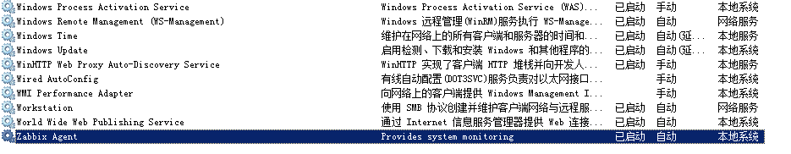

## Linux上安装agent

# rpm -ivh zabbix-agent-3.4.10-1.el7.x86_64.rpm

配置文件

# This is a configuration file for Zabbix agent daemon (Unix)

# To get more information about Zabbix, visit <http://www.zabbix.com>

############ GENERAL PARAMETERS #################

### Option: PidFile

#        Name of PID file.

#

# Mandatory: no

# Default:

# PidFile=/tmp/zabbix_agentd.pid #PID输出的路径

PidFile=/var/run/zabbix/zabbix_agentd.pid

### Option: LogType

#        Specifies where log messages are written to:

#                system - syslog

#                file - file specified with LogFile parameter

#                console - standard output

#

# Mandatory: no

# Default:

# LogType=file

### Option: LogFile

#        Log file name for LogType 'file' parameter.

#

# Mandatory: no

# Default:

# LogFile= #日志输出的路径

LogFile=/etc/zabbix/logs/zabbix_agentd.log

### Option: LogFileSize

#        Maximum size of log file in MB.

#        0 - disable automatic log rotation.

#

# Mandatory: no

# Range: 0-1024

# Default:

# LogFileSize=1 #当日志文件达到多大时进行轮询操作

LogFileSize=0

### Option: DebugLevel

#        Specifies debug level:

#        0 - basic information about starting and stopping of Zabbix processes

#        1 - critical information

#        2 - error information

#        3 - warnings

#        4 - for debugging (produces lots of information)

#        5 - extended debugging (produces even more information)

#

# Mandatory: no

# Range: 0-5

# Default:

# DebugLevel=3 #日志信息级别

DebugLevel=3

### Option: SourceIP

#        Source IP address for outgoing connections.

#

# Mandatory: no

# Default:

# SourceIP= #连接的源ip地址，默认为空，即可

### Option: EnableRemoteCommands

#        Whether remote commands from Zabbix server are allowed.

#        0 - not allowed

#        1 - allowed

#

# Mandatory: no

# Default:

# EnableRemoteCommands=0 #是否允许zabbix server端的远程指令，0表示不允许，1表示允许

### Option: LogRemoteCommands

#        Enable logging of executed shell commands as warnings.

#        0 - disabled

#        1 - enabled

#

# Mandatory: no

# Default:

# LogRemoteCommands=0 #是否开启日志记录shell命令作为警告 0表示不允许，1表示允许

##### Passive checks related #被动检测模式

### Option: Server

#        List of comma delimited IP addresses, optionally in CIDR notation, or hostnames of Zabbix servers and Zabbix proxies.

#        Incoming connections will be accepted only from the hosts listed here.

#        If IPv6 support is enabled then '127.0.0.1', '::127.0.0.1', '::ffff:127.0.0.1' are treated equally and '::/0' will allow any IPv4 or IPv6 address.

#        '0.0.0.0/0' can be used to allow any IPv4 address.

#        Example: Server=127.0.0.1,192.168.1.0/24,::1,2001:db8::/32,zabbix.domain

#

# Mandatory: no

# Default:

# Server= #被动zabbix服务器IP地址或主机名，可同时列出多个，需要用逗号隔开

Server=172.17.70.22

### Option: ListenPort

#        Agent will listen on this port for connections from the server.

#

# Mandatory: no

# Range: 1024-32767

# Default:

# ListenPort=10050 #zabbix agent监听的端口

ListenPort=10050

### Option: ListenIP

#        List of comma delimited IP addresses that the agent should listen on.

#        First IP address is sent to Zabbix server if connecting to it to retrieve list of active checks.

#

# Mandatory: no

# Default:

# ListenIP=0.0.0.0 #zabbix agent监听的ip地

### Option: StartAgents

#        Number of pre-forked instances of zabbix_agentd that process passive checks.

#        If set to 0, disables passive checks and the agent will not listen on any TCP port.

#

# Mandatory: no

# Range: 0-100

# Default:

# StartAgents=3 #zabbix agent开启进程数

##### Active checks related 主动检测模式

### Option: ServerActive

#        List of comma delimited IP:port (or hostname:port) pairs of Zabbix servers and Zabbix proxies for active checks.

#        If port is not specified, default port is used.

#        IPv6 addresses must be enclosed in square brackets if port for that host is specified.

#        If port is not specified, square brackets for IPv6 addresses are optional.

#        If this parameter is not specified, active checks are disabled.

#        Example: ServerActive=127.0.0.1:20051,zabbix.domain,[::1]:30051,::1,[12fc::1]

#

# Mandatory: no

# Default:

# ServerActive= #主动模式的server IP地址(开启主动检查)

# ServerActive=127.0.0.1

### Option: Hostname

#        Unique, case sensitive hostname.

#        Required for active checks and must match hostname as configured on the server.

#        Value is acquired from HostnameItem if undefined.

#

# Mandatory: no

# Default:

# Hostname= #在zabbix server前端配置时指定的主机名要相同，最重要的配置

# Hostname=Zabbix server

### Option: HostnameItem

#        Item used for generating Hostname if it is undefined. Ignored if Hostname is defined.

#        Does not support UserParameters or aliases.

#

# Mandatory: no

# Default:

# HostnameItem=system.hostname

### Option: HostMetadata

#        Optional parameter that defines host metadata.

#        Host metadata is used at host auto-registration process.

#        An agent will issue an error and not start if the value is over limit of 255 characters.

#        If not defined, value will be acquired from HostMetadataItem.

#

# Mandatory: no

# Range: 0-255 characters

# Default:

# HostMetadata=

### Option: HostMetadataItem

#        Optional parameter that defines an item used for getting host metadata.

#        Host metadata is used at host auto-registration process.

#        During an auto-registration request an agent will log a warning message if

#        the value returned by specified item is over limit of 255 characters.

#        This option is only used when HostMetadata is not defined.

#

# Mandatory: no

# Default:

# HostMetadataItem=

### Option: RefreshActiveChecks

#        How often list of active checks is refreshed, in seconds.

#

# Mandatory: no

# Range: 60-3600

# Default:

# RefreshActiveChecks=120 #主动检查刷新的时间，单位为秒数

### Option: BufferSend

#        Do not keep data longer than N seconds in buffer.

#

# Mandatory: no

# Range: 1-3600

# Default:

# BufferSend=5 #数据缓冲的时间

### Option: BufferSize

#        Maximum number of values in a memory buffer. The agent will send

#        all collected data to Zabbix Server or Proxy if the buffer is full.

#

# Mandatory: no

# Range: 2-65535

# Default:

# BufferSize=100 #zabbix agent数据缓冲区的大小，当达到该值便会发送所有的数据到zabbix server

### Option: MaxLinesPerSecond

#        Maximum number of new lines the agent will send per second to Zabbix Server

#        or Proxy processing 'log' and 'logrt' active checks.

#        The provided value will be overridden by the parameter 'maxlines',

#        provided in 'log' or 'logrt' item keys.

#

# Mandatory: no

# Range: 1-1000

# Default:

# MaxLinesPerSecond=20 #zabbix agent发送给zabbix server最大的数据行

############ ADVANCED PARAMETERS #################

### Option: Alias

#        Sets an alias for an item key. It can be used to substitute long and complex item key with a smaller and simpler one.

#        Multiple Alias parameters may be present. Multiple parameters with the same Alias key are not allowed.

#        Different Alias keys may reference the same item key.

#        For example, to retrieve the ID of user 'zabbix':

#        Alias=zabbix.userid:vfs.file.regexp[/etc/passwd,^zabbix:.:([0-9]+),,,,\1]

#        Now shorthand key zabbix.userid may be used to retrieve data.

#        Aliases can be used in HostMetadataItem but not in HostnameItem parameters.

#

# Mandatory: no

# Range:

# Default:

### Option: Timeout

#        Spend no more than Timeout seconds on processing

#

# Mandatory: no

# Range: 1-30

# Default:

# Timeout=3 #设定处理超时的时间

### Option: AllowRoot

#        Allow the agent to run as 'root'. If disabled and the agent is started by 'root', the agent

#        will try to switch to the user specified by the User configuration option instead.

#        Has no effect if started under a regular user.

#        0 - do not allow

#        1 - allow

#

# Mandatory: no

# Default:

# AllowRoot=0

### Option: User

#        Drop privileges to a specific, existing user on the system.

#        Only has effect if run as 'root' and AllowRoot is disabled.

#

# Mandatory: no

# Default:

# User=zabbix

### Option: Include

#        You may include individual files or all files in a directory in the configuration file.

#        Installing Zabbix will create include directory in /usr/local/etc, unless modified during the compile time.

#

# Mandatory: no

# Default:

# Include=

Include=/etc/zabbix/zabbix_agentd.d/*.conf

# Include=/usr/local/etc/zabbix_agentd.userparams.conf

# Include=/usr/local/etc/zabbix_agentd.conf.d/ #包含子配置文件的路径

# Include=/usr/local/etc/zabbix_agentd.conf.d/*.conf

####### USER-DEFINED MONITORED PARAMETERS #######

### Option: UnsafeUserParameters

#        Allow all characters to be passed in arguments to user-defined parameters.

#        The following characters are not allowed:

#        \ ' " ` * ? [ ] { } ~ $ ! & ; ( ) < > | # @

#        Additionally, newline characters are not allowed.

#        0 - do not allow

#        1 - allow

#

# Mandatory: no

# Range: 0-1

# Default:

# UnsafeUserParameters=0 #是否允许所有字符参数的传递

### Option: UserParameter

#        User-defined parameter to monitor. There can be several user-defined parameters.

#        Format: UserParameter=<key>,<shell command>

#        See 'zabbix_agentd' directory for examples.

#

# Mandatory: no

# Default:

# UserParameter= #指定用户自定义参数

####### LOADABLE MODULES #######

### Option: LoadModulePath

#        Full path to location of agent modules.

#        Default depends on compilation options.

#

# Mandatory: no

# Default:

# LoadModulePath=${libdir}/modules

### Option: LoadModule

#        Module to load at agent startup. Modules are used to extend functionality of the agent.

#        Format: LoadModule=<module.so>

#        The modules must be located in directory specified by LoadModulePath.

#        It is allowed to include multiple LoadModule parameters.

#

# Mandatory: no

# Default:

# LoadModule=

####### TLS-RELATED PARAMETERS #######

### Option: TLSConnect

#        How the agent should connect to server or proxy. Used for active checks.

#        Only one value can be specified:

#                unencrypted - connect without encryption

#                psk - connect using TLS and a pre-shared key

#                cert - connect using TLS and a certificate

#

# Mandatory: yes, if TLS certificate or PSK parameters are defined (even for 'unencrypted' connection)

# Default:

# TLSConnect=unencrypted

### Option: TLSAccept

#        What incoming connections to accept.

#        Multiple values can be specified, separated by comma:

#                unencrypted - accept connections without encryption

#                psk - accept connections secured with TLS and a pre-shared key

#                cert - accept connections secured with TLS and a certificate

#

# Mandatory: yes, if TLS certificate or PSK parameters are defined (even for 'unencrypted' connection)

# Default:

# TLSAccept=unencrypted

### Option: TLSCAFile

#        Full pathname of a file containing the top-level CA(s) certificates for

#        peer certificate verification.

#

# Mandatory: no

# Default:

# TLSCAFile=

### Option: TLSCRLFile

#        Full pathname of a file containing revoked certificates.

#

# Mandatory: no

# Default:

# TLSCRLFile=

### Option: TLSServerCertIssuer

# Allowed server certificate issuer.

#

# Mandatory: no

# Default:

# TLSServerCertIssuer=

### Option: TLSServerCertSubject

# Allowed server certificate subject.

#

# Mandatory: no

# Default:

# TLSServerCertSubject=

### Option: TLSCertFile

#        Full pathname of a file containing the agent certificate or certificate chain.

#

# Mandatory: no

# Default:

# TLSCertFile=

### Option: TLSKeyFile

#        Full pathname of a file containing the agent private key.

#

# Mandatory: no

# Default:

# TLSKeyFile=

### Option: TLSPSKIdentity

#        Unique, case sensitive string used to identify the pre-shared key.

#

# Mandatory: no

# Default:

# TLSPSKIdentity=

### Option: TLSPSKFile

#        Full pathname of a file containing the pre-shared key.

#

# Mandatory: no

# Default:

# TLSPSKFile=

# systemctl enable zabbix-agent.service

# systemctl restart zabbix-agent.service

# systemctl status zabbix-agent.service

# 

# 安装邮件服务

## 安装mailx

# systemctl stop sendmail.service

# chkconfig sendmail off

# rpm -ivh mailx-12.5-19.el7.x86_64.rpm

# mkdir /app/zabbix/mail/ /app/zabbix/mail/.certs/

# echo -n | openssl s_client -connect smtp.163.com:465 | sed -ne '/-BEGIN CERTIFICATE-/,/-END CERTIFICATE-/p' > /app/zabbix/mail/.certs/hichina.crt

# certutil -A -n "GlobalSign SSL CA" -t "C,," -d /app/zabbix/mail/.certs -i /app/zabbix/mail/.certs/hichina.crt

# certutil -A -n "GlobalSign Global CA" -t "C,," -d /app/zabbix/mail/.certs -i /app/zabbix/mail/.certs/hichina.crt

#vim /etc/mail.rc

set bsdcompat

set send charsets=iso-8859-1,utf-8

set from=monitor@mail.domain.com

set smtp=smtps://smtp.mxhichina.com:465

set smtp-auth-user=monitor@mail. domain.com

set smtp-auth-password=passwd

Tips:如这里是网易邮箱,则是的授权码,非邮件账号的密码

set smtp-auth=login

set ssl-verify=ignore

set nss-config-dir=/app/zabbix/mail/.certs

certutil -A -n "GlobalSign SSL CA - G3" -t "Pu,Pu,Pu" -d ./ -i /app/zabbix/mail/.certs/hichina.crt

# chown zabbix:ZBX_Group mail -R

# echo "zabbix test mail" | mail -s "zabbix" youname@ mxhichina.com

Tips:测试是否正常发送邮件

# Error in certificate: Peer's certificate issuer has been marked as not trusted by the.

证书中的错误：对方的证书颁发者已被标记为不受信任

## 配置告警媒介类型

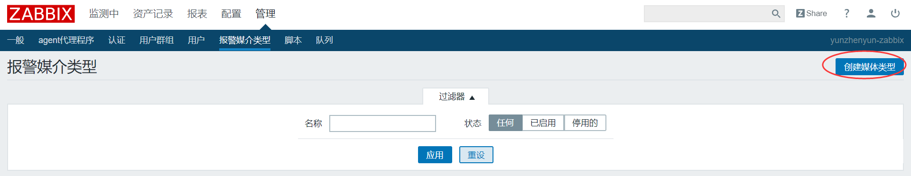

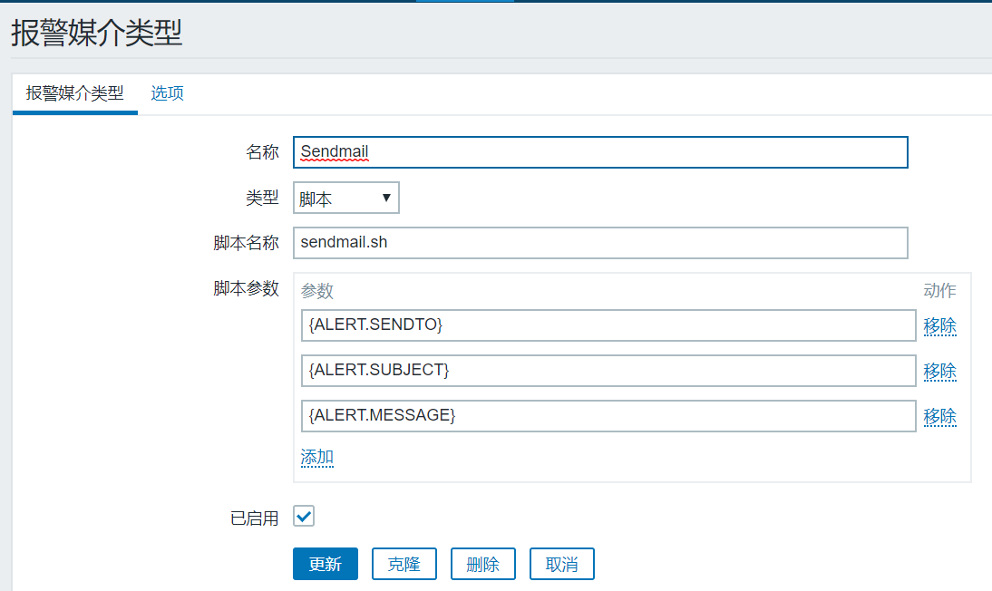

脚本参数：

{ALERT.SENDTO}

{ALERT.SUBJECT}

{ALERT.MESSAGE}

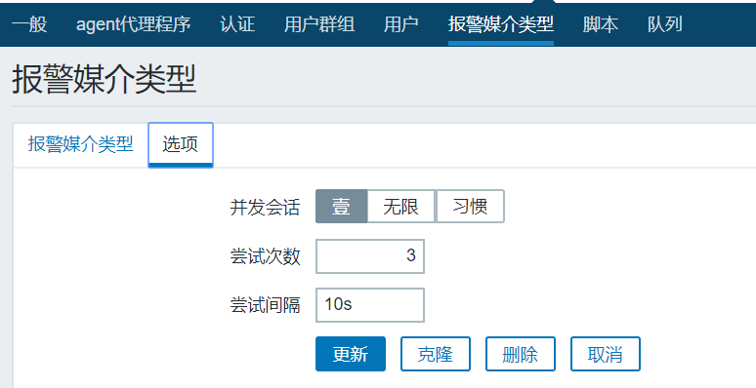新建sendmail.sh脚本

#!/bin/bash

to=$1

subject=$2

file="/tmp/mail$RANDOM"

echo $3 > $file

sed -i -e 's/ //g' -e 's/\r/\n/g' $file

date "+%F %T" >> /app/zabbix/logs/sendmail.log

echo "$to" "$subject" >> /app/zabbix/logs/sendmail.log

cat "$file" >> /app/zabbix/logs/sendmail.log

cat "$file" | /bin/mail -s "$subject" "$to"

rm -f $file

# chmod +x /app/zabbix/alertscripts/sendmail.sh

# chown Zabbix:ZBX_Group /app/zabbix/alertscripts

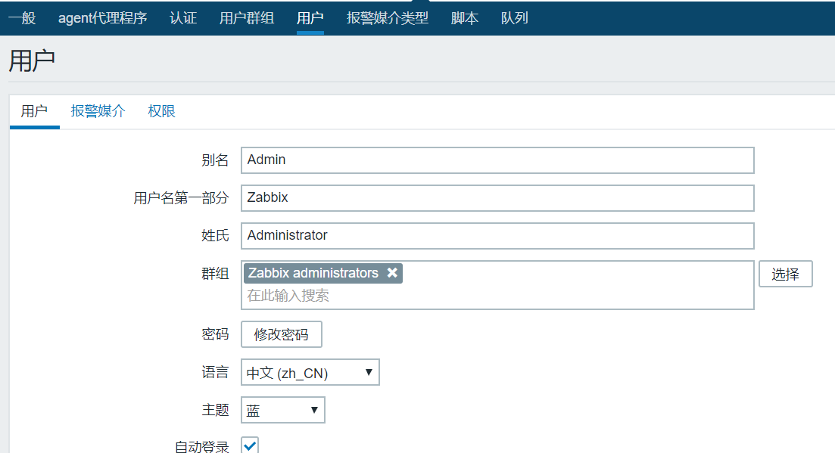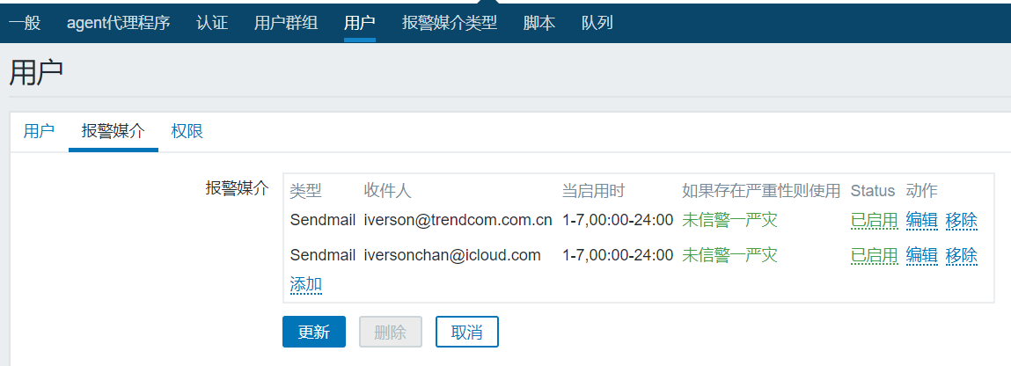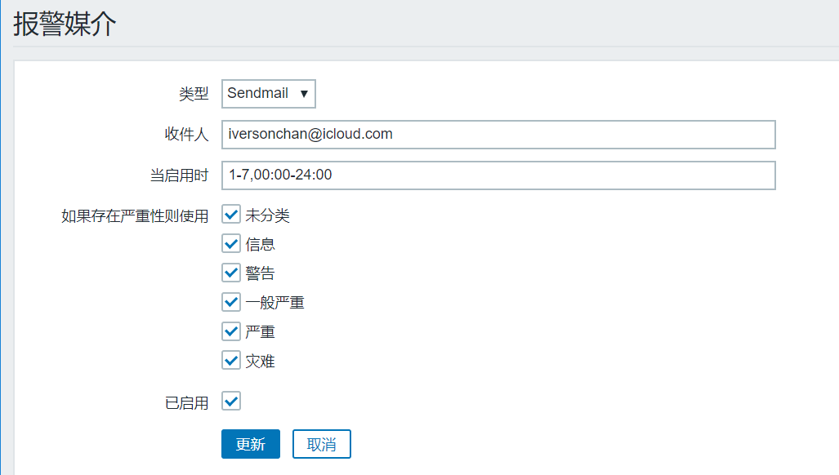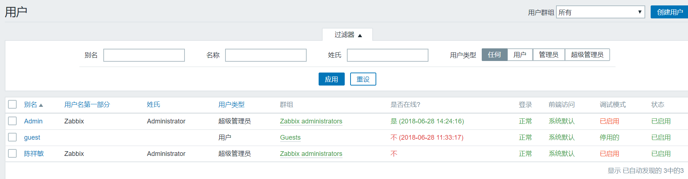

## 动作配置邮件通知用户

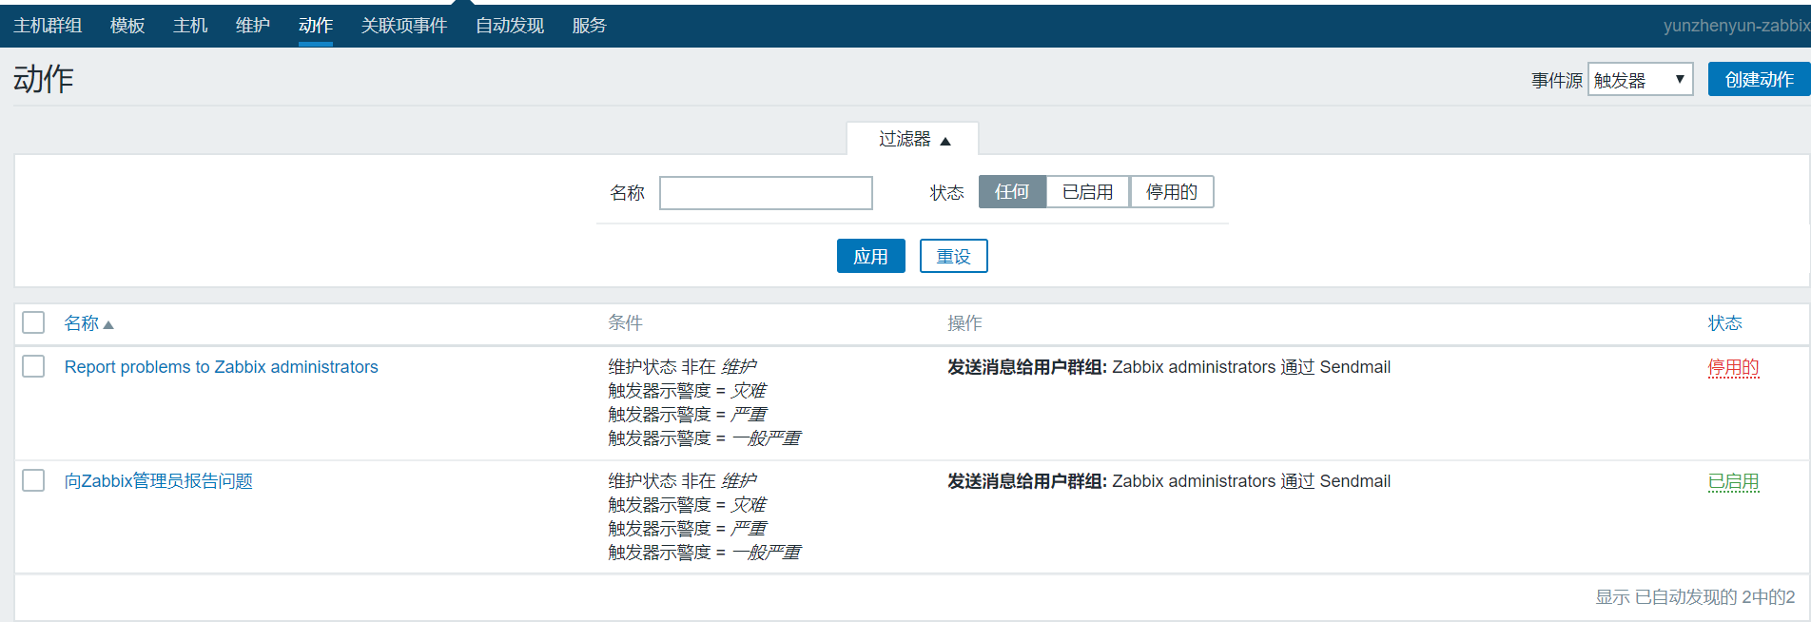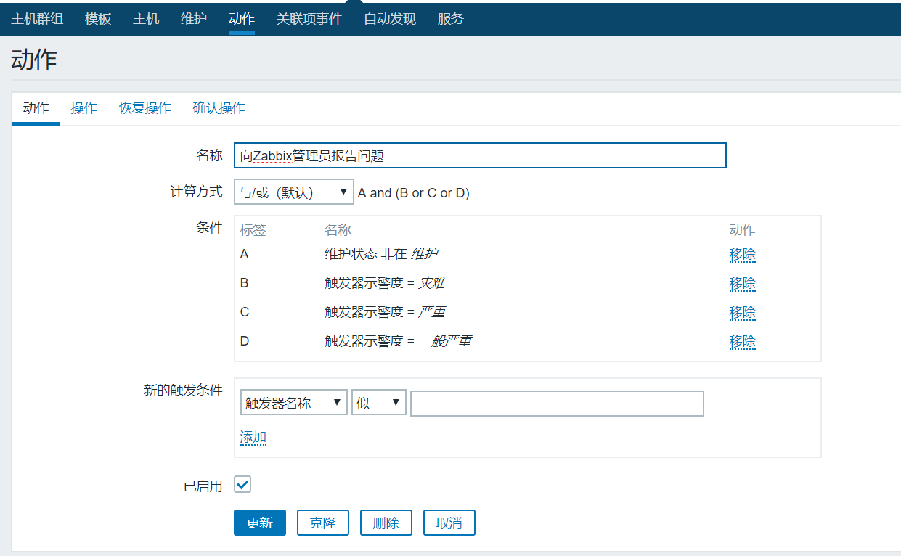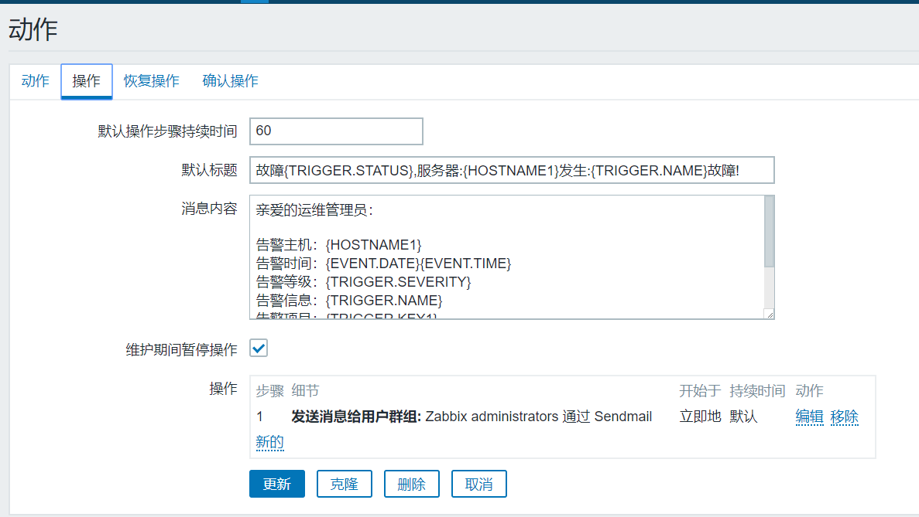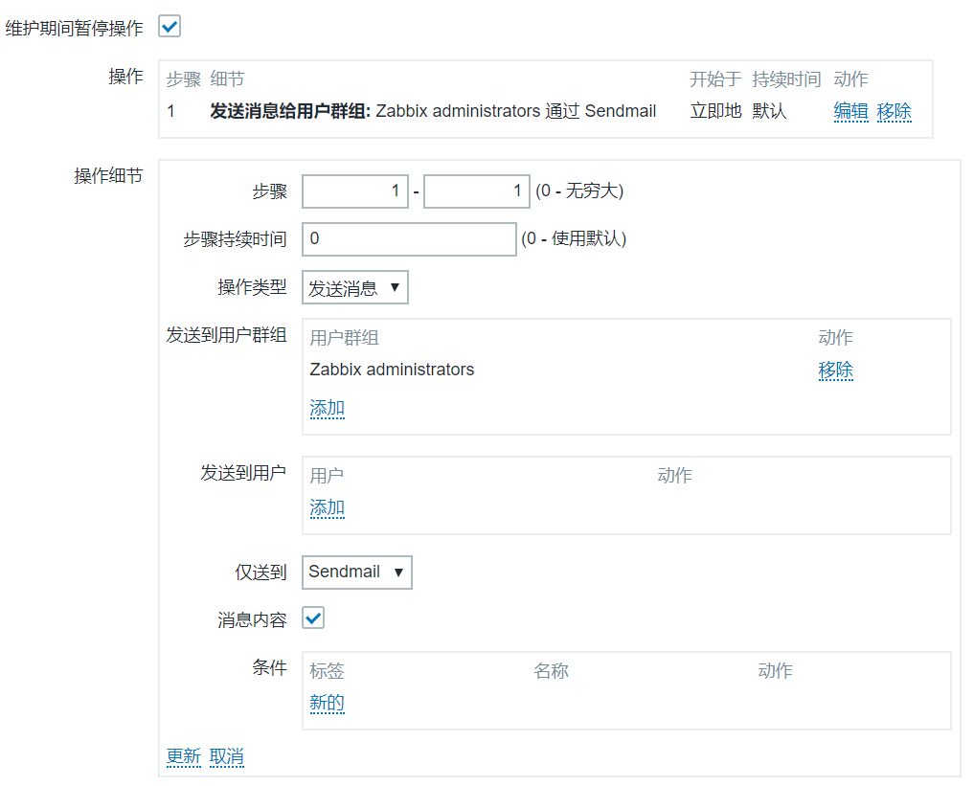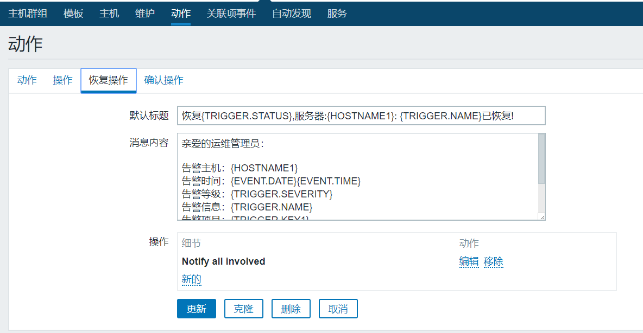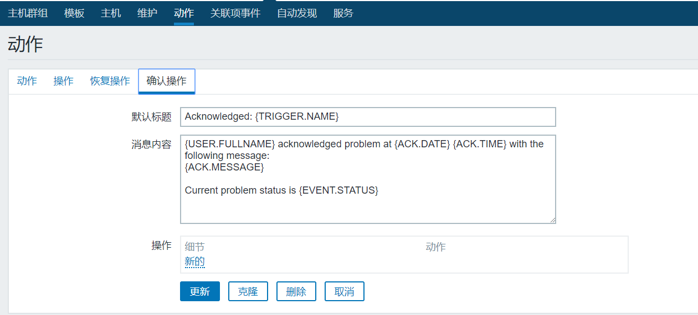

故障操作：

故障{TRIGGER.STATUS},服务器:{HOSTNAME1}发生:{TRIGGER.NAME}故障!

告警主机：{HOSTNAME1}

告警时间：{EVENT.DATE}{EVENT.TIME}

告警等级：{TRIGGER.SEVERITY}

告警信息：{TRIGGER.NAME}

告警项目：{TRIGGER.KEY1}

问题详情：{ITEM.NAME}:{ITEM.VALUE}

当前状态：{TRIGGER.STATUS}:{ITEM.VALUE1}

事件ID：{EVENT.ID}

恢复操作：

恢复{TRIGGER.STATUS},服务器:{HOSTNAME1}: {TRIGGER.NAME}已恢复!

告警主机：{HOSTNAME1}

告警时间：{EVENT.DATE}{EVENT.TIME}

告警等级：{TRIGGER.SEVERITY}

告警信息：{TRIGGER.NAME}

告警项目：{TRIGGER.KEY1}

问题详情：{ITEM.NAME}:{ITEM.VALUE}

当前状态：{TRIGGER.STATUS}:{ITEM.VALUE1}

事件ID：{EVENT.ID}

# 添加windows服务器

## 添加windows服务器

启动windows服务agent服务，确认agent的windows服务器端口10050与server服务器通信正常（telnet IP 10050）

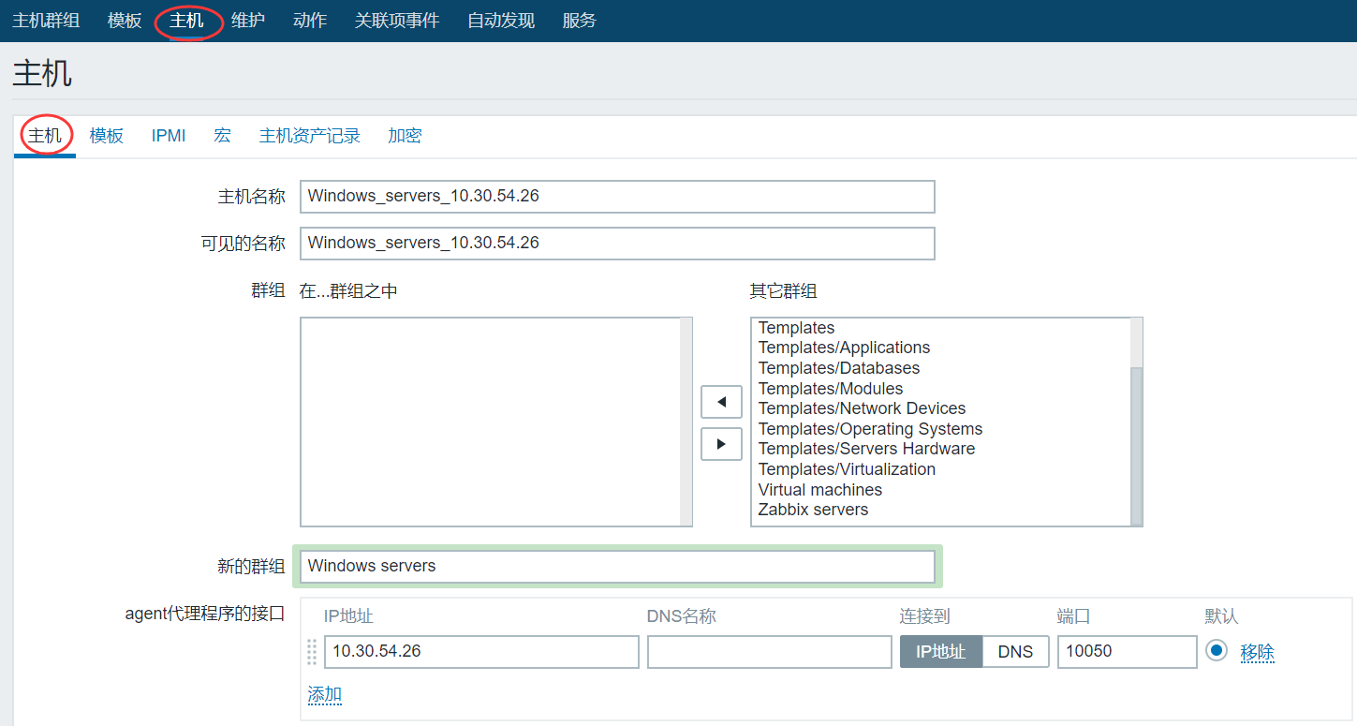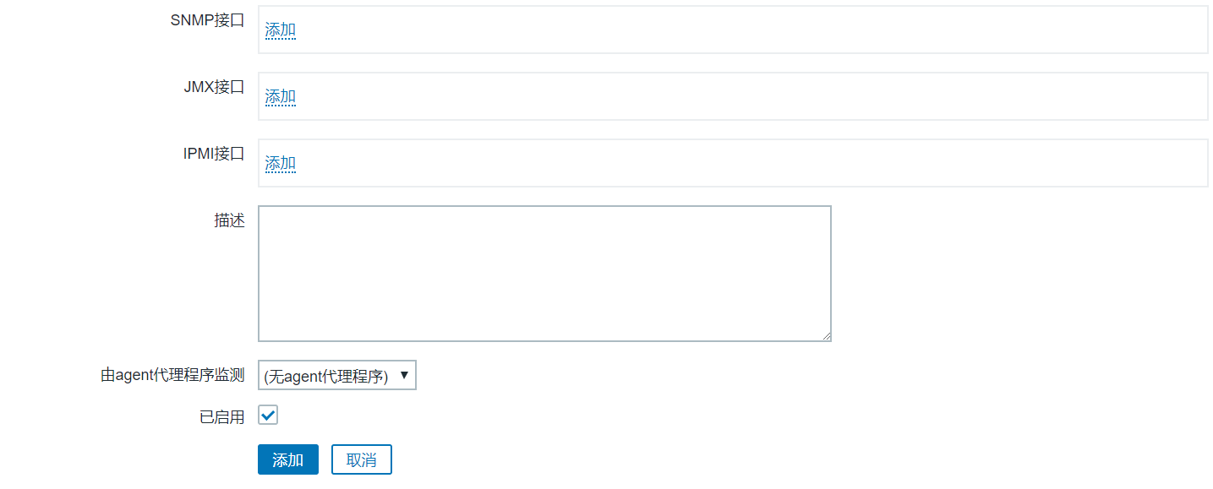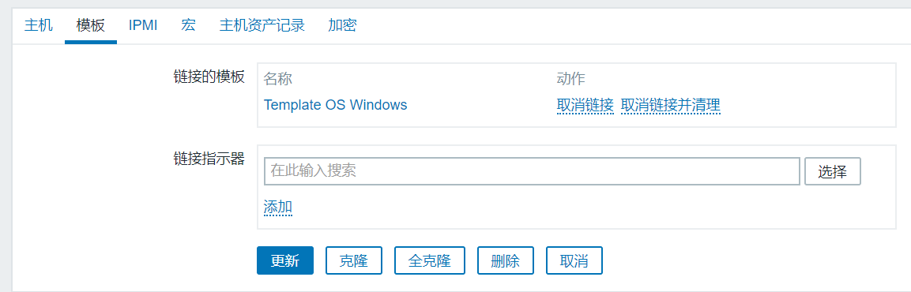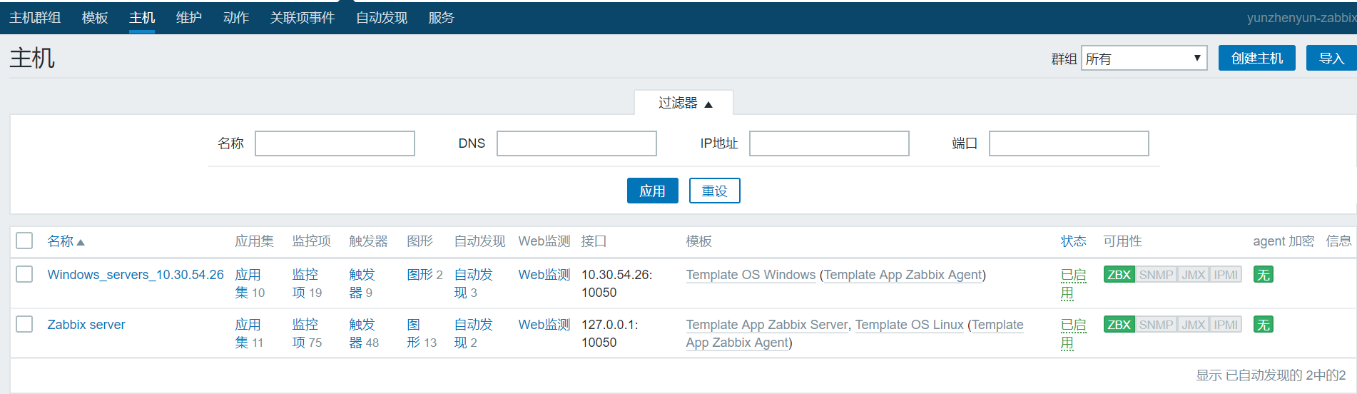

## 查看服务器图形数据

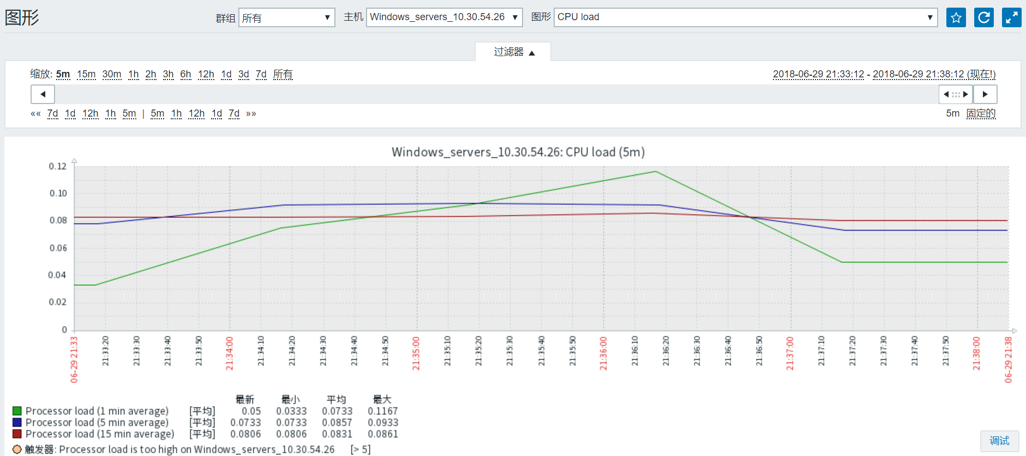 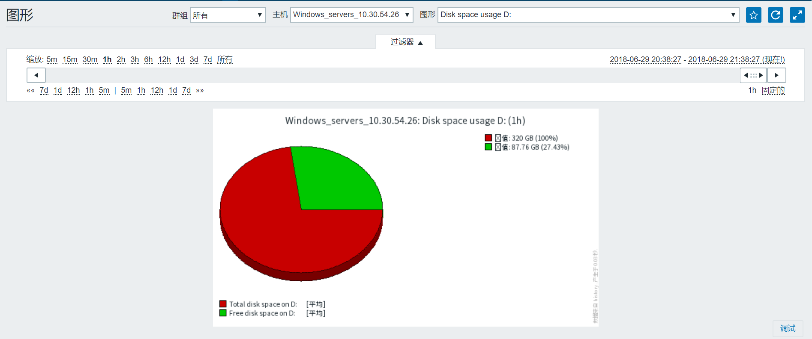 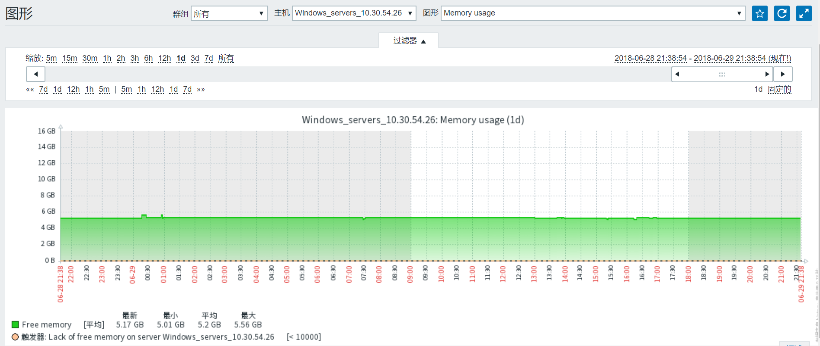

# 添加linux服务器

## 添加linux服务器

启动linux服务agent服务，确认agent的linux服务器端口10050与server服务器通信正常（telnet IP 10050）

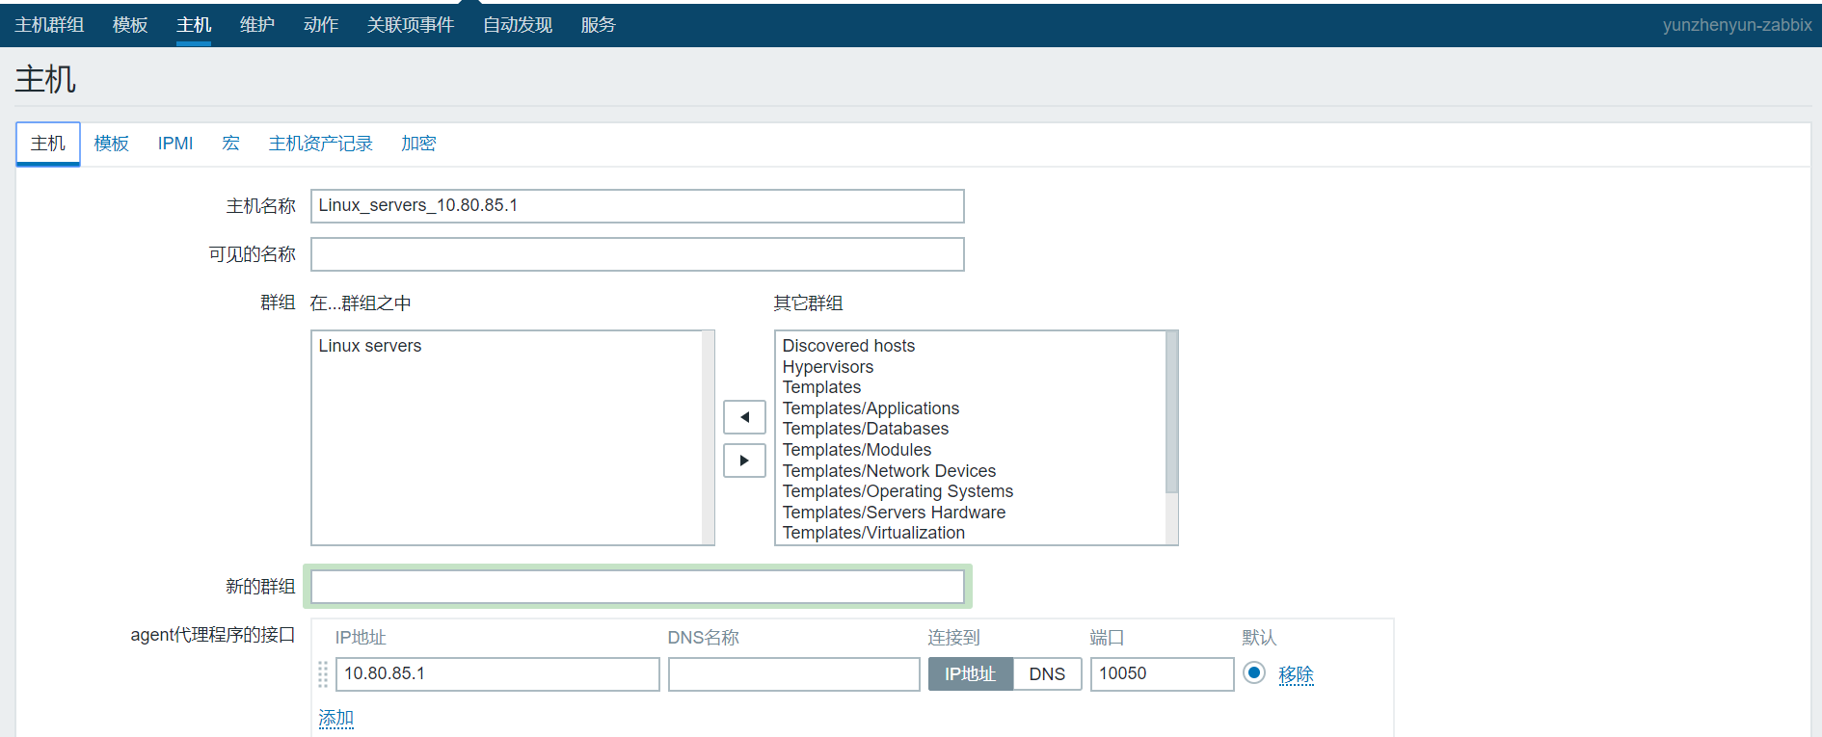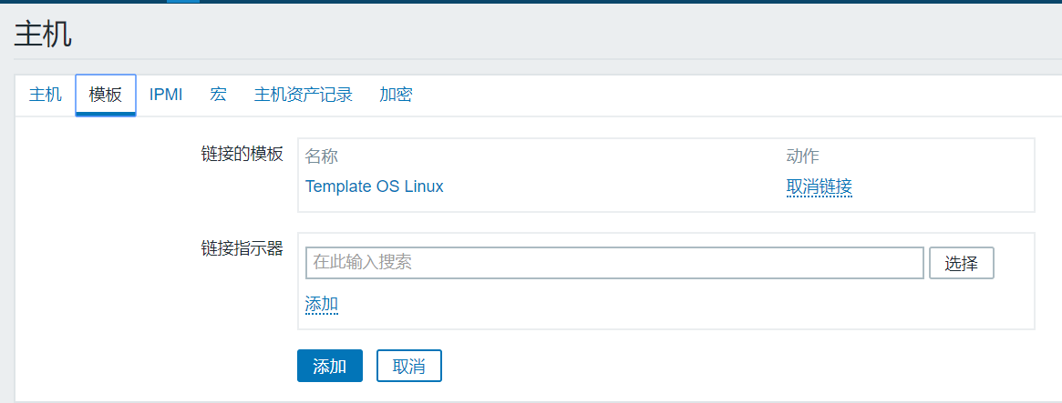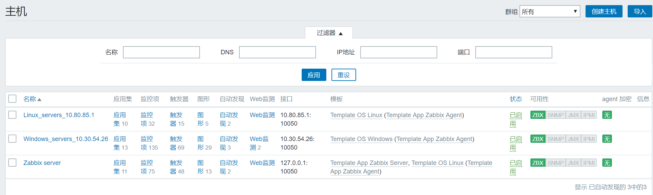

## 查看服务器图形数据

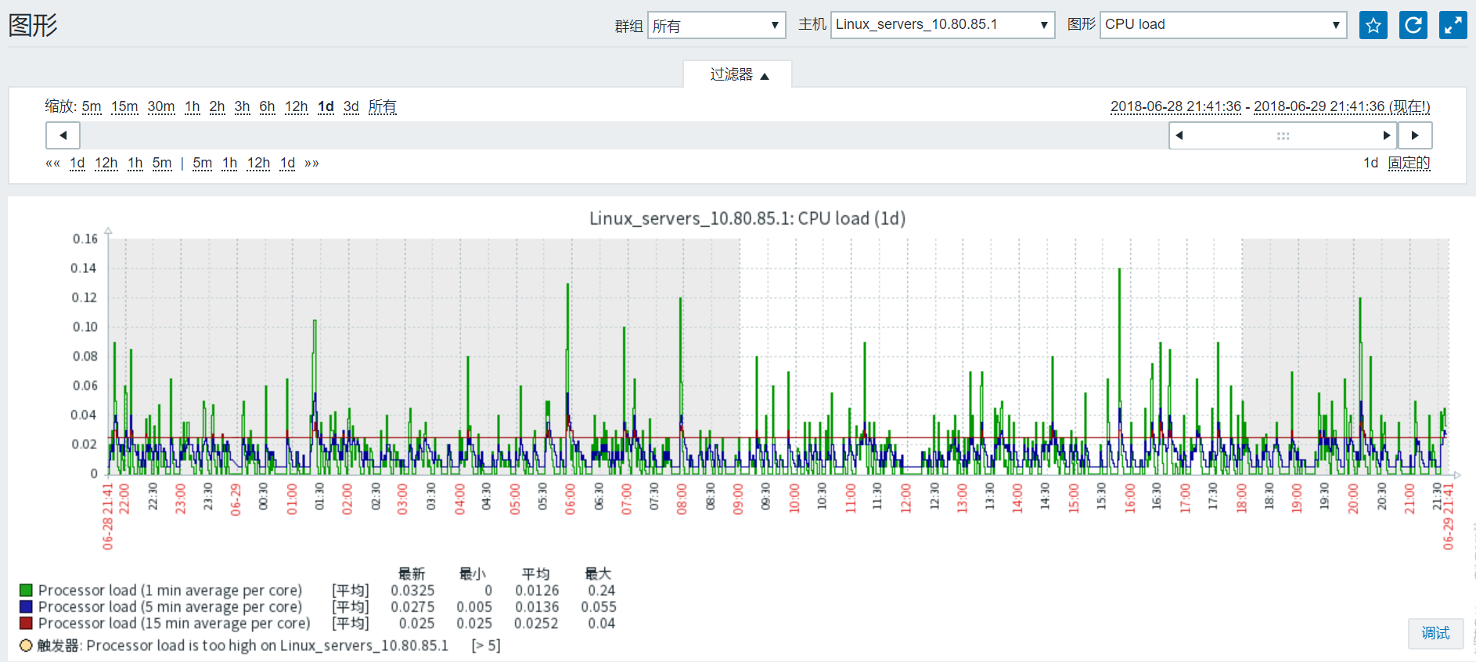 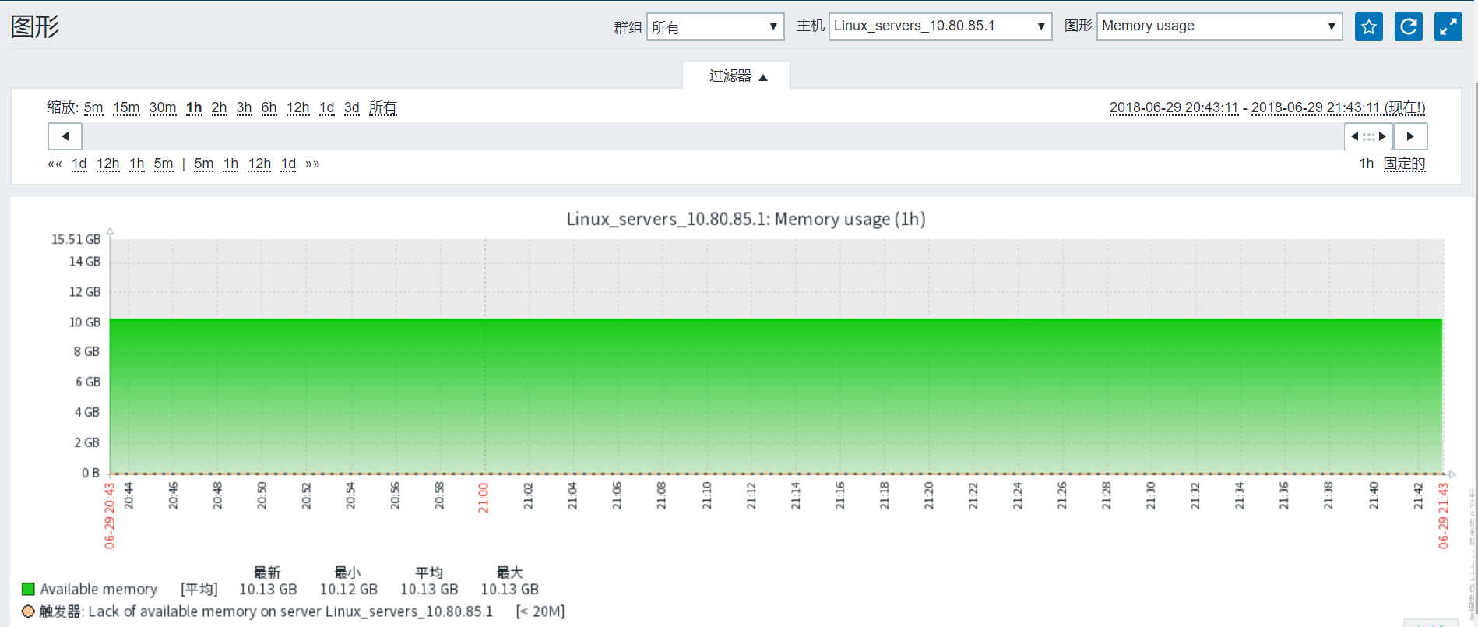 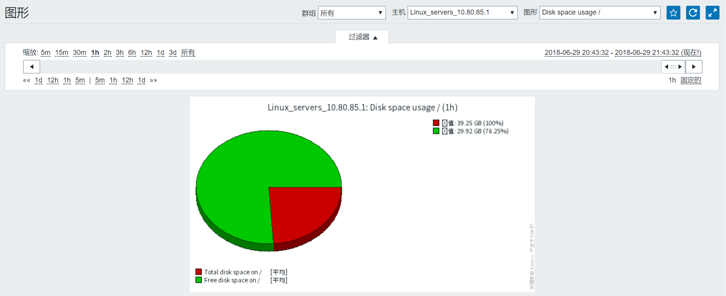 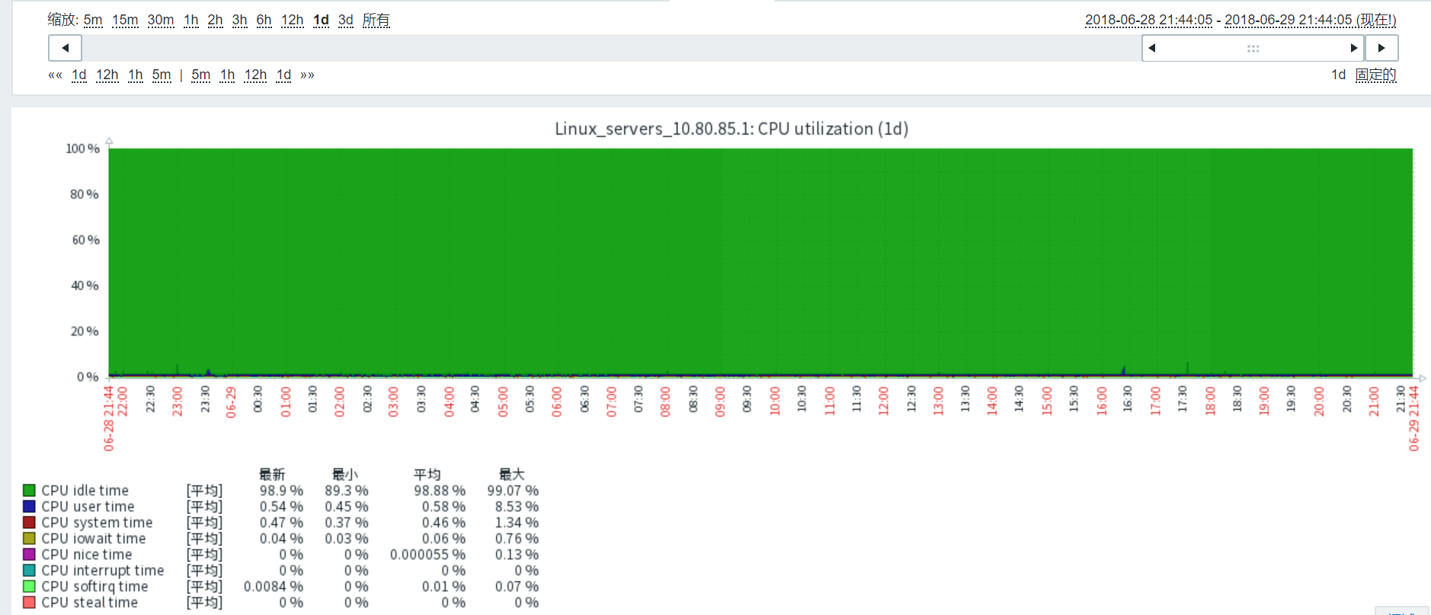

# 添加web监控

## 添加web监控

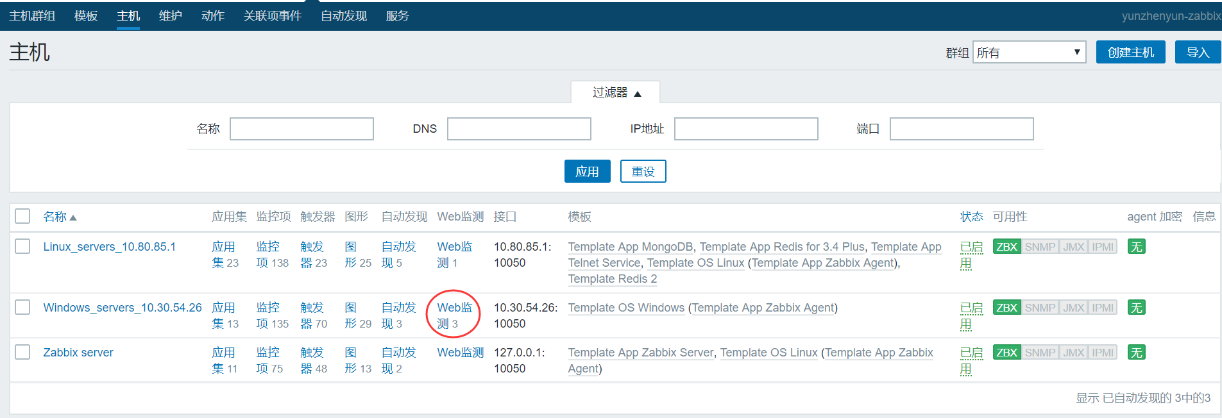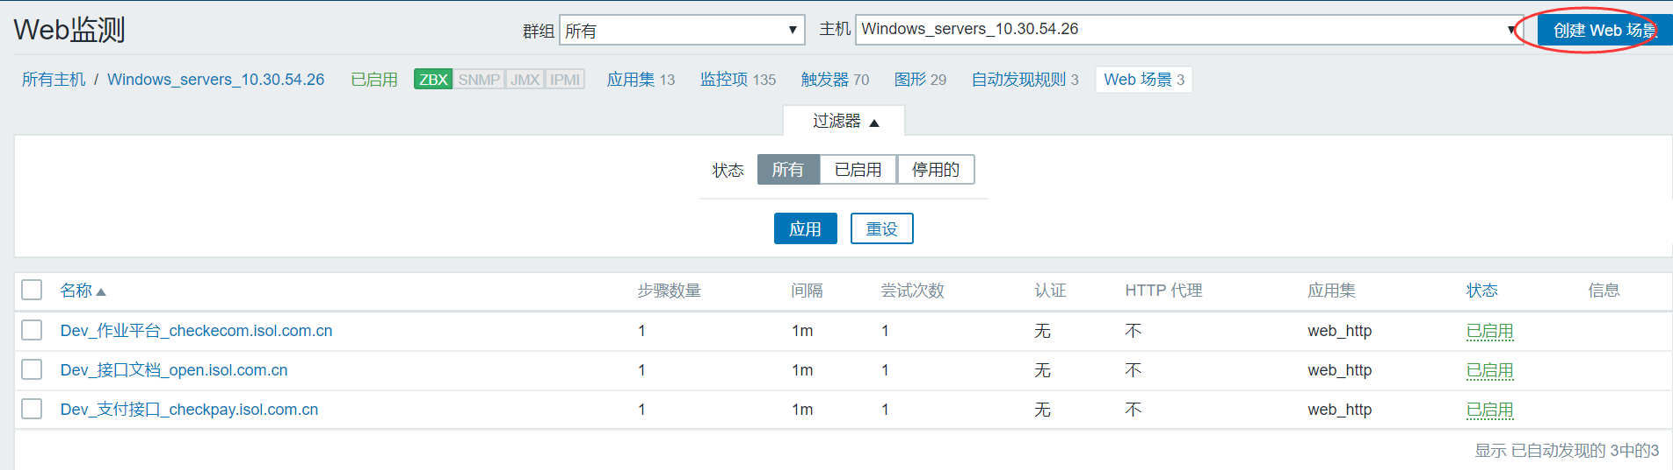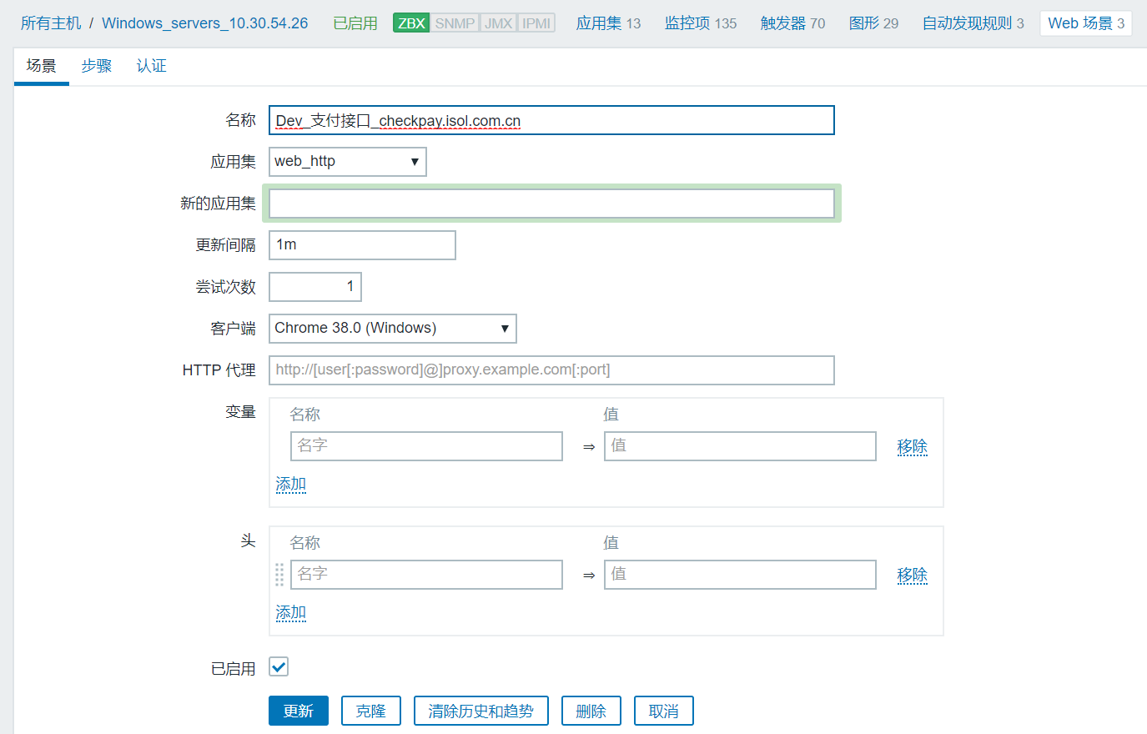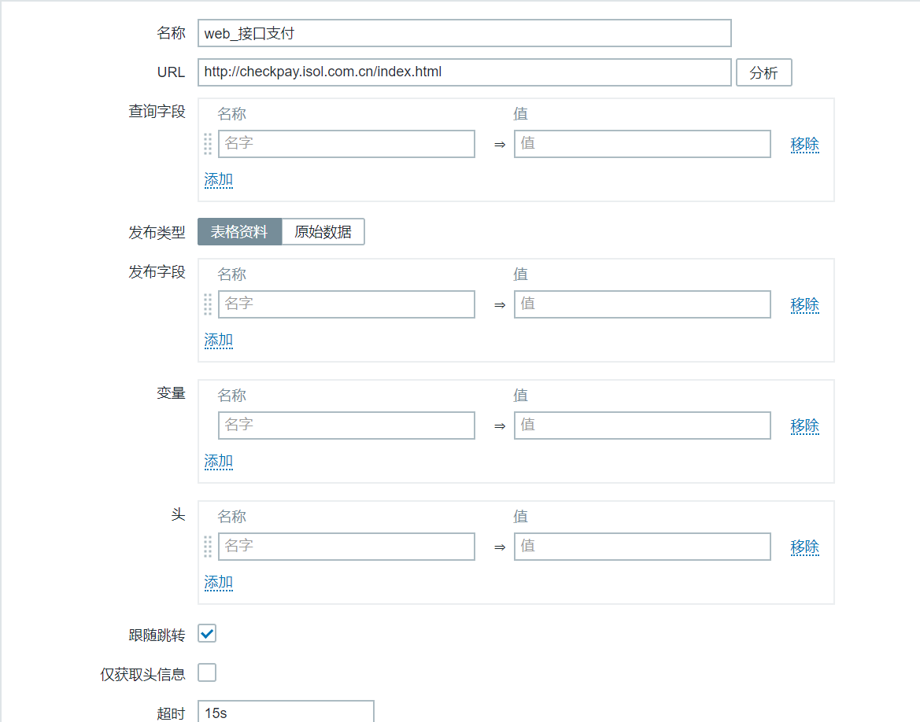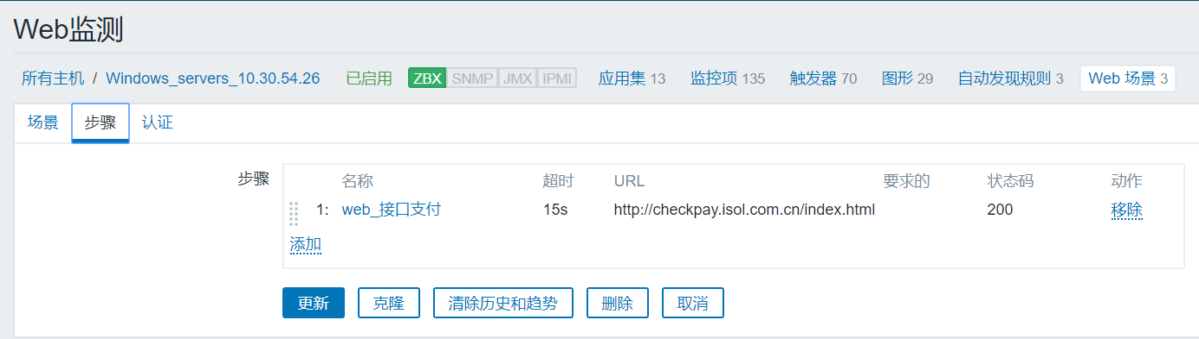

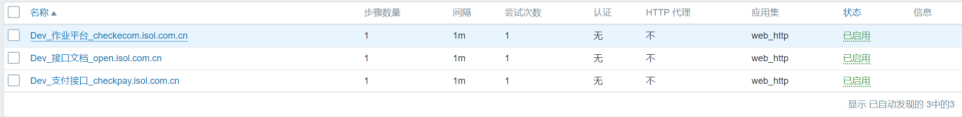

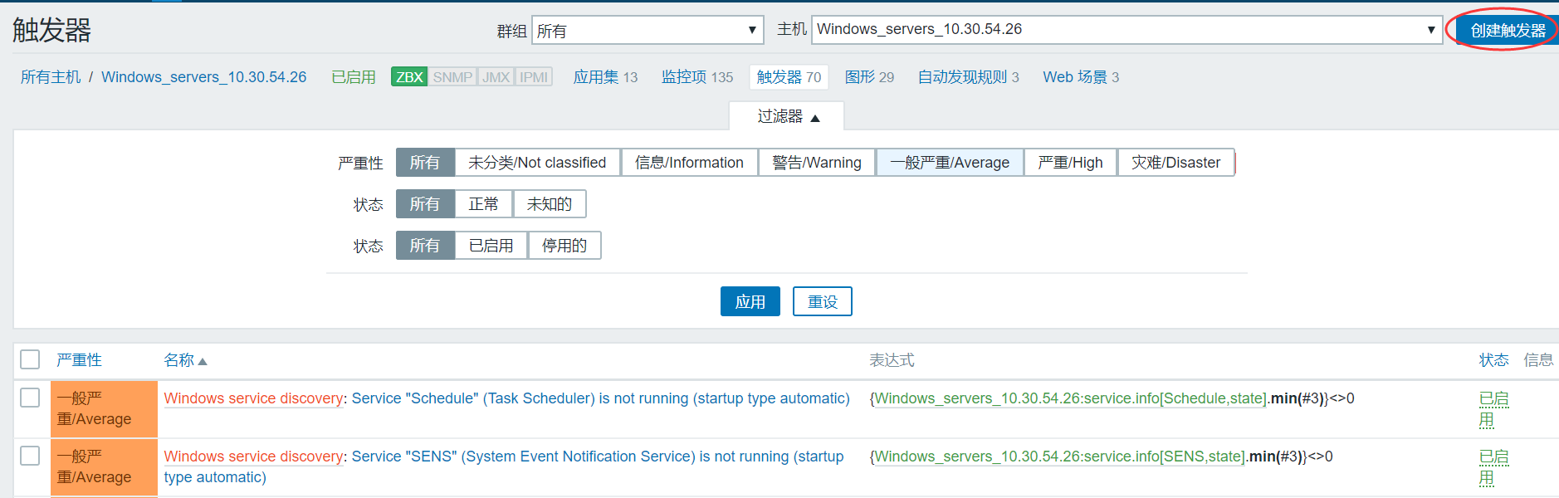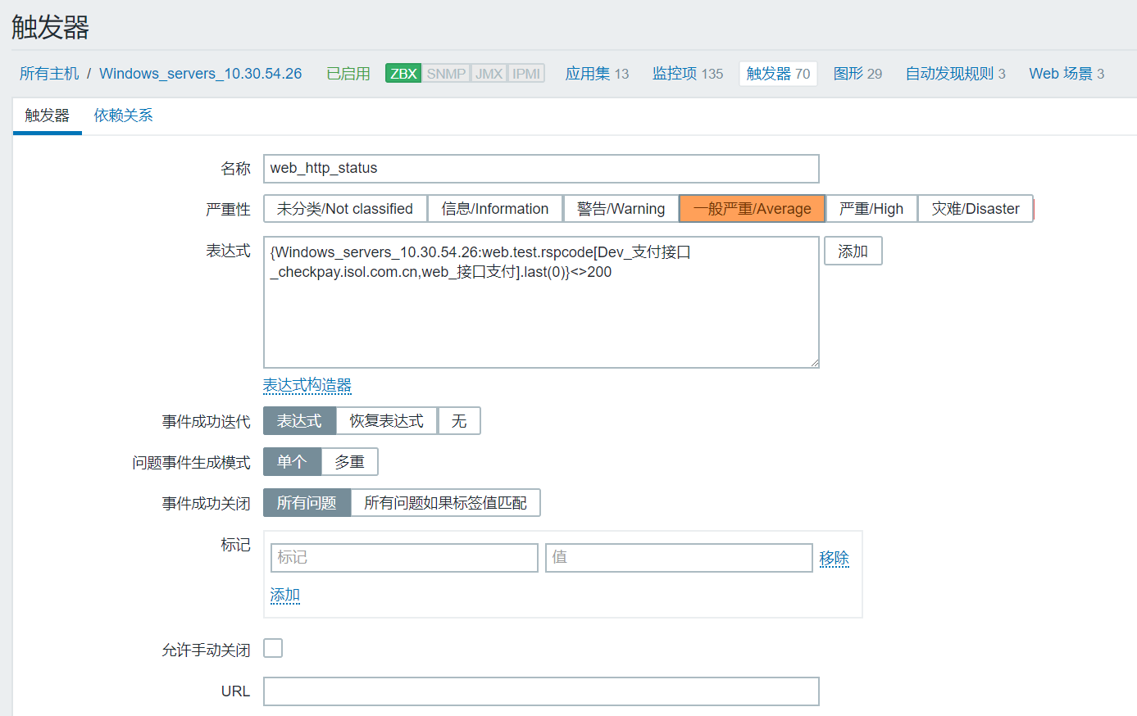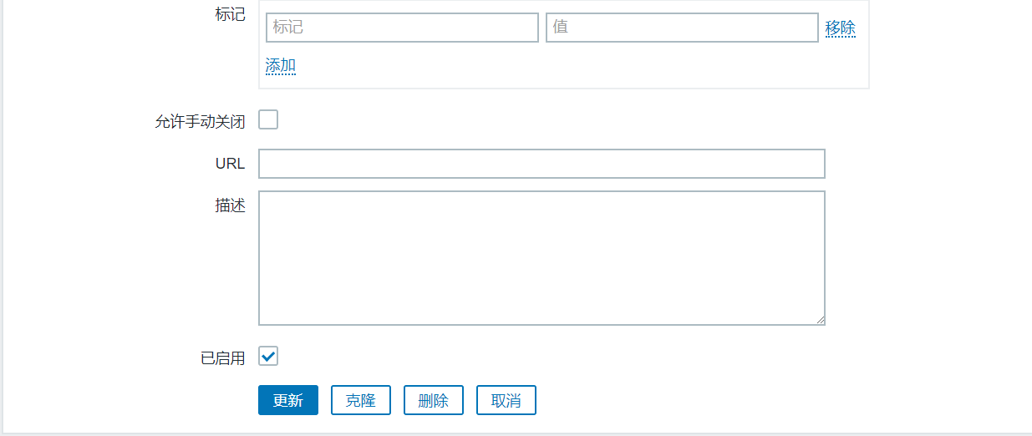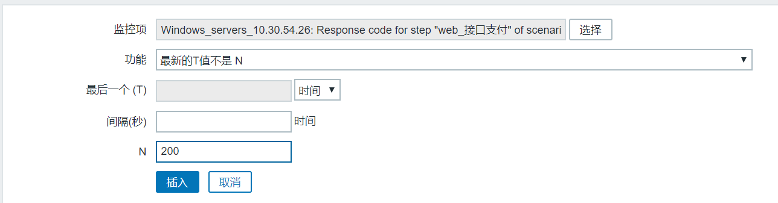

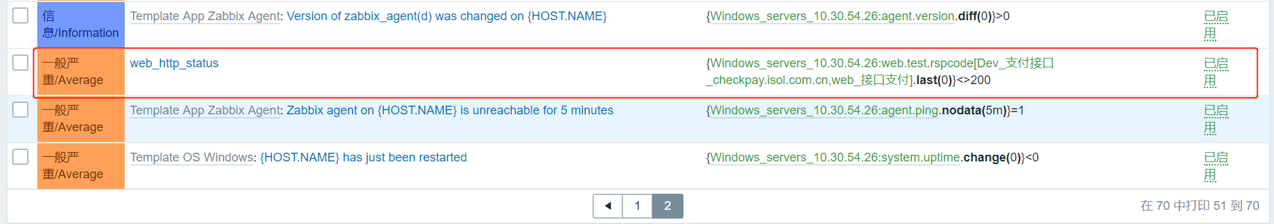

## 查看web图形数据

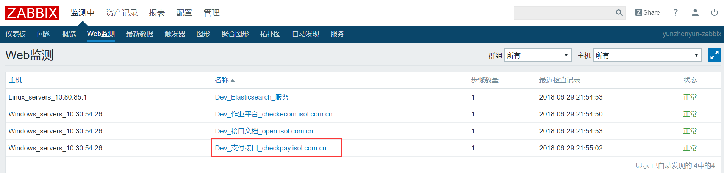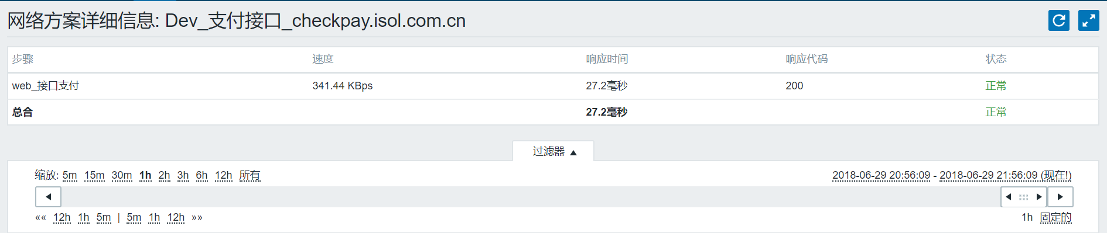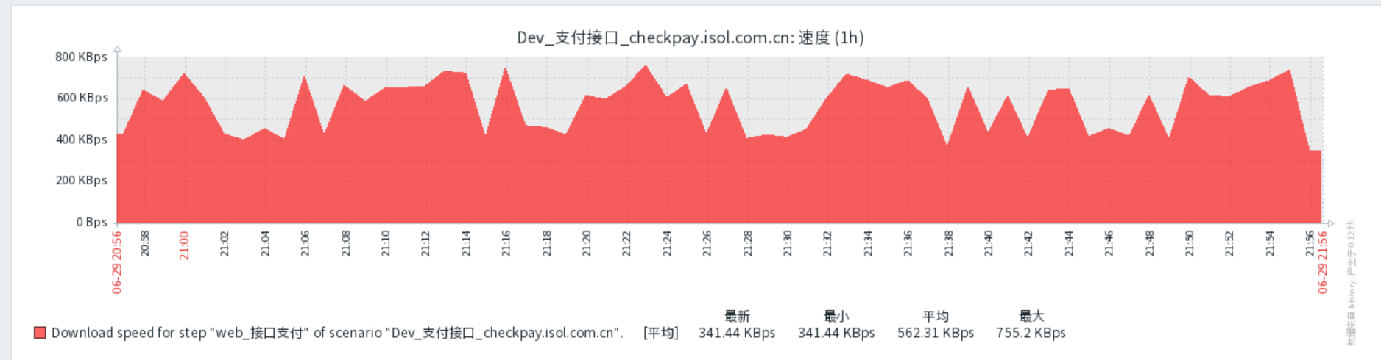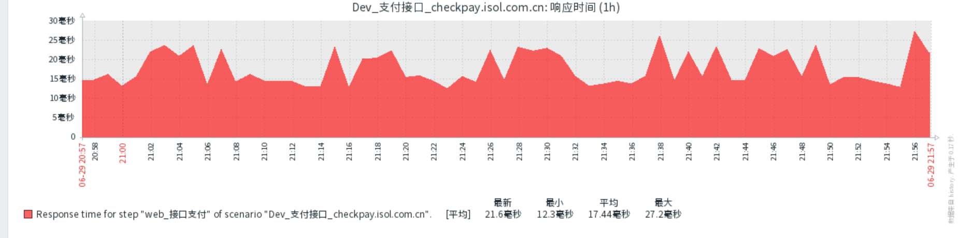

# 添加应用监控

## 添加mongodb端口监听监控

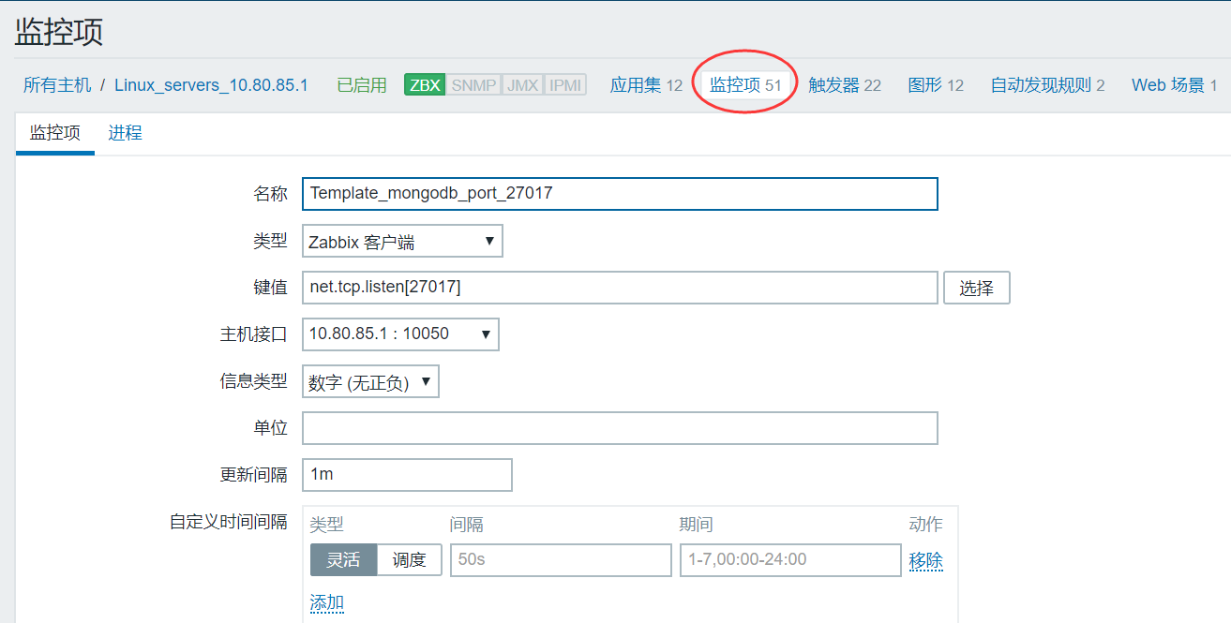

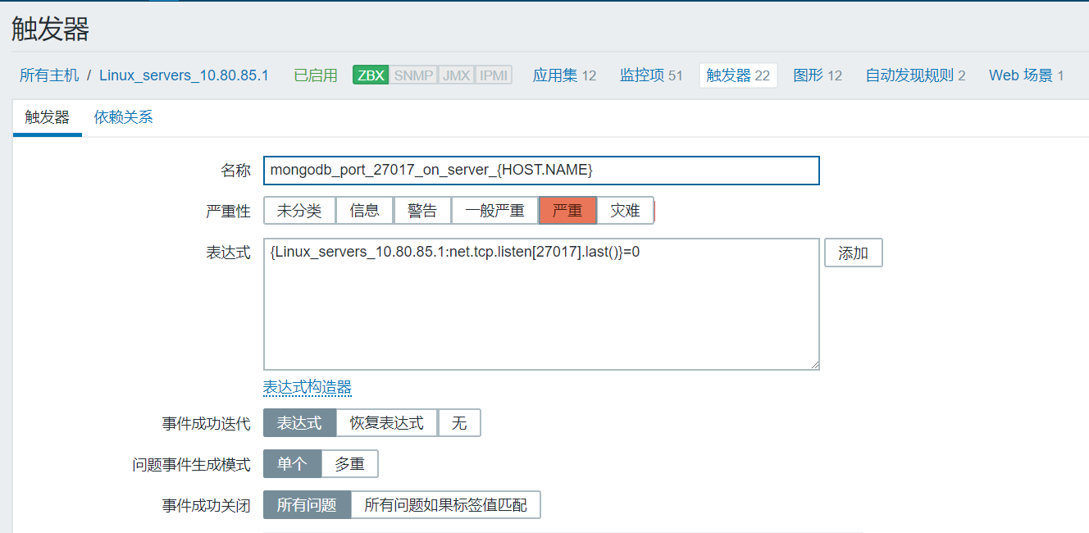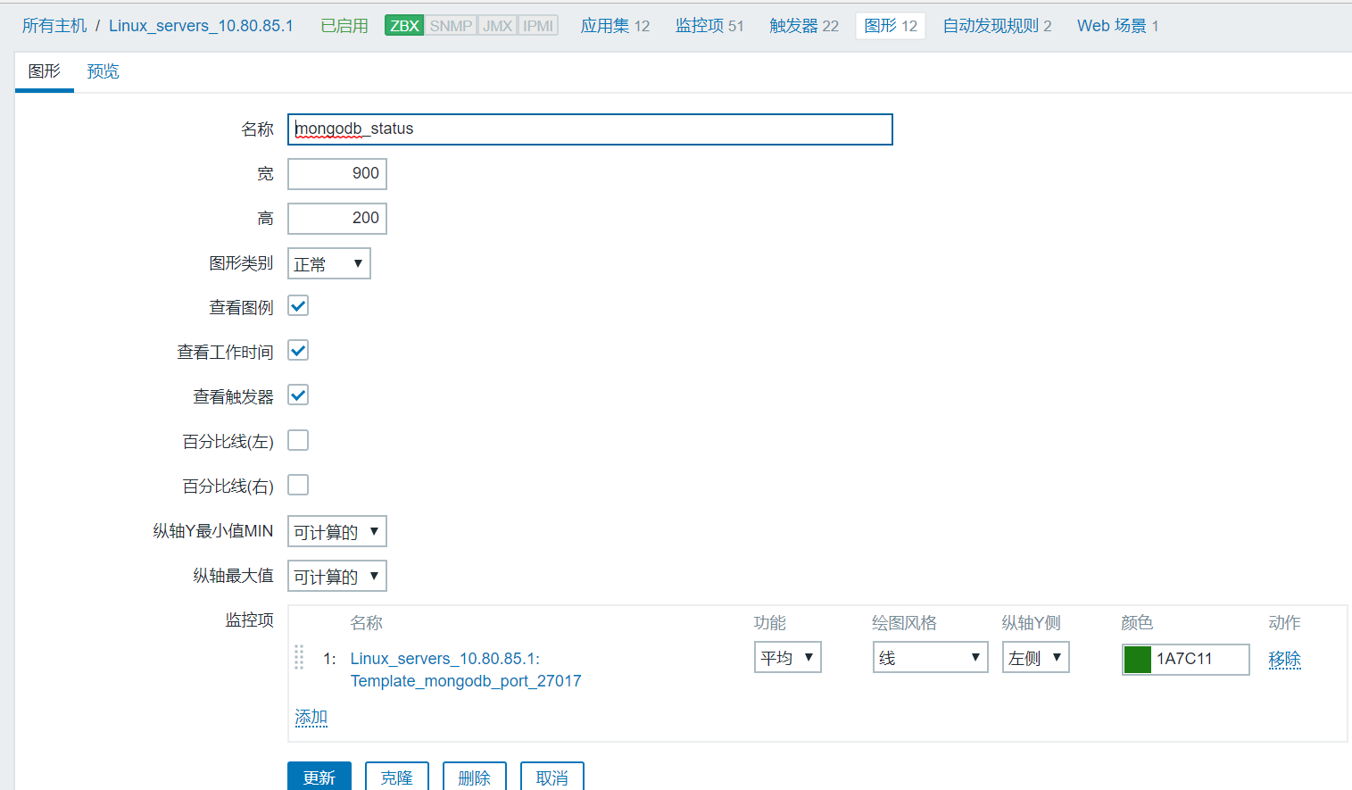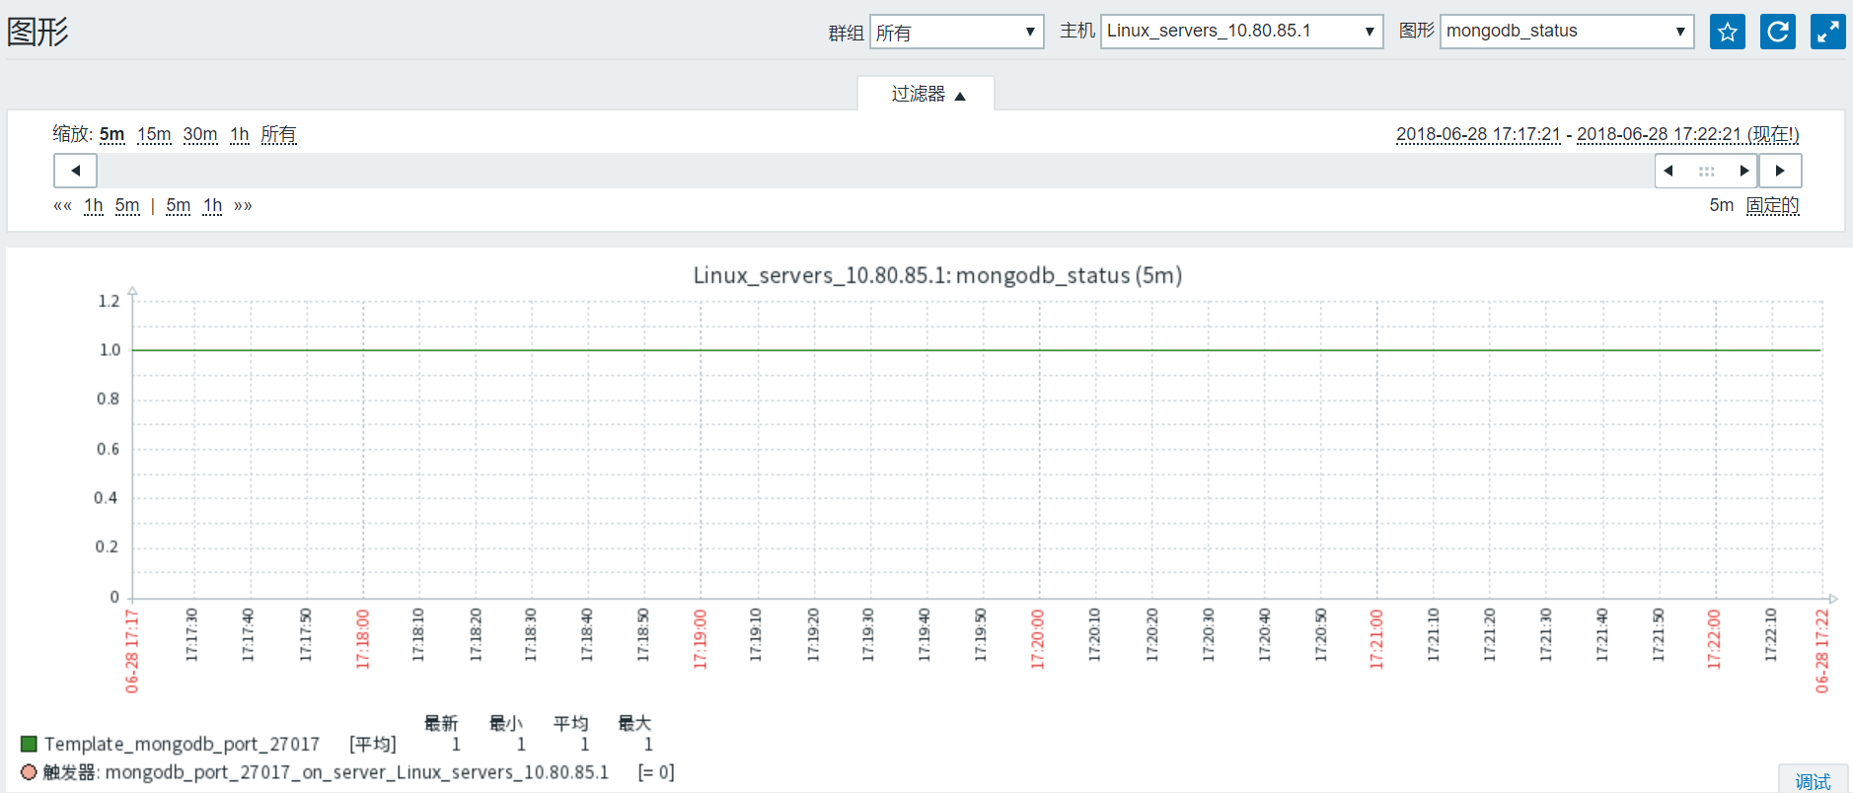

## 模版mongodb监控

在被监控的mongodb上通过以下命令查看mongodb的状态：

# echo "db.serverStatus()" | mongo admin #在被监控的mongodb服务器

# echo "db.serverStatus().opcounters" | mongo admin #在被监控的mongodb服务器

# ll /app/zabbix/etc/zabbix_agentd.conf.d/userparameter-mongodb.conf

# systemctl restart zabbix_agentd.service

# ll /app/zabbix/alertscripts/mongodb.sh

# ll /app/zabbix/etc/zabbix_agentd.conf.d/userparameter-mongodb.conf

导入模版

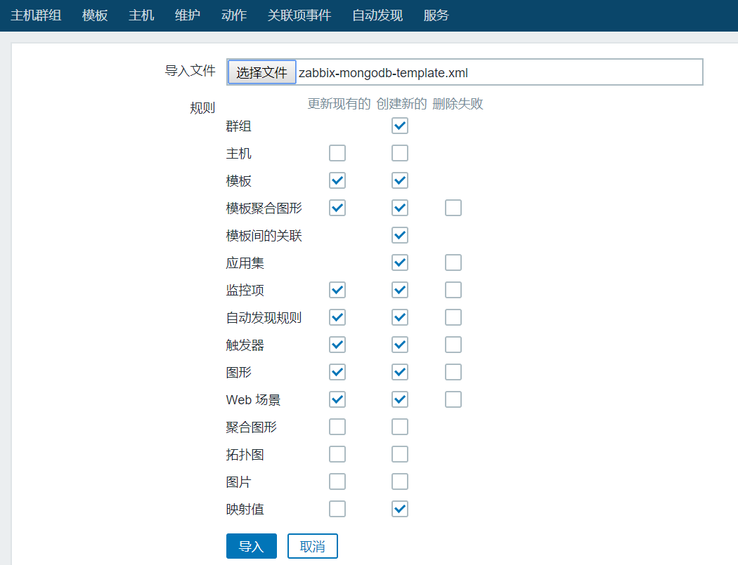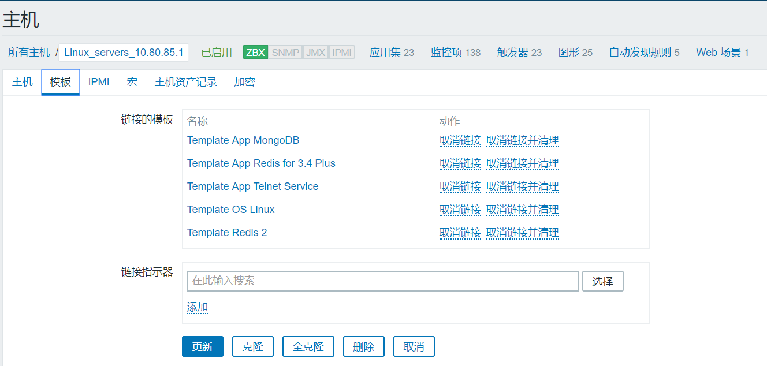

## 添加Redis端口监听监控

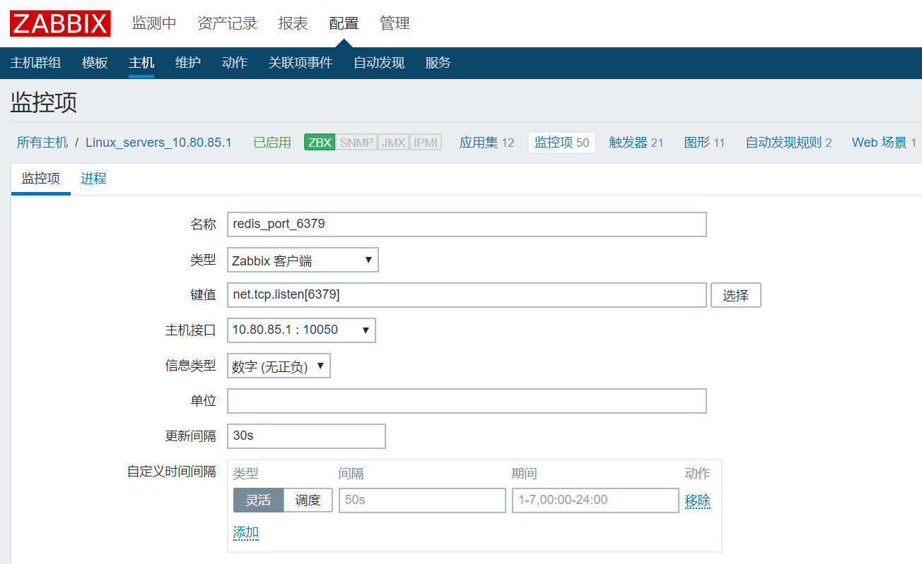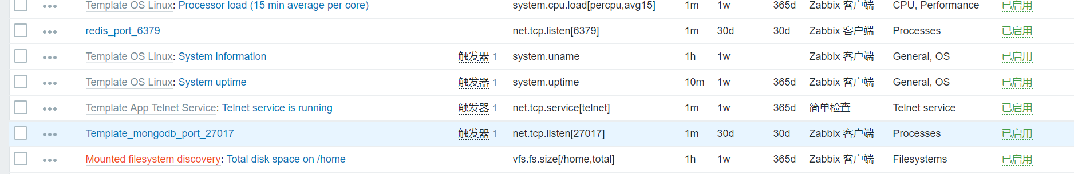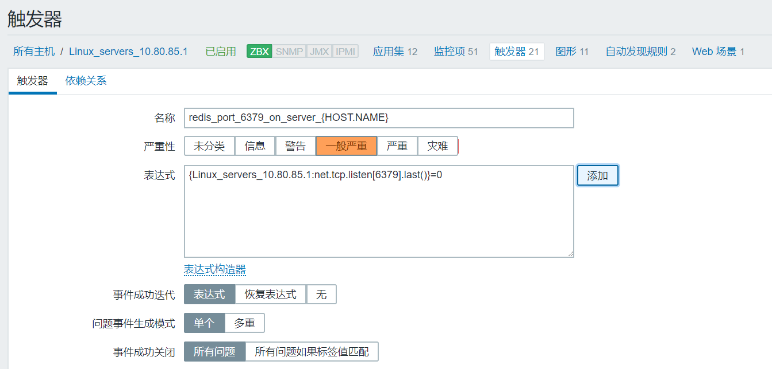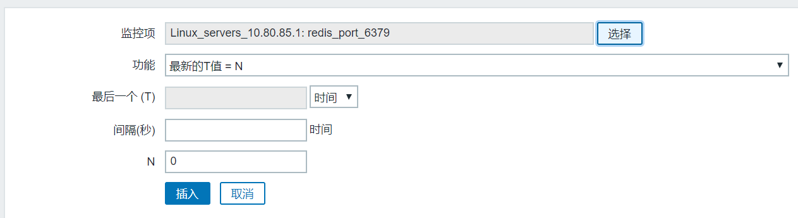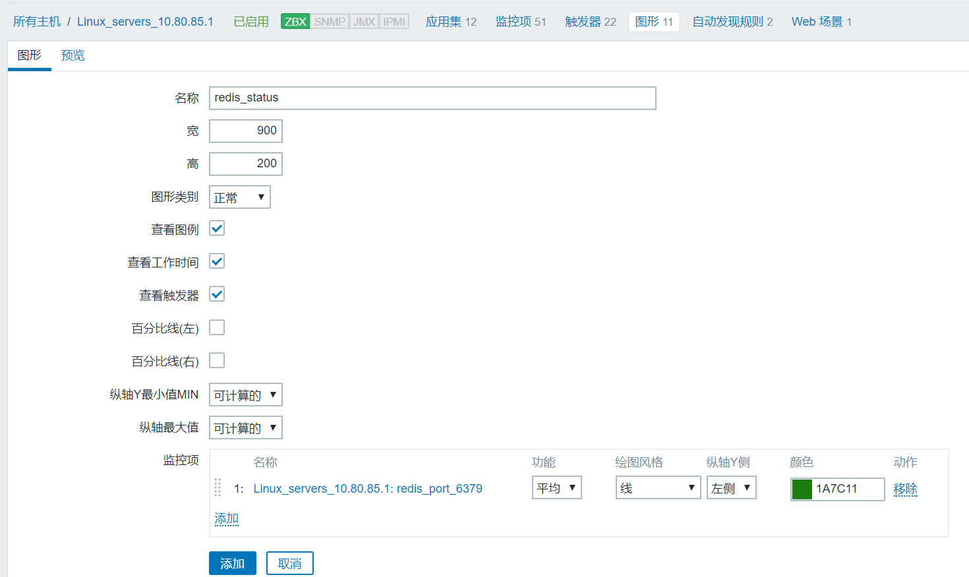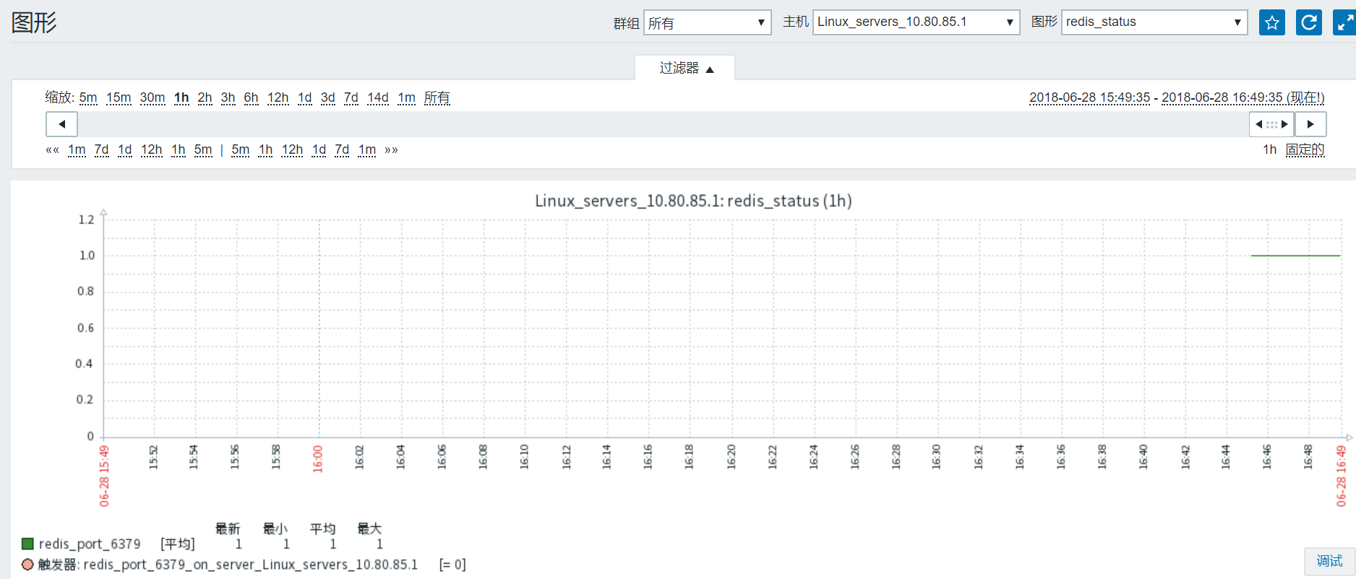

## 模版redis监控

# chown zabbix:ZBX_Group /app/zabbix/alertscripts/redis-status.sh

# chown +x /app/zabbix/alertscripts/redis-status.sh

# ll /app/zabbix/etc/zabbix_agentd.conf.d/userparameter-redis.conf

# vim zabbix_agentd.conf

# Include=/usr/local/etc/zabbix_agentd.userparams.conf

# Include=/usr/local/etc/zabbix_agentd.conf.d/

# Include=/usr/local/etc/zabbix_agentd.conf.d/*.conf

Include=/app/zabbix/etc/zabbix_agentd.conf.d/*.conf

# systemctl restart zabbix_agentd.service

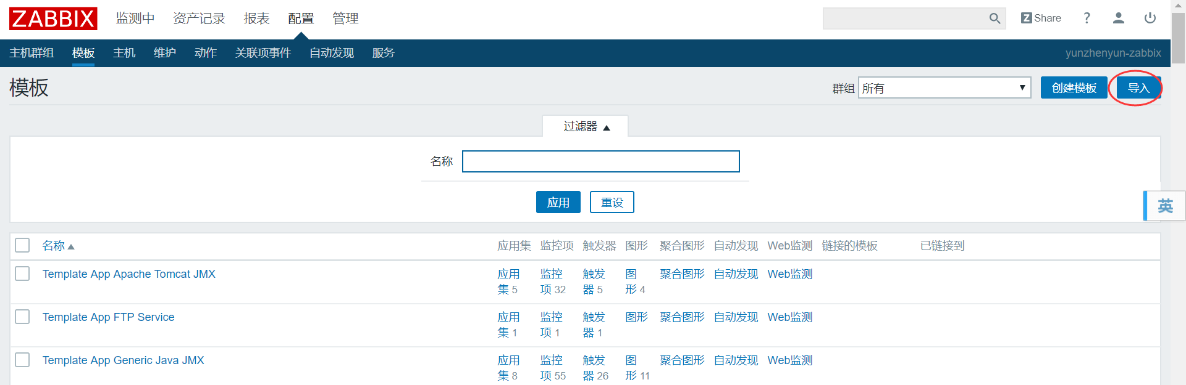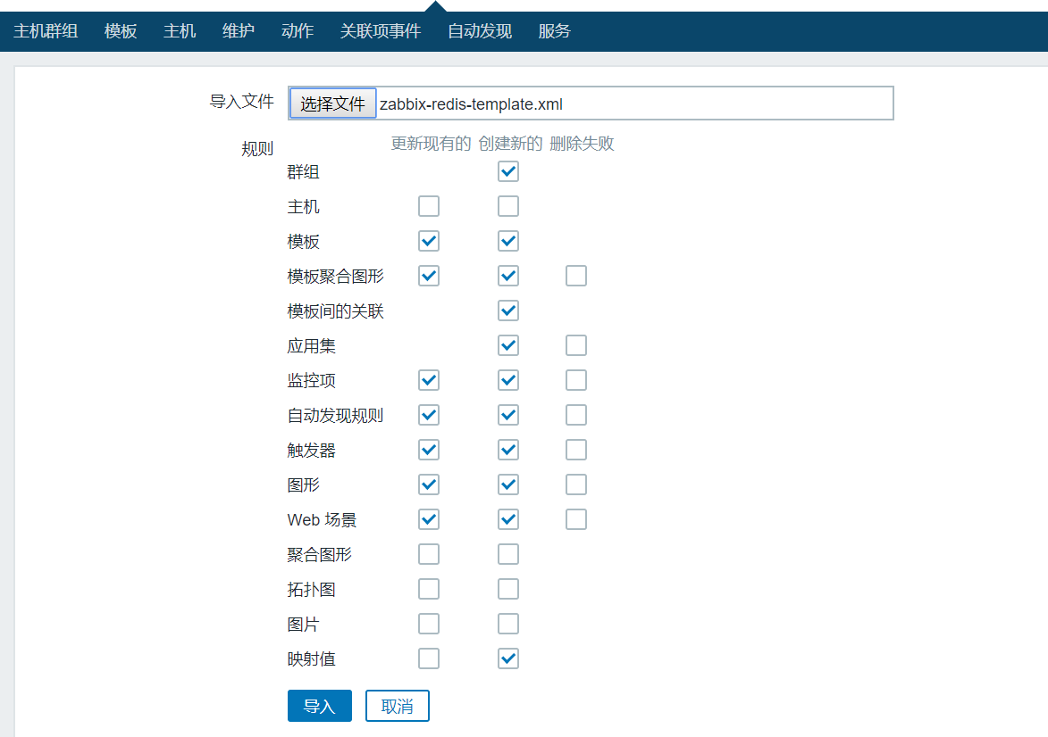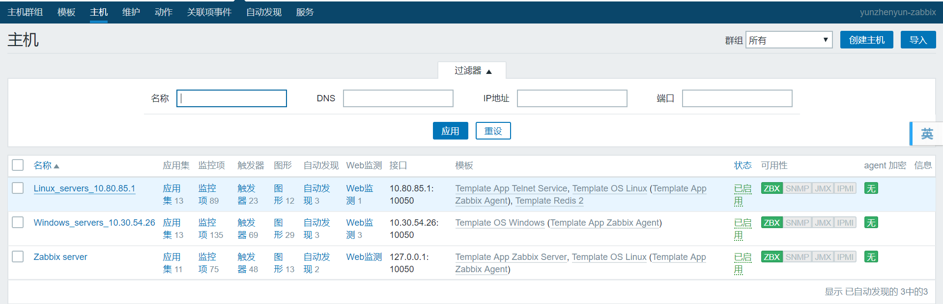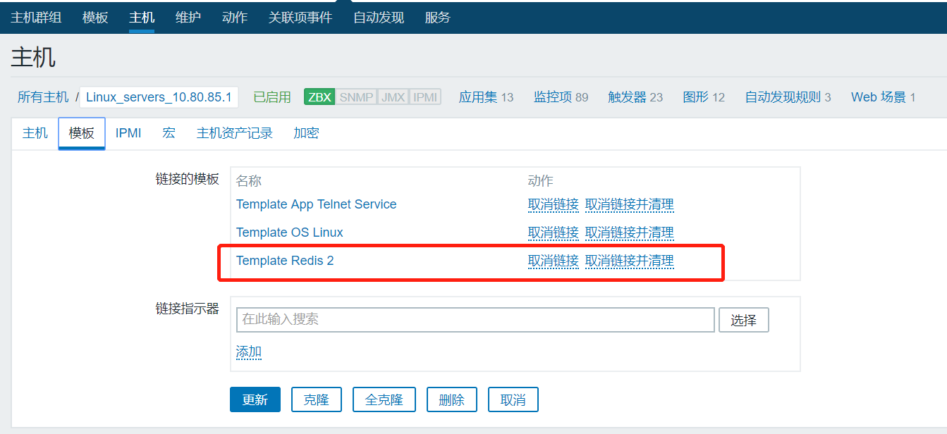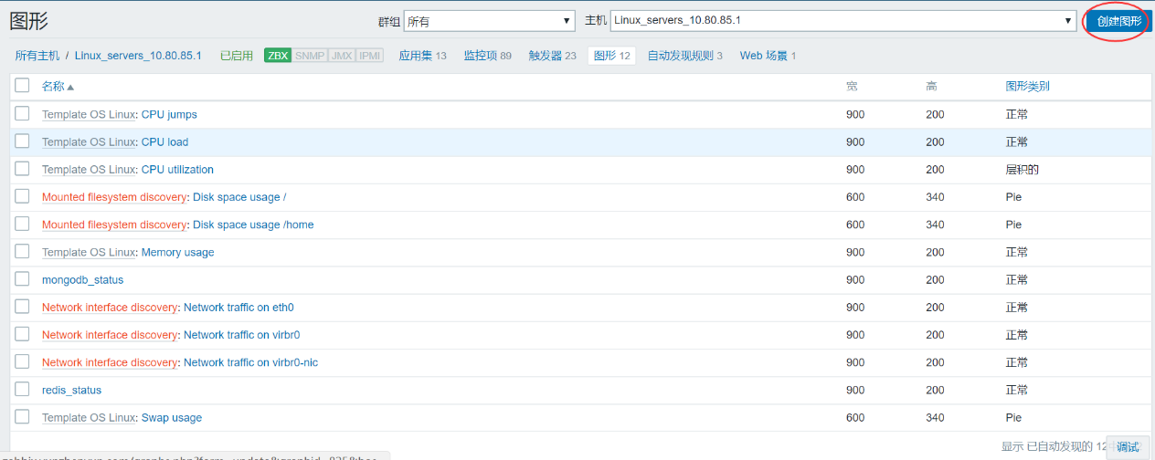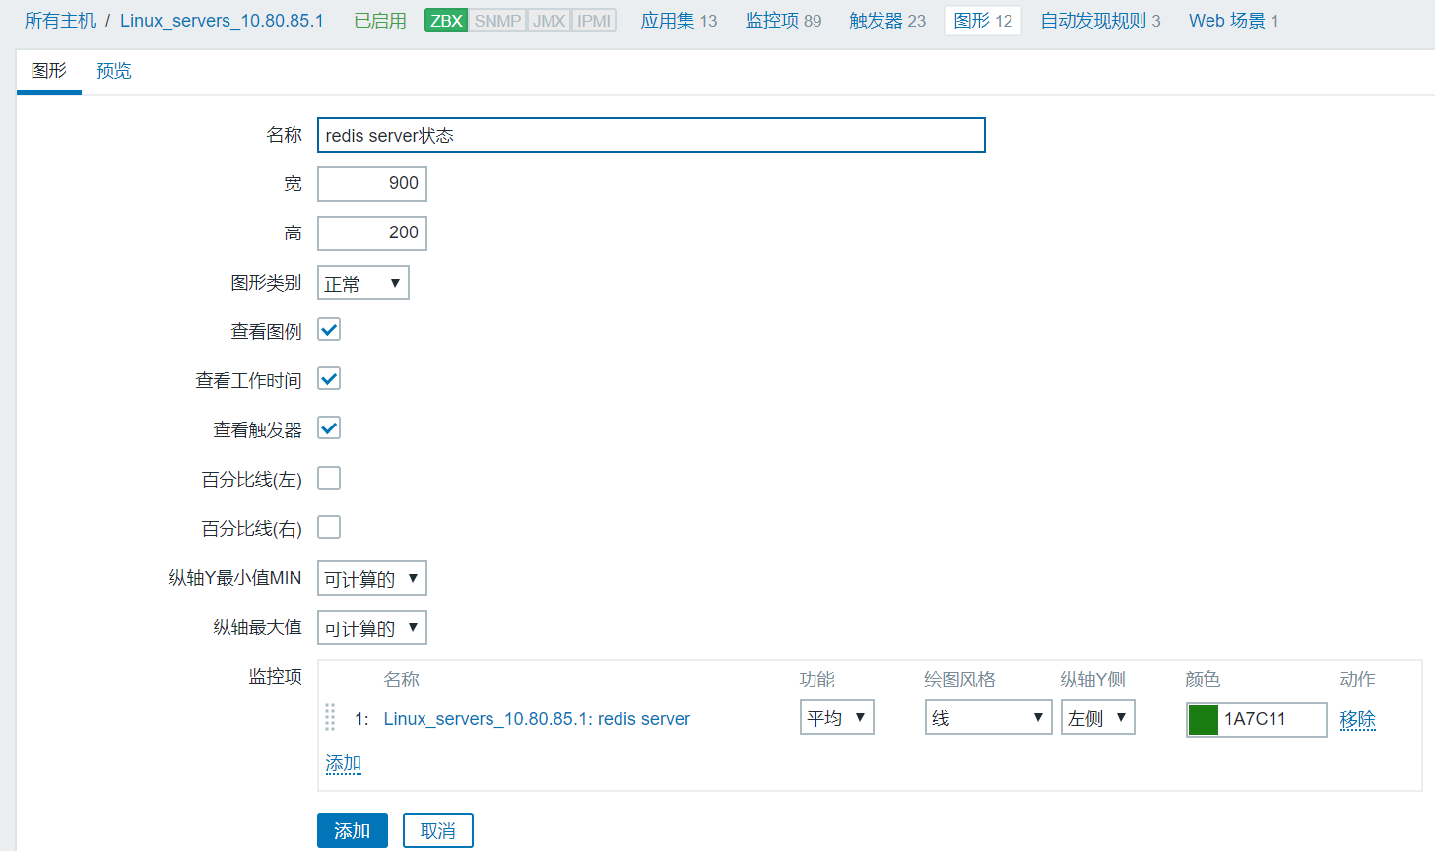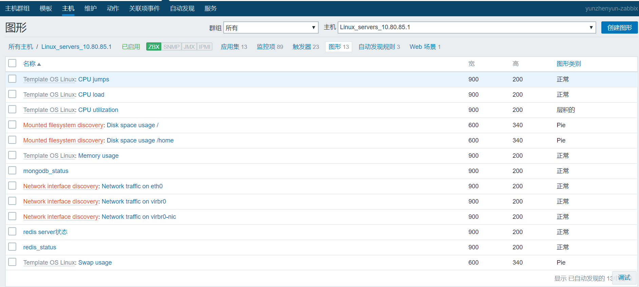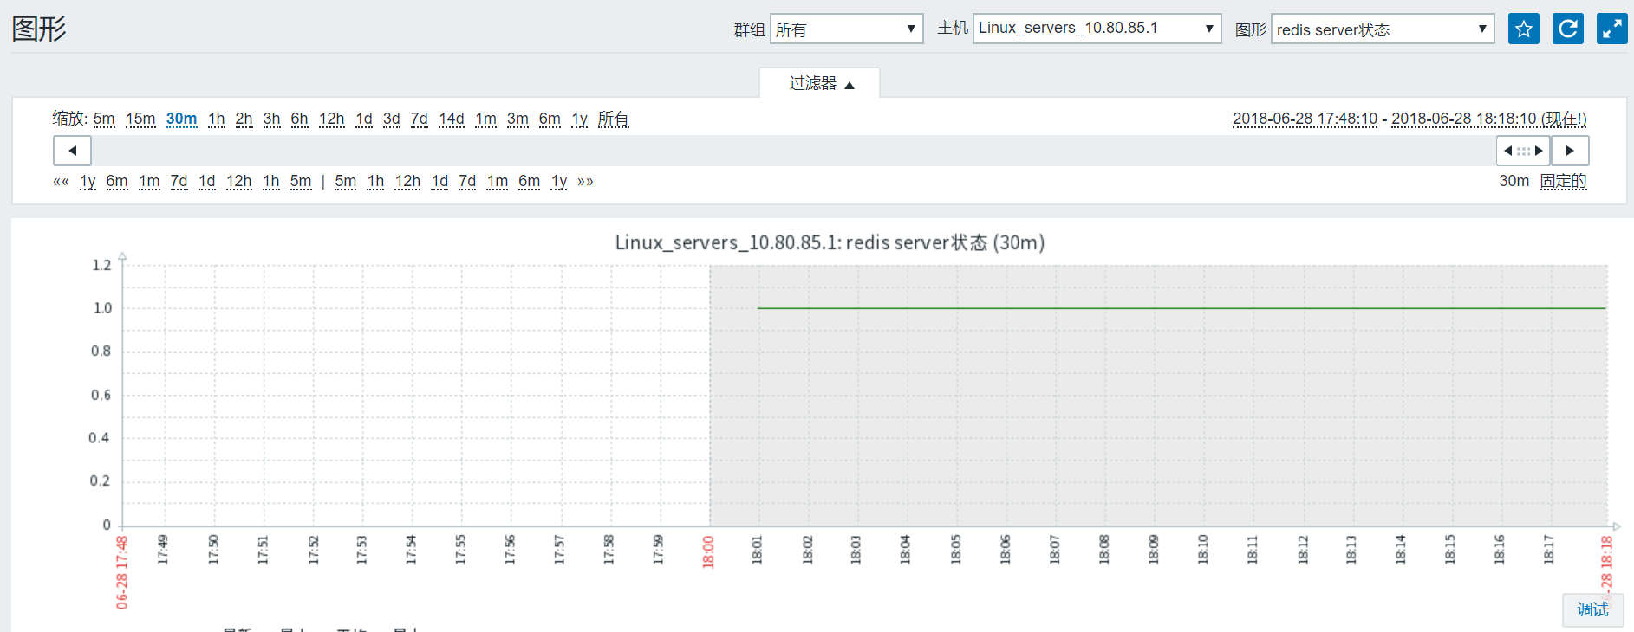

## 添加tomcat端口监听监控

参照8.1方法。

## 模版tomcat监控

# yum install -y java java-devel zabbix-java-gateway

# java -version

# service zabbix-java-gateway status 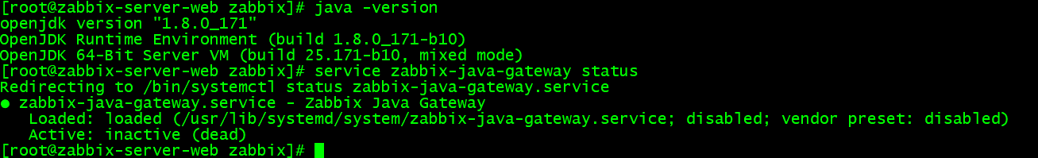

# systemctl start zabbix-java-gateway.service

chkconfig zabbix-java-gateway on

或者

# vim /etc/rc.d/rc.local

#!/bin/bash

# THIS FILE IS ADDED FOR COMPATIBILITY PURPOSES

#

# It is highly advisable to create own systemd services or udev rules

# to run scripts during boot instead of using this file.

#

# In contrast to previous versions due to parallel execution during boot

# this script will NOT be run after all other services.

#

# Please note that you must run 'chmod +x /etc/rc.d/rc.local' to ensure

# that this script will be executed during boot.

touch /var/lock/subsys/local

su - root -lc "systemctl start zabbix-java-gateway.service"

# chmod +x /etc/rc.d/rc.local

# netstat -luntp|grep java

# vim /etc/profile

JAVA_HOME=/usr/lib/jvm/java-1.8.0-openjdk-1.8.0.171-8.b10.el7_5.x86_64

PATH=$JAVA_HOME/bin:$PATH

CLASSPATH=.:$JAVA_HOME/lib/dt.jar:$JAVA_HOME/lib/tools.jar

export JAVA_HOME

export PATH

export CLASSPATH

# source /etc/profile

# echo $JAVA_HOME

# grep ^[a-Z] /etc/zabbix/zabbix_java_gateway.conf

# vim /etc/zabbix/zabbix_java_gateway.conf #默认不修改

检测是否正常启动

lsof -i:10052

# vim /app/etc/zabbix/zabbix_server.conf

# JavaGateway的服务器IP地址

JavaGateway=服务器IP地址

# JavaGateway的服务端口

JavaGatewayPort=10052

# 从javaGateway采集数据轮询进程

StartJavaPollers=5

重启zabbix_server服务

# systemctl restart zabbix-server

被监控tomcat客户端配置

在tomcat下的/bin/catalina.sh文件中添加以下内容：

# vim catalina.sh

CATALINA_OPTS="$CATALINA_OPTS

-Djavax.management.builder.initial=

-Djava.rmi.server.hostname=192.168.3.253

-Dcom.sun.management.jmxremote=true

-Dcom.sun.management.jmxremote.port=8110

-Dcom.sun.management.jmxremote.ssl=false

-Dcom.sun.management.jmxremote.authenticate=false"

# chmod +x catalina.sh

# sh startup.sh

主机中添加模版

Template APP Apache Tomcat JMX

Template APP Generic Java JMX

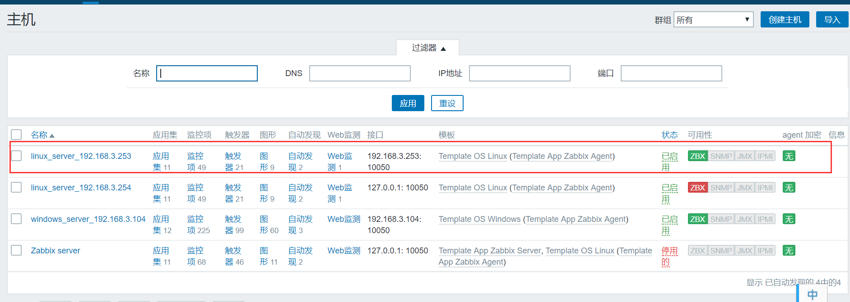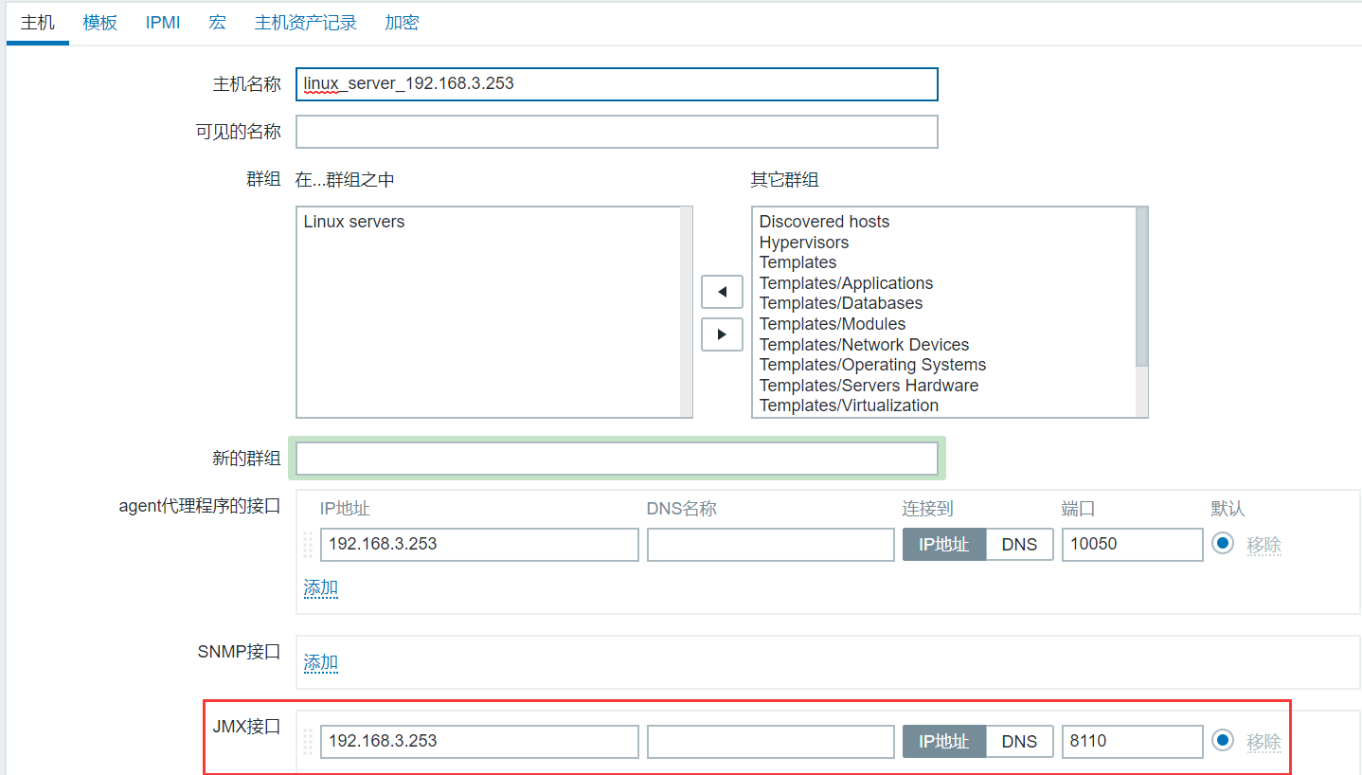

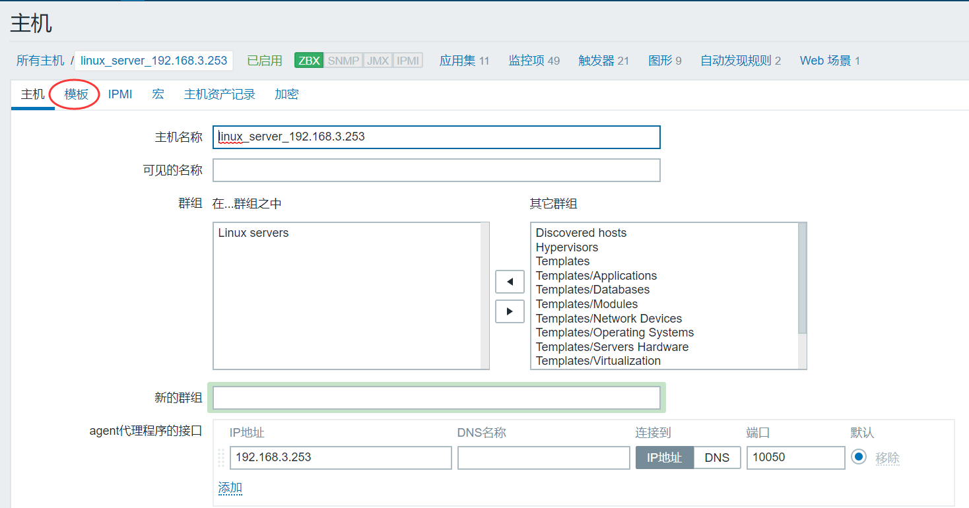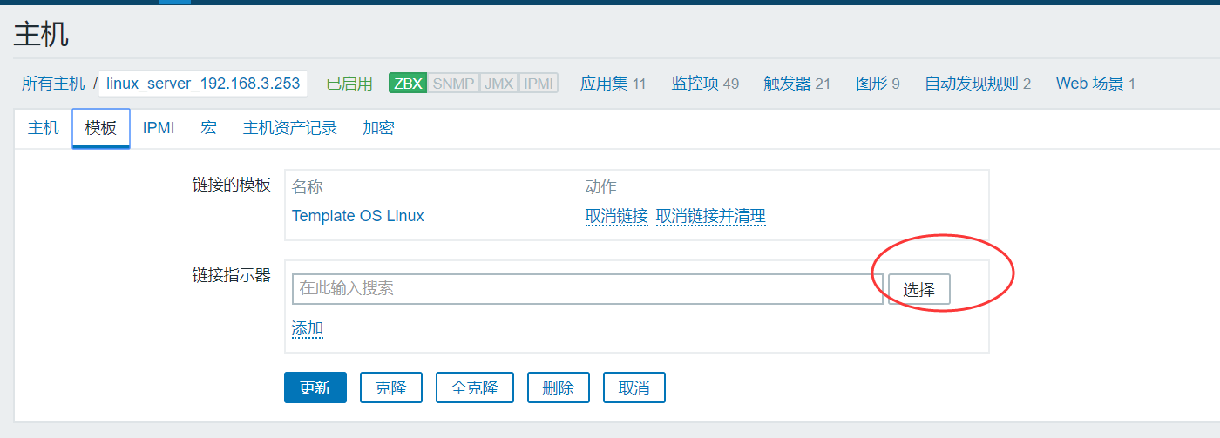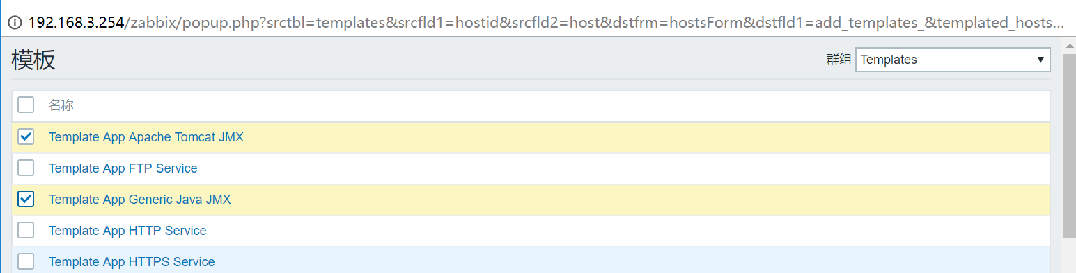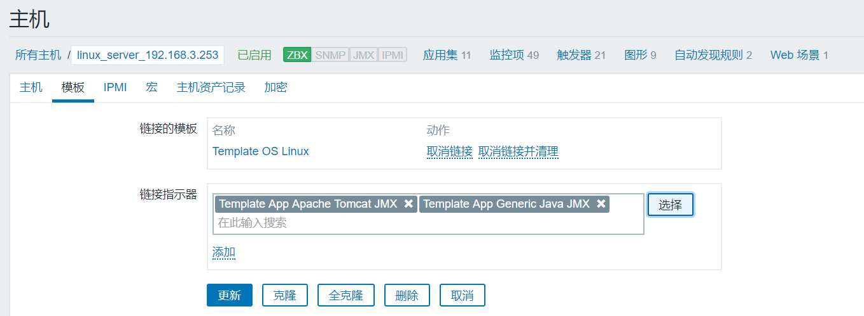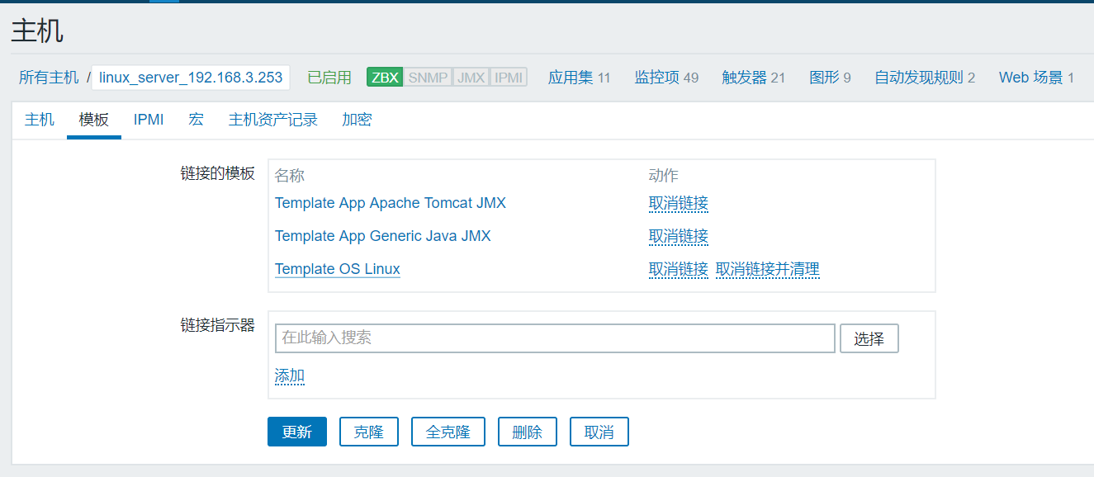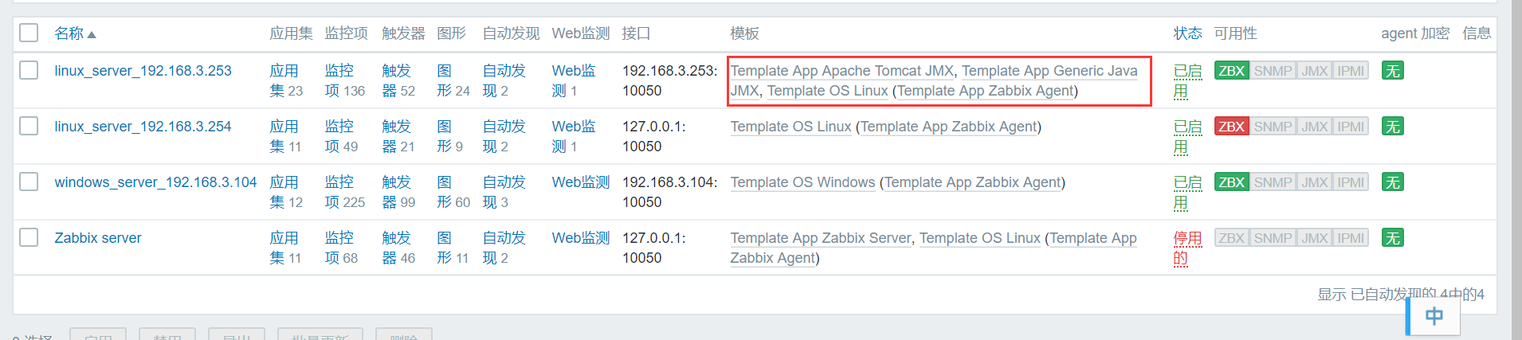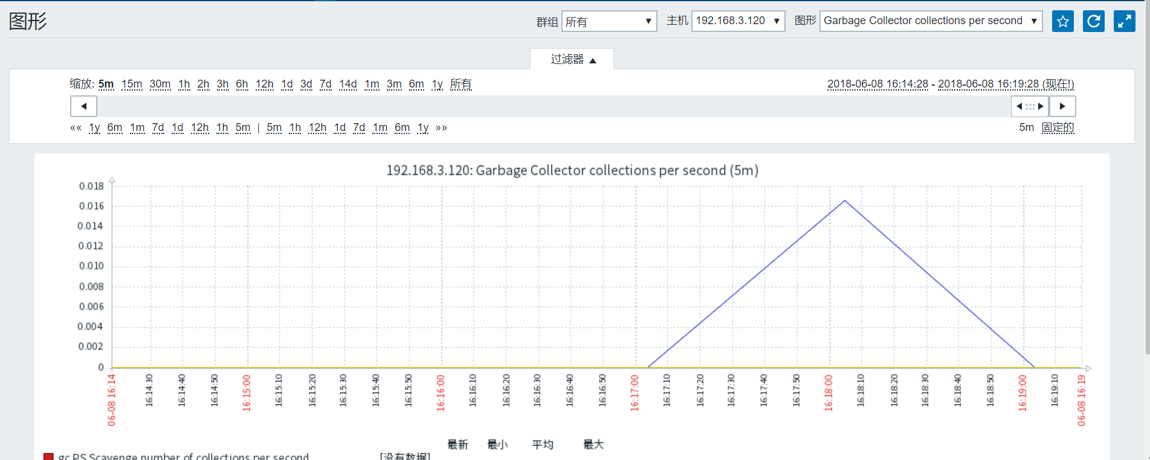

## Fping添加监控

# yum install fping -y

# vim /app/etc/zabbix/zabbix_server.conf

FpingLocation=/usr/sbin/fping

# chown root:root /usr/sbin/fping

# chmod u+s /usr/sbin/fping

# /usr/sbin/fping ip地址

# systemctl restart zabbix-server

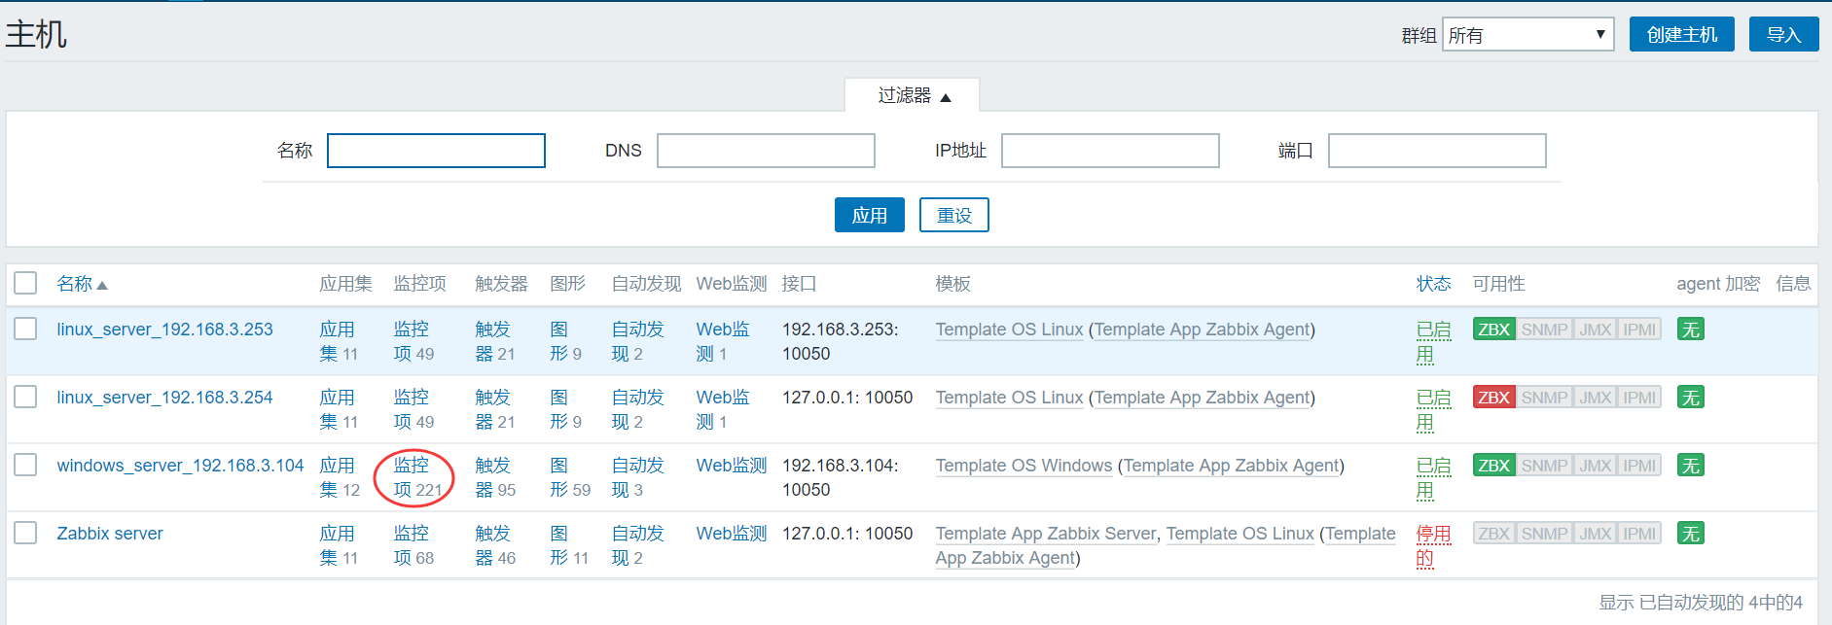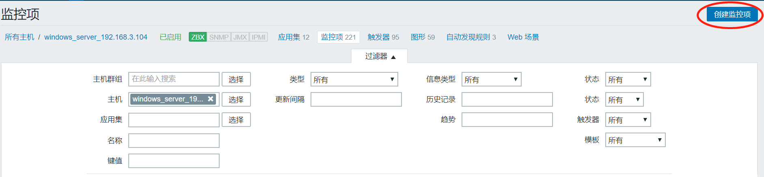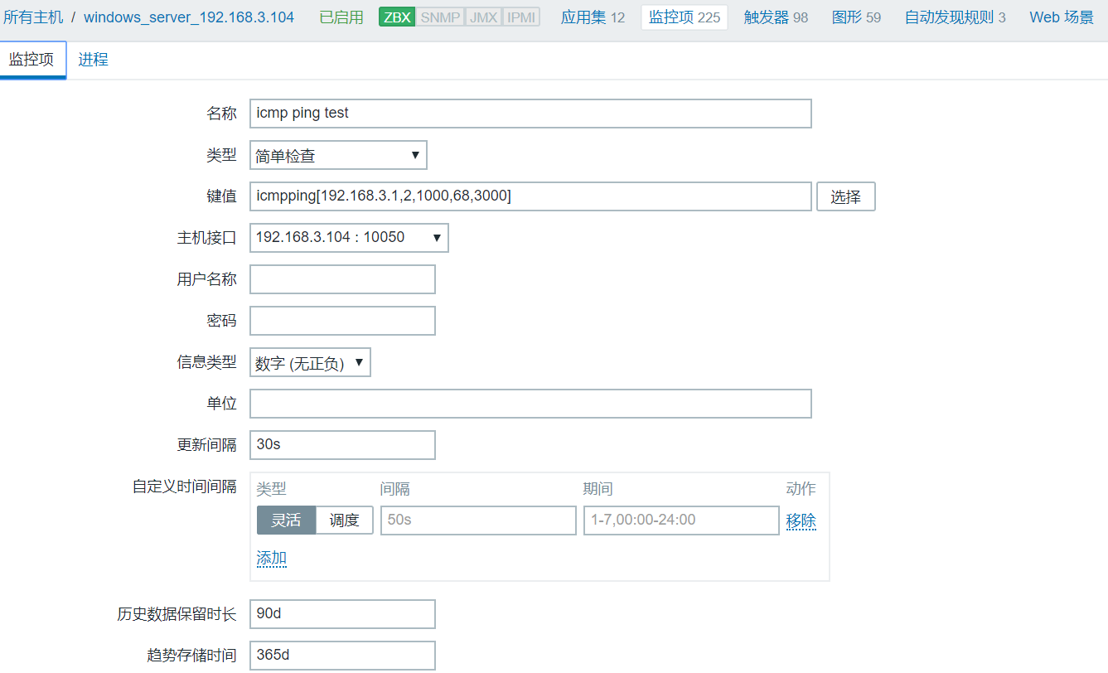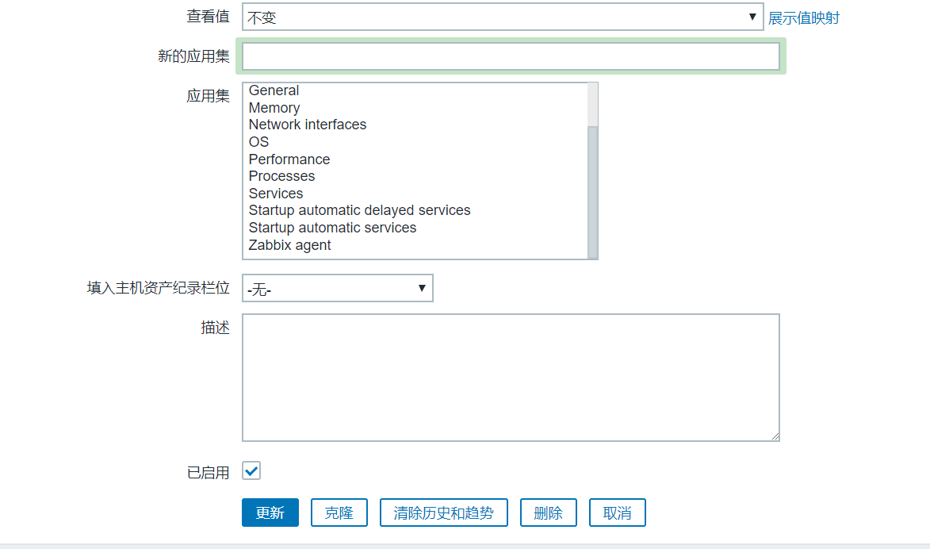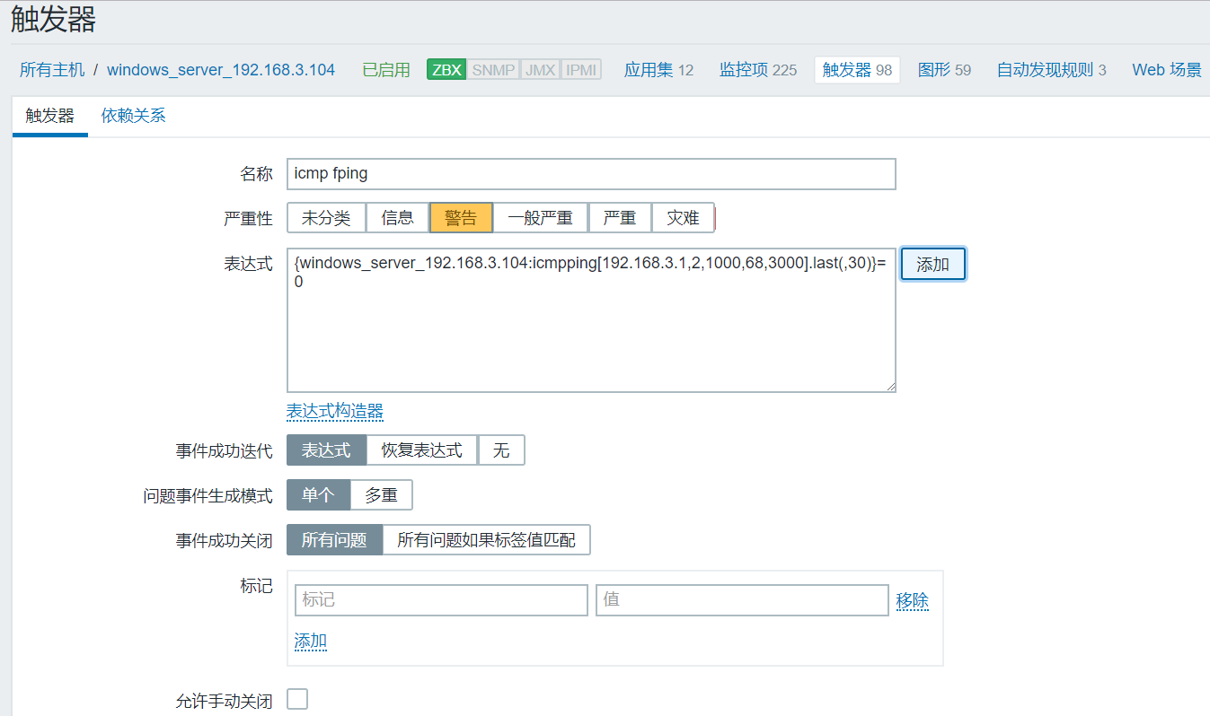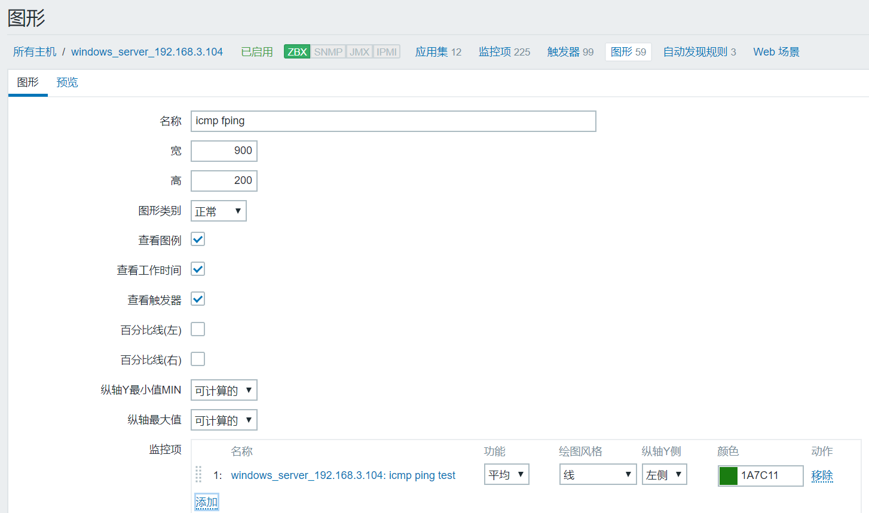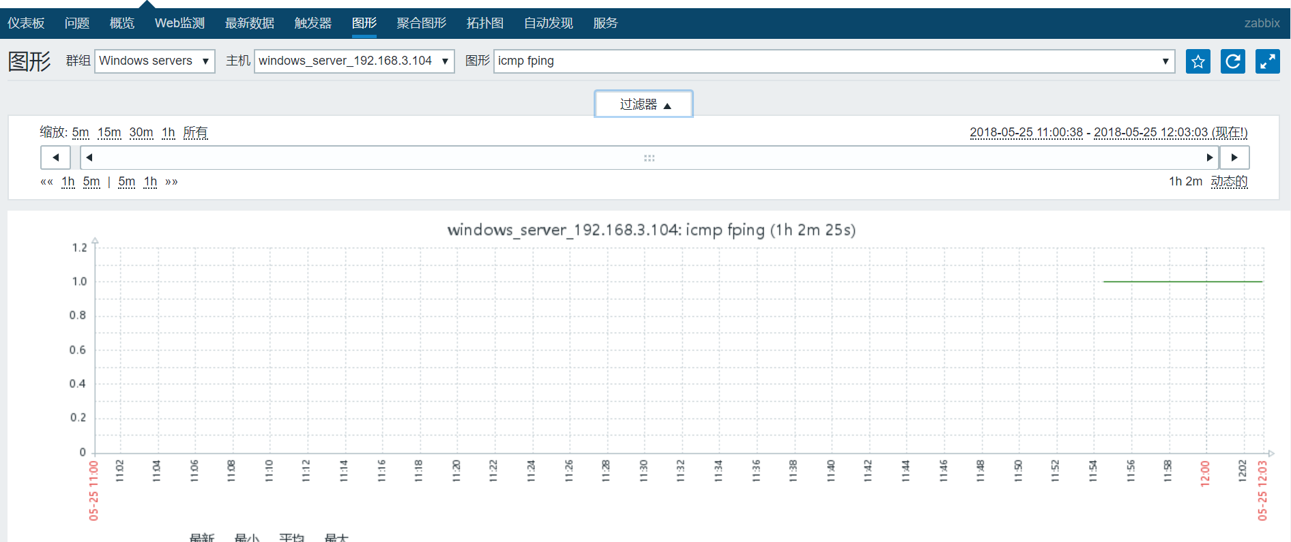

## 添加memcached端口监听监控

参照8.1方法。

## 添加oracle端口监听监控

参照8.1方法

## 添加oracle端口监听监控

参照8.1方法

## 添加elasticcearch端口监听监控

参照8.1方法。按照web监控模式增加url

 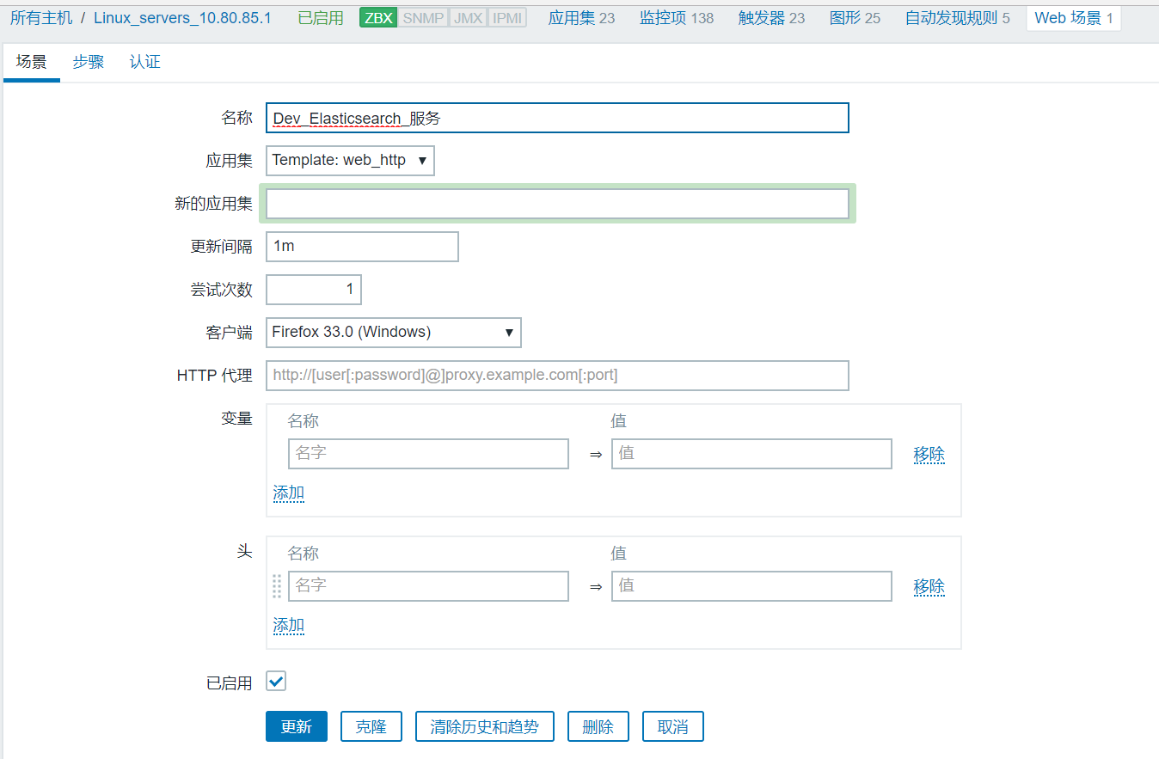 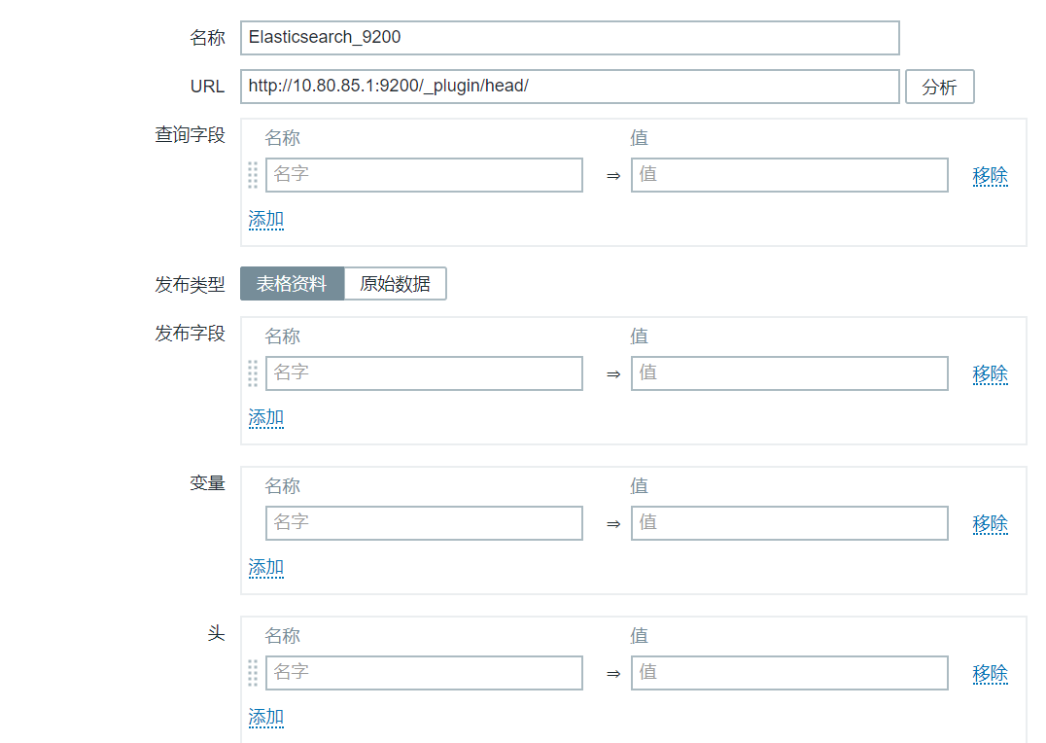 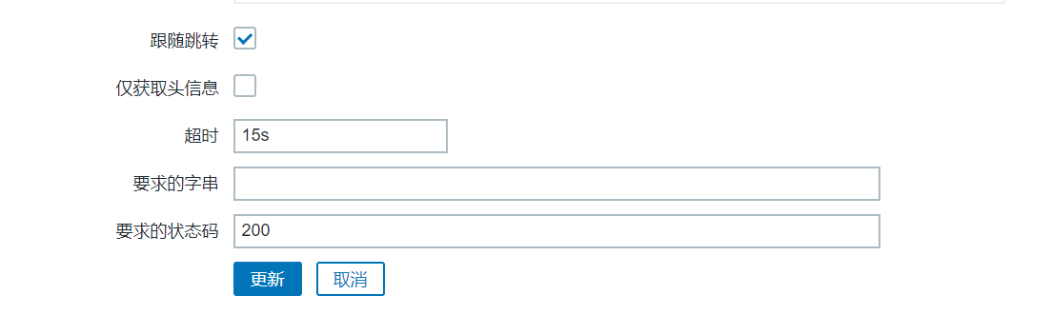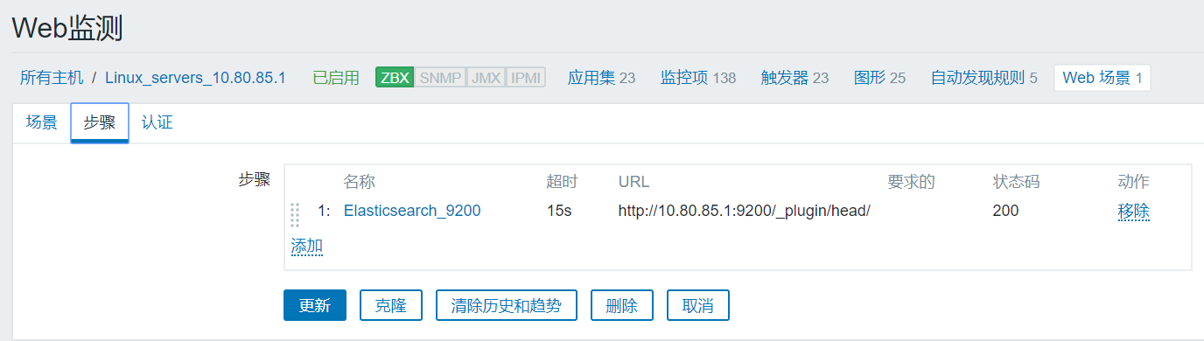

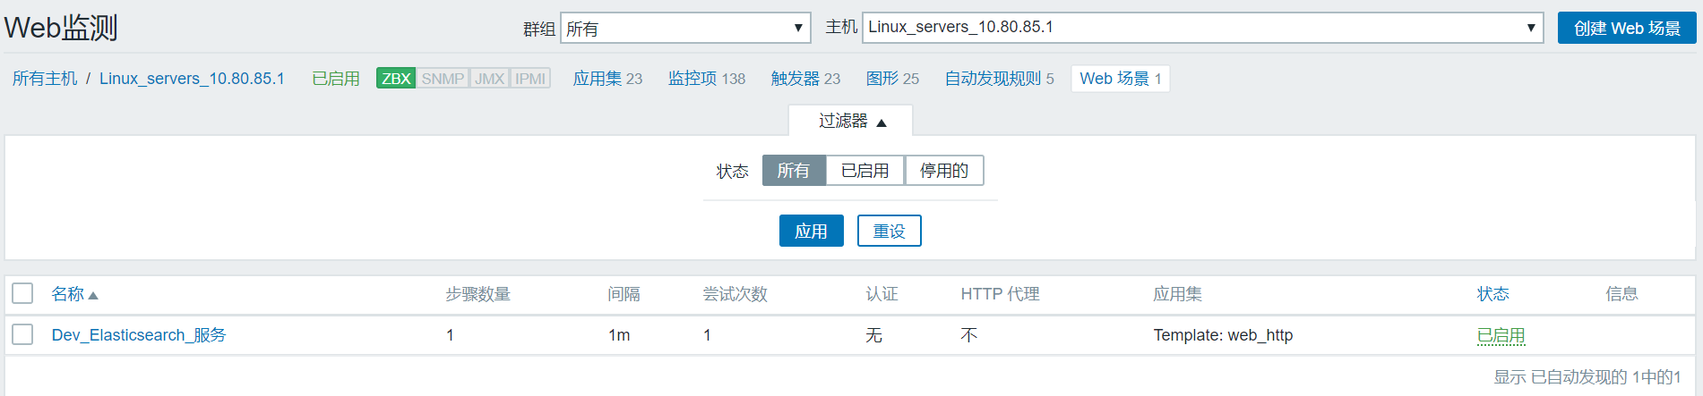

 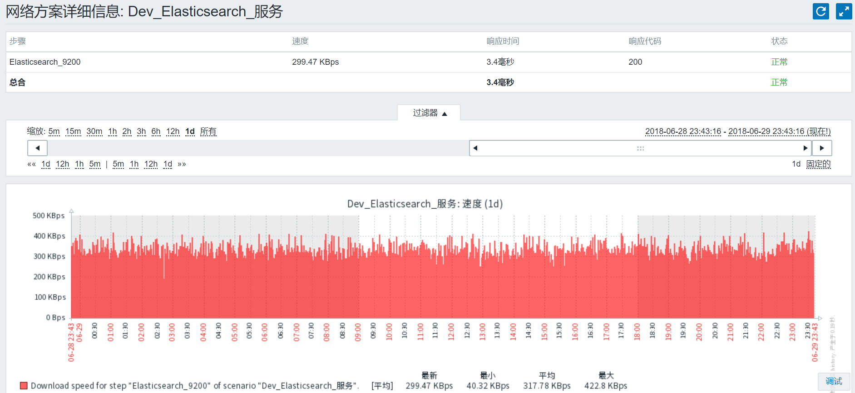 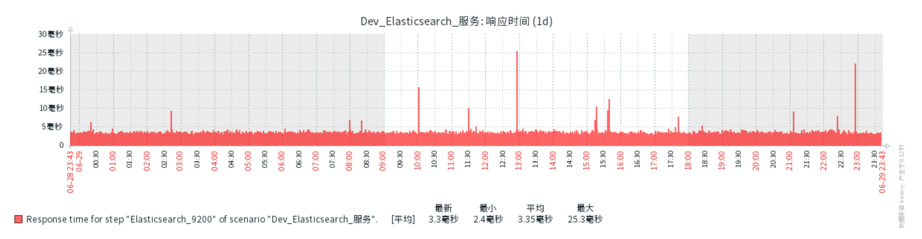

# 告警与通知

每个监控项，设置触发器，这里设置阀值条件，告警检测机制就根据触发器来触发告警，并通过邮件等方式发送告警通知。

## 触发器的设置

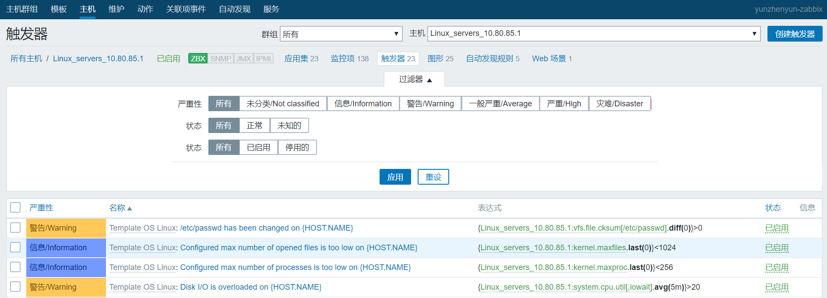 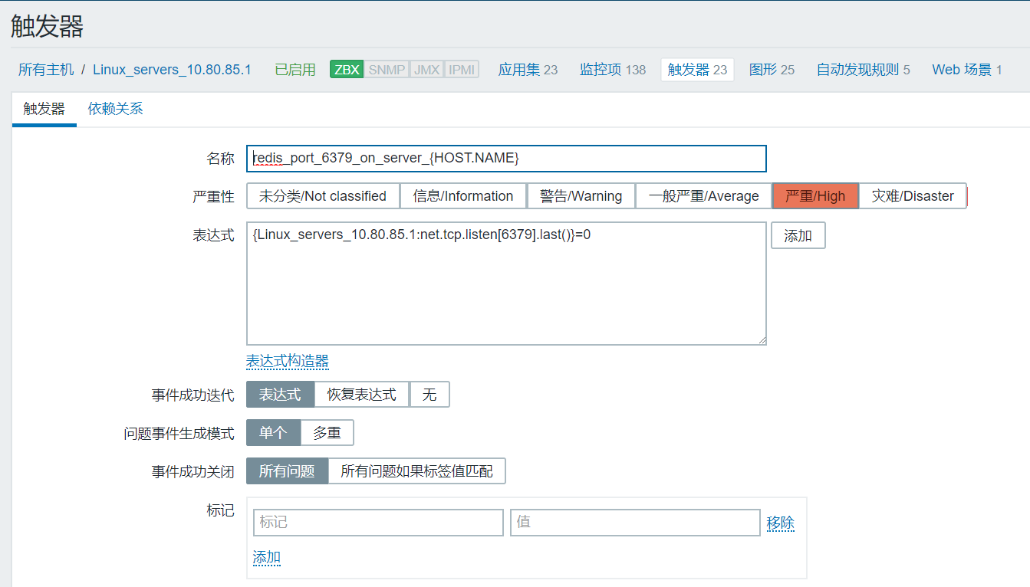 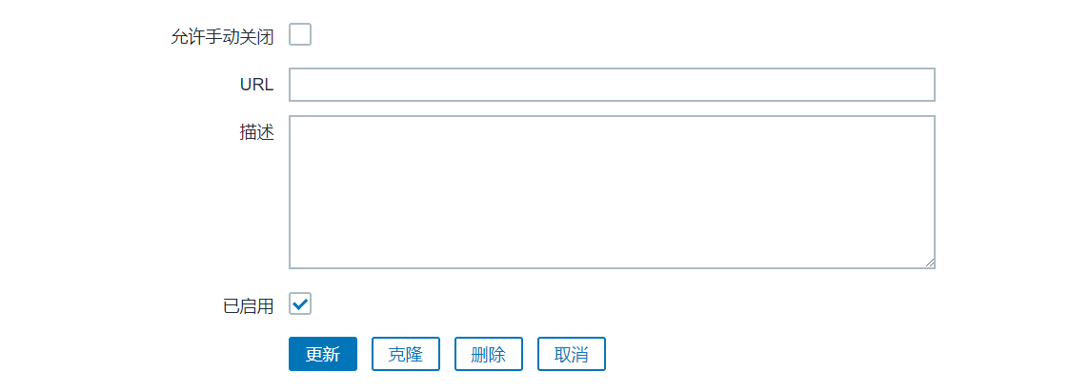 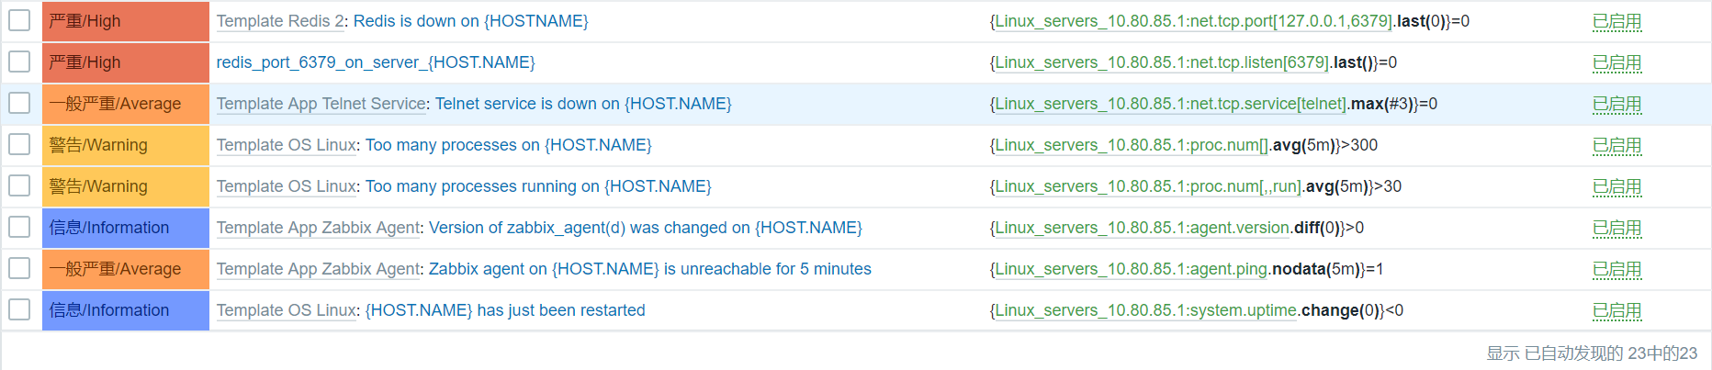

## 告警处置

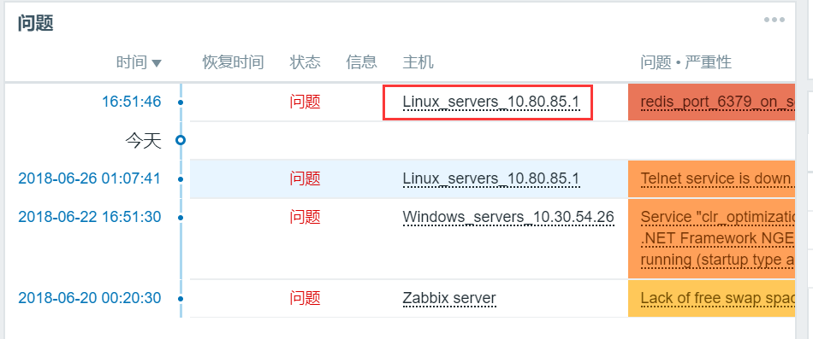

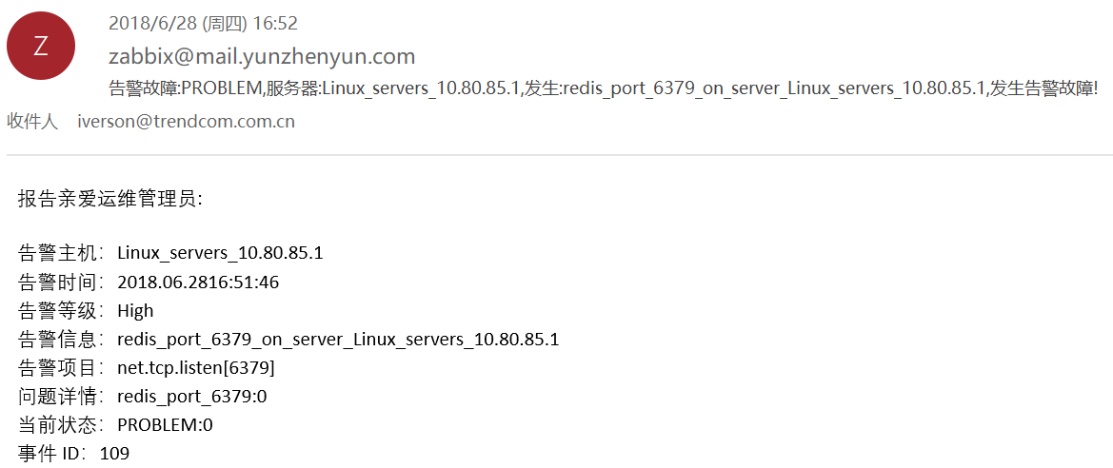

人工介入处理redis的掉线后

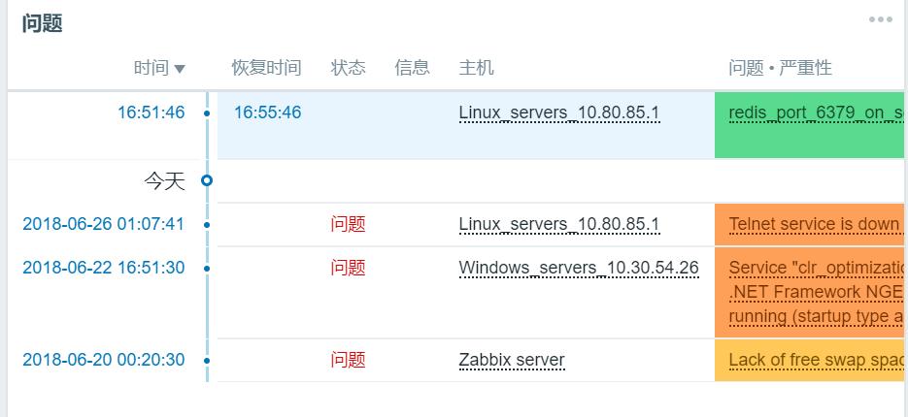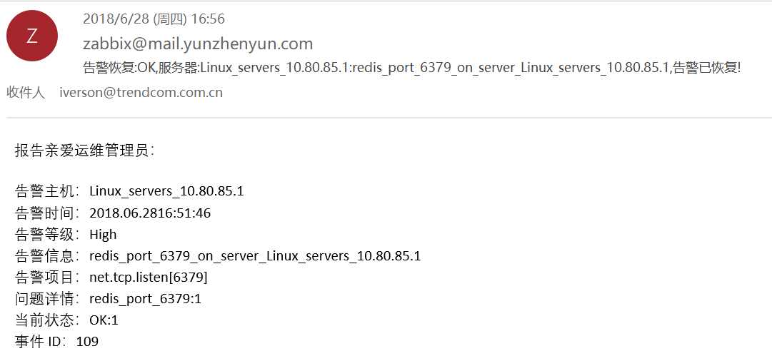

# 全局监控仪表板

## 仪表板

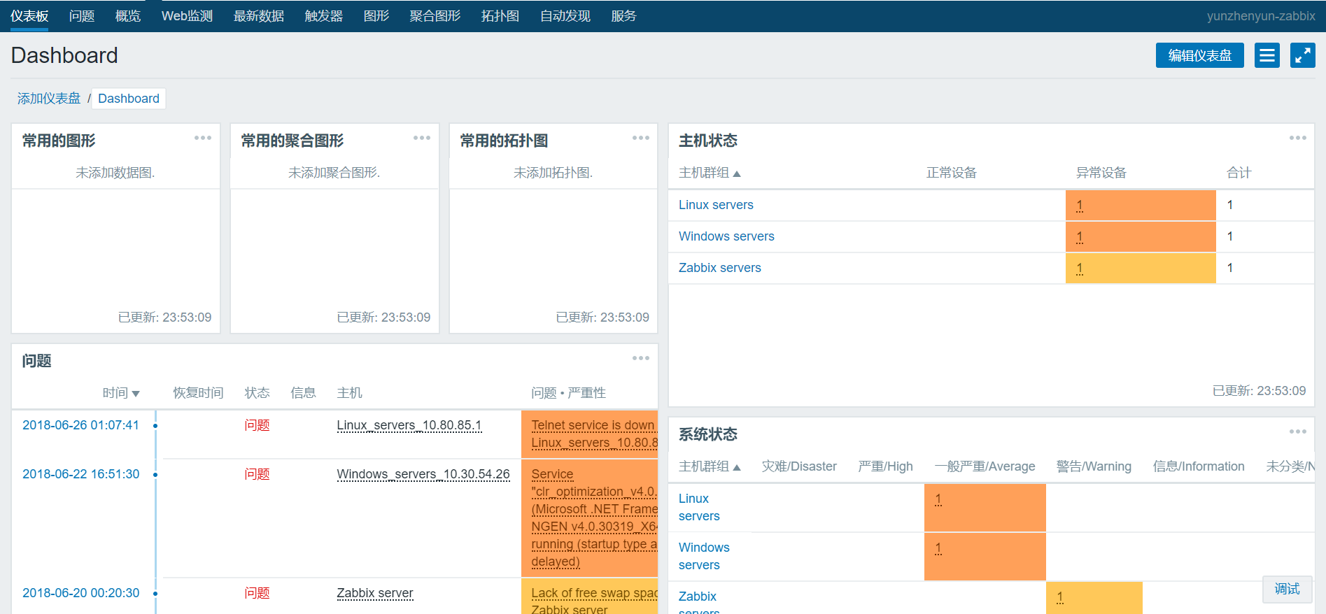

## 问题

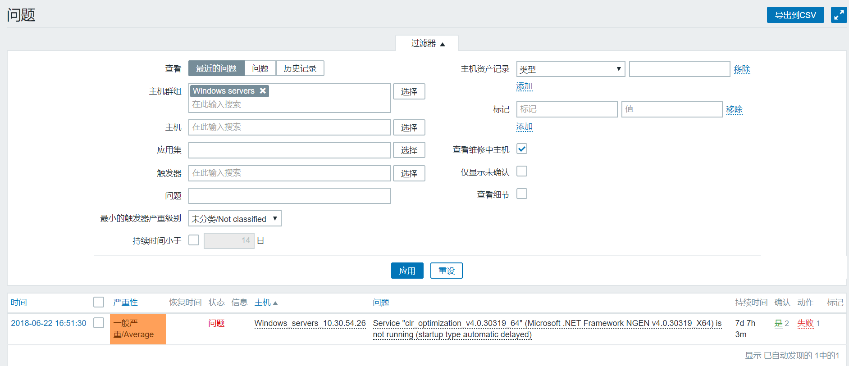

# 图形和数据图

## Web监测

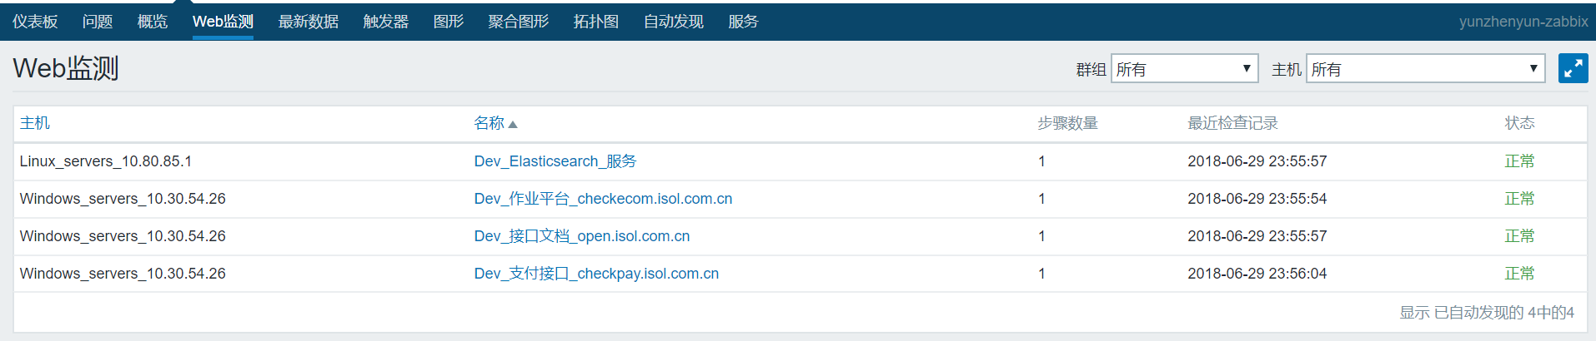 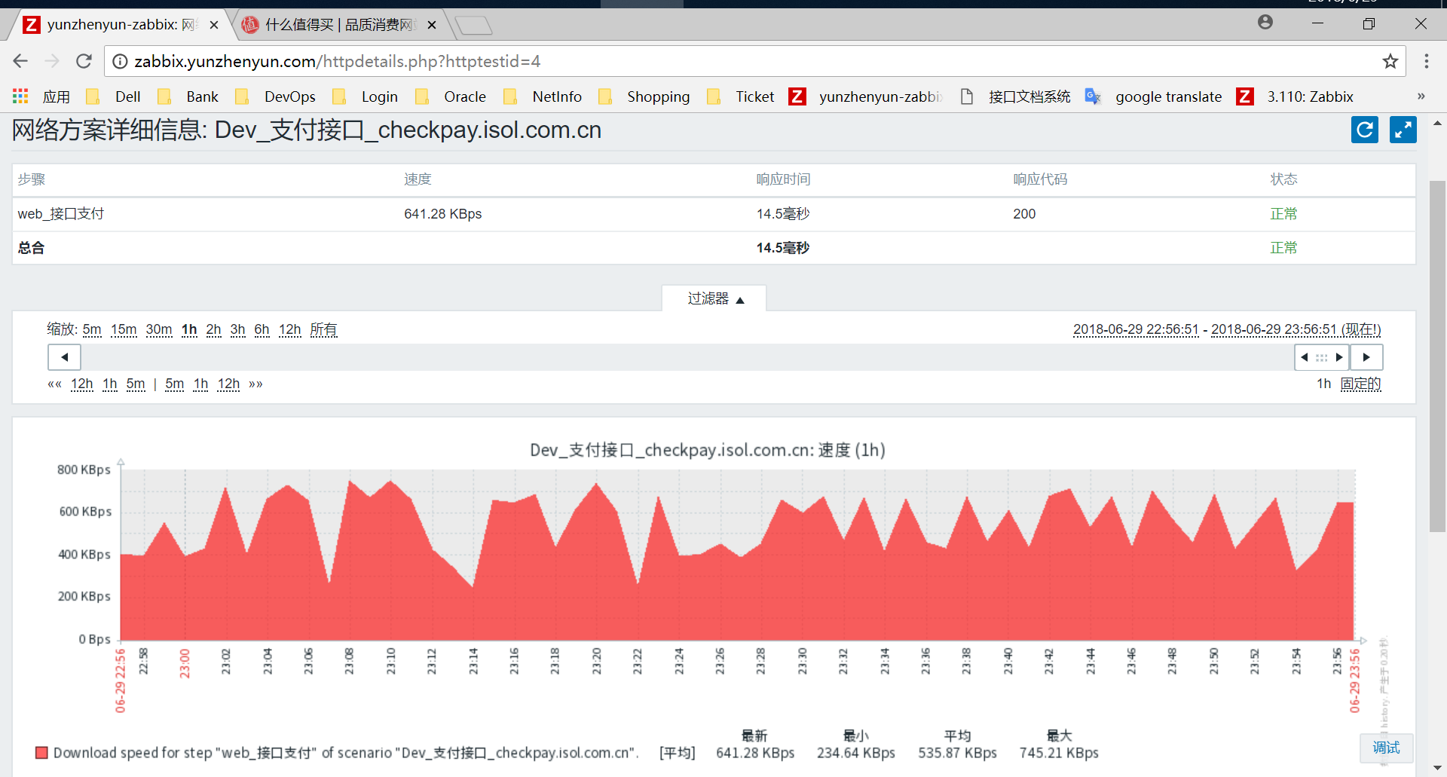 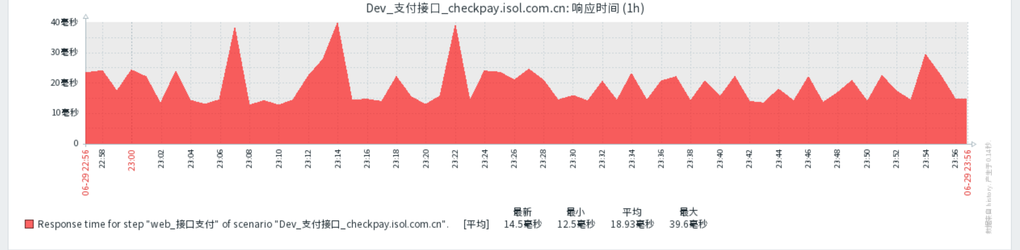

## 图形

